2014 October

^{23rd}

08
Fall

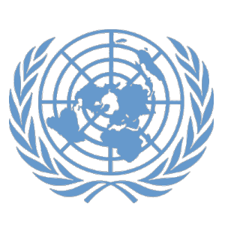

Denver Center for International Studies and South High School

Model United Nations Conference
0
Topic: Israel and Palestine: The Occupied Territories
Advanced Council Question of Palestine (CEIRPP)

BACKGROUND GUIDE

Authors: Elsa Lantz
Editor: Dillon Hunter

Background of the Council
The Committee on the Exercise of the Inalienable Rights of the Palestinian People (CEIRPP) was established in 1975 by the UN General Assembly. The creation of the committee was a significant step in aligning Palestinian people with the rights given to them in Article 13 of the Universal Declaration of Human Rights. In the first year of the CEIRPP’s creation, the council created a two-phase plan that would allow Palestinians to return to their homes and have the Israeli forces leave, using peacekeeping forces to facilitate if necessary. The goal of the committee eventually became the self-determination and sovereignty of an independent Arab State of Palestine.
Currently, the CEIRPP continues to work towards the withdrawal of Israel from the occupied Palestinian territories, as well as respect for the right of all States in the region to live in peace within secure and internationally recognized borders, and the exercise of the inalienable rights of the Palestinian people. This is the only UN committee dedicated solely to the question of Palestine, but it does coordinate with other UN bodies as well as NGOs (non-governmental organizations) and IGOs (intergovernmental organizations).

History of the Issue
Israel and Palestine has a long and complicated history. There are Israeli Jewish people and Palestinian Arabs that both want to live in a small piece of land. This piece of land is also home to Jerusalem, which is the holiest city for Jews, Christians, and Muslims. Although this is the case, the issue has not been primarily a religious battle. The conflict began as a struggle for land. From the end of World War I to about 1948, both groups claimed the land that was internationally known as Palestine. Between 1948 and 1949, the land was divided into three parts: the State of Israel, the West Bank, and the Gaza Strip.
In the nineteenth century, people around the world started to identify themselves nationally and to demand national rights, mainly the right to self-rule a state of their own. Among these people were Jewish people and Palestinian people. Because of the Jewish diaspora, Jewish people were spread across the globe. There was a trend, known as Zionism, to identify a place where Jews could come together through immigration and settlement. The Zionist movement began in 1882, and it was decided that they would immigrate to Palestine, because it was the place where Judaism originated.
At that time, Palestine was a part of the Ottoman Empire. It started to weaken, which allowed European powers to strengthen their grip on areas along the Mediterranean, including Palestine. Around World War I, Britain encouraged the Arab Hashemite tribe to rebel against the Ottoman Empire, which was siding with Germany in WWI. The deal was that in exchange for their help, Britain would support an independent Arab state, although the promise was vague and the borders were disputed. This led to the Arab revolt in 1916, which was successful in getting rid of the Ottoman Empire, and allowing Britain to seize control of the territory. The following year, British Foreign Secretary Arthur James Balfour expressed support to Britain’s Jewish community for a Jewish homeland in Palestine. The expression is known as the Balfour Declaration, and it spurred Jewish immigration, which led to the establishment of the foundation of Israel.
In 1922, the League of Nations declared that Britain and France had administrative power over much of the former Ottoman Empire until it was deemed ready for self-rule. Britain gained control over equivalent to modern-day Israel and Jordan, while France got control of modern-day Syria and Lebanon. Starting in 1929, violence began to break out between Jews and Arabs living in the British Mandate. A Jewish militia, the Haganah, emerged and teamed up with Britain to protect Jewish communities from the violence. In 1936, a second Arab revolt started a sustained three-year period of violence, in which Arab militants attacked Jewish and British troops.
In 1936, the Grand Mufti of Jerusalem, Haj Amin al-Husseini created an Arab Higher Committee to fight against the British rule and Jewish nationalism. The next year Britain disbanded the committee and exiled the Mufti. In 1937, Britain put together the Peel Commission to explore the causes of the Arab-Jewish violence, and to recommend a long-term solution. Their plan was to divide the land into two parts: one for the Arab people and one for the Jewish people. The Arab leadership at the time, the Grand Mufti of Jerusalem, strongly opposed the plan. Mainstream Jewish groups thought that this plan was a good idea. The commission also decided to cap the amount of Jews that could immigrate to Palestine.
The Pact of the League of Arab States was signed by seven nations, thus founding the Arab League in 1945. It was a way for Arab states to rally against the Axis powers, but it also adopted a nationalist tone, pressed for freedom from colonial rule, and the prevention of a Jewish state in Palestine.
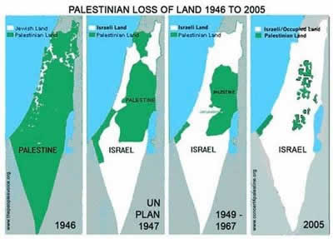
By 1947 the British had decided to leave and the mandate ended in civil conflict as the Arabs and the Jews fought over the land. At that time the United Nations had just been started and they passed Resolution 181 to split the land up, giving some to the Jews and some to the Arabs. The Arabs rejected this idea, while the Jews accepted it. Fighting continued, and by 1948 Israel was declared as an independent state. Egypt ended up with control over the Gaza Strip while Jordan controlled the West Bank.
Fast-forwarding to 1973, Israel engaged in a war with Egypt and Syria, causing tensions. The US Secretary of State Henry Kissinger employed “shuttle diplomacy” to serve as an intermediary between the hostile parties in an attempt at negotiating an agreement. In 1974, the Palestinian National Council ratified a ten-point program with the goal to liberate Palestinian territory.
In 1984 the Palestinian population in the West Bank and Gaza began a mass uprising. This uprising is known as the first intifada, and it was sparked because an Israeli jeep ran over Palestinian teachers. It was not orchestrated but rather developed from popular mobilization through various organizations and institutions that had developed under occupation. Israel tried to stop the uprising by using violence, and by arresting people. At this time, Israel also used a secret policy of targeted killings in the Occupied Territories. Political divisions rose, as did violence within the Palestinian communities. The intifada ended with Israel claiming that the Palestinian Liberation Organization (PLO) was a terrorist organization that was not willing to negotiate.
The United States tried to stabilize its position in the Middle East by promoting a resolution of the Arab-Israeli conflict. A multilateral conference convened in Madrid, Spain in 1991 to open negotiations with Palestinians and the Arab states. In the following negotiations in Washington, Palestinians were represented by a group from the Occupied Territories. Although the Israeli and Palestinian delegations met many times, little progress was made. Meanwhile, human rights conditions in the Gaza Strip and the West Bank deteriorated after Yitzhak Rabin became Prime Minister in 1992. This development undermined the legitimacy of the Palestinian delegations to the Washington talks.
The lack of progress in the negotiations and the human rights violations along with economic decline increased the growth of a radical Islamic challenge to the PLO. Violent attacks against Israeli military and civilian attacks against Hamas and Islamic Jihad continued and exacerbated tensions.
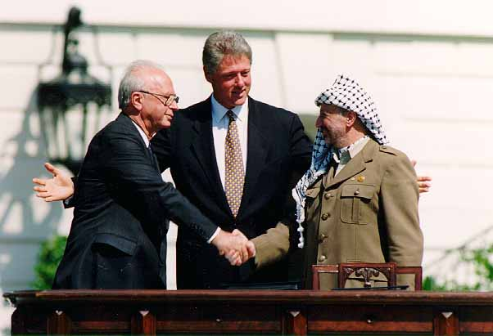
Because of the stalemate in the Washington talks and the fear of radical Islam, secret meetings were held between Israel and the PLO in Oslo, Norway. They produced the Israel-PLO Declaration of Principles, which were then signed in Washington in 1993. The picture to the left is of the signing in Washington. The Declaration of Principles established that Israel would withdraw from the Gaza Strip and Jericho, with additional withdrawals from areas of the West Bank over a span of five years. The key issues-the extent of the territories to be ceded by Israel, the nature of the Palestinian entity to be established, the future of Israeli settlements and settlers, water rights, the resolution of the refugee problem and the status of Jerusalem-were set aside to be discussed in the final status talks. The Oslo accords set up a process without specifying an outcome. The process was supposed to be done by 1999, but a new Prime Minister came to power and the accords were not engaged.
The problems with the Oslo accords, along with daily frustrations and humiliations inflicted upon the Palestinians in the Occupied Territories converged to ignite a second intifada in late September 2000. This intifada was sparked when prime minister Ariel Sharon visited the Temple Mount, accompanied by 1,000 armed guards. Palestinians threw rocks at Jews praying, and in retaliation the Israeli police stormed the Temple Mount and killed four and injured over 200 protesters. This caused several demonstrations and clashes across the West Bank and the Gaza Strip. The second intifada was much bloodier than the first, and during the first three weeks of the uprising, Israeli forces had shot 1 million live bullets at unarmed Palestinian demonstrators. Israel characterized the protests as acts of aggression. The use of force continued to expand to include tanks, helicopter gunships, and F-16 fighter planes. Officials justified the full-scale war by arguing that the law enforcement model was no longer viable because the military was “out” of Palestinian areas and because Palestinians possessed (small) arms and thus constituted an armed “foreign adversary.” Palestinian-Israeli negotiations resumed briefly, this time with no US presence, at Taba in January 2001. The parties came close to agreement, but they were called off because of elections for Prime Minister.
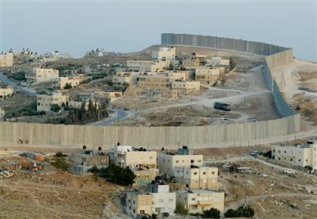
In 2002, at the Beirut Summit of the Arab League, all Arab states excluding Libya endorsed a peace plan. The plan offered an end to the Arab-Israeli conflict, including the recognition of Israel, peace agreements and normal relations for all Arab states, in exchange for full Israeli withdrawal from all the territories occupied since 1967, including the Golan Heights, and the establishment of an independent Palestinian state in the West Bank and the Gaza strip with East Jerusalem as its capital. Prime Minister Sharon authorized the construction of a separation wall between Israel and the West Bank, but he only agreed when he realized that Israel could not annex the West Bank and the Gaza Strip and remain a primarily Jewish state. The wall (pictured to the right) cuts through communities, and has reconfigured the geography of the West Bank. Palestinians refer to the wall as the “apartheid wall.”
In 2005, all Jewish settlements in the Gaza Strip were evacuated and the wall was sealed, leaving checkpoints controlled by Israel as the only way to enter and exit. Israeli officials considered this their withdrawal, even though nothing changed and Israel continues to exercise “effective control” over the land. Israel also has incursions to arrest residents and move them to Israel. In September 2007 Israel declared the Gaza Strip to be a “hostile territory” and tightened its grip on the blockade of the Strip.

Recent Action
In 2011, Palestine petitioned to be accepted as a member state in the UN. However, they did not get the nine required votes, and the US would have vetoed the petition, preventing it from reaching the General Assembly. In 2012, Palestine requested the General Assembly accept Palestine as a non-member observer state, and there were 138 votes in favor, 9 votes against, and 41 abstentions. The vote did not affect the control Israel had on the West Bank and the Gaza Strip, but it did give Palestine the option to approach the International Criminal Court to pursue Israeli officials for crimes committed in the course of the occupation.
In August of 2014, it was revealed that Hamas (a Palestinian Islamic organization) has admitted to the kidnapping and killing of three Israeli teens. This sparked an Israeli crackdown on Hamas members throughout the West Bank. Hamas responded with a heavy rocket fire out of the Gaza Strip, which lead to Israel launching an aerial and ground invasion of the territory. More than 2,000 Palestinians were killed in the fighting, and 67 Israelis were killed, all but three of them being soldiers. Egypt attempted a cease-fire but it collapsed and the heavy fighting resumed. Secretary-General Ban Ki-moon called for an emergency meeting of the Security Council to discuss the conflict. NPR reporter Jackie Northam said, “Ban told the Security Council that Gaza and the region as a whole cannot afford another full-blown war. He said the risk of an all-out escalation is preventable if Hamas stops firing rockets and mortars into Israel. But Ban also took Israel to task for what he called excessive force.”
Both parties agreed to an Egyptian-sponsored deal that, unlike the previous ceasefires, is open-ended. The deal, as described by Palestinians, outlined that Israel would ease up on their restrictions on the Gaza Strip, and humanitarian supplies and needed materials would be let in.
In September 2014, Israel claimed a portion of the West Bank as state land, which reignited political sparks between Israelis and Palestinians. Palestinians want the land for their future state, but Israel wants it to build more settlements in the West Bank, where there are currently more than 350,000 settlers. The United States then called on Israel to reverse its decision, which further raised tensions. Since then, tensions have lowered slightly, but no long-term peace agreements have been cemented.

Timeline
1897: First Zionist Congress
1917: Palestine is declared “a national home for the Jewish people.”- Balfour Declaration
1929-36: British Mandate Palestine, Israeli/Arab unrest was evoked. Clashes began to occur.
1947: UN Partition of Palestine
1948: Establishment of Israel
1964: Formation of the PLO (Palestinian Liberation Organization)
1967: The 1967 War- tensions culminated into six days of hostilities
1973: The 1973 Yom Kippur War
1979: Israel and Egypt make peace.
1982: Israel invades Lebanon
1987: Palestinian intifada
1988: PLO opens door to make peace
1991: Madrid summit
1993: Oslo Peace Process
1994: Palestinian Authority is created
2000: Second intifada
2002: West Bank is re-occupied by Israel
2005: Israel pulls out of the Gaza Strip
2006: Hamas Elected to Palestinian Leadership
2006 – present: Continued violence between Palestinian territories and Israel and deepening humanitarian crisis for Palestinian people
Questions to Consider
- Is Palestine still an occupied territory even though Israel “left” the Gaza Strip?
- Does your country think that Israel’s control over the Gaza Strip justifiable?
- How do the Palestinians living in occupied territory regain their inalienable human rights?
- Does your country want a two-state solution, or would a one-state solution work better?
- What sort of solution should be put into place to ensure peace in the future?

Sources
http://www.nmun.org/ny_archives/ny13_downloads/BGG13CEIRPP.pdf- More information on the Council
http://www.merip.org/primer-palestine-israel-arab-israeli-conflict-new- Extensive history of the conflict
http://www.bbc.com/news/world-middle-east-13331522- Hamas Palestinian Movement information
http://news.bbc.co.uk/2/shared/spl/hi/middle_east/03/v3_ip_timeline/html/2005.stm

