2014 October

^{23rd}

08
Fall

Denver Center for International Studies and South High School

Model United Nations Conference
0

^{Advanced General Assembly}
Economic and Financial Committee:
^{Diamonds in Conflict}

BACKGROUND GUIDE

Authors: Sydney Oswald and Kyle Salois
Editor: Dillon Hunter

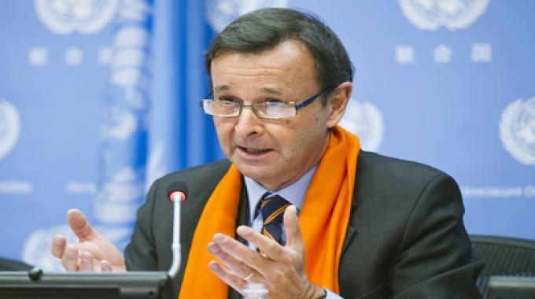
Economic and Financial Committee Values and Goals:
The ECOFIN Committee is committed to the development of world economies, particularly those of Least Developed Countries (LDCs) and Landlocked Developed Countries (LLDCs), and resolves to address roadblocks to these developments. ECOFIN prioritizes discussing macroeconomic policy questions, including international trade, the international financial system, external debt sustainability, sustainable development, human settlements, poverty eradication, education, and globalization and interdependence.
The goals of the ECOFIN committee during this session are to address unresolved concerns of African nations regarding the industry of mining precious gems as a producer of further conflict, and as an opportunity for economic development in these countries. Specifically, diamonds provide a currently overlooked source of wealth and financial leverage. The diamond industry could give developing nations in Africa the financial power to take up a strong position on the world stage. With this opportunity, however, comes the possibility of conflict. The diamond industry has been in the past and continues to be an issue and conflict in resources among nations, for these precious gems do not follow national borders, but are transnational, making the problems they create transnational as well.
ECOFIN recognizes the need for further discussion on the effectiveness of the previously instituted Kimberley Process Certification Scheme (KPCS), and additionally requests conversation on Western African nations that are not members of the KPCS furthering efforts to meet requirements to apply for membership.

History of the Issue
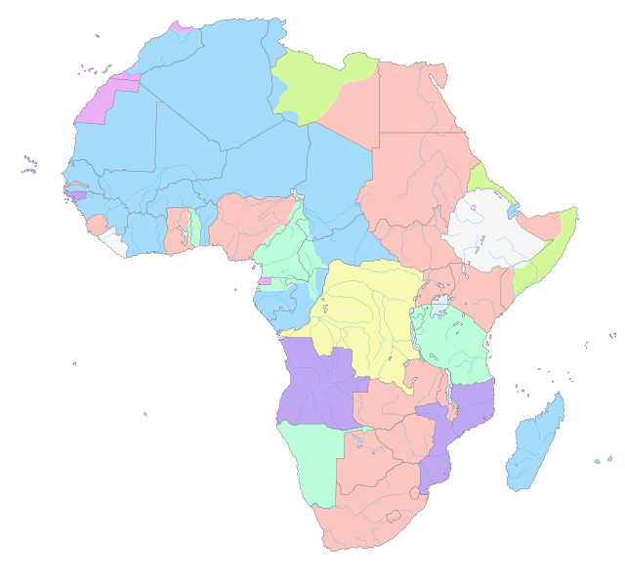
The history of the diamonds in conflict issue date back to the Berlin Conference of 1884, in which European powers debated over the distribution of African territories for colonization purposes. After European colonization, most African regions were neglected, as colonizers prioritized exclusively resource extraction of Africa, while neglecting cultural traditions of local nations, as well as actively dehumanizing and disempowering said people. The Conference utterly disregarded the existing cultural and tribal boundaries, splitting tribes and families and neglecting to take into account the desires of the native people to the land. Just as the European colonists cut through preexisting borders, diamond industry and mining and ensuing conflict do not respect national borders.
The direct cause of the United Nation’s addressing of the conflict related to diamonds during the fifty-fifth session of the General Assembly was the Angolan Civil War. After the first, United Nations-monitored, election of 1992, the UNITA party practiced violence against the leading MPLA party. This prompted U.N. sanctions against the UNITA party, in an effort to remove their militarization efforts. In the Fowler Report, however, presented by Robert Fowler, it was determined that the UNITA party had continued its revolts with the funding of “conflict diamonds”, regardless of the sanctions that had been imposed. In response, the U.N. Security Council decided to create the Kimberley Process Certification Scheme, which would discourage further funding of violence-producing diamond trade.
The KPCS instituted that all member countries had to ship diamonds in tamper-proof containers, that diamonds must be accompanied by a government-validated Kimberley Process approved certificate. The certificate must be resistant to forgery and uniquely numbered, and countries included in the KPCS may only ship diamonds to other KPCS participant countries. Breaching these regulations could result in dismissal from the Kimberley Process Certification Scheme. The World Trade Organization is the institution charged with the investigation and determination of the failure to comply with the rules by a member country.

Timeline of the Issue

Sierra Leone
1991 -- Former army Corporal Foday Sankoh leads Revolutionary United Front (RUF) attacks on Sierra Leone border towns from Liberia.
1995 -- RUF beaten back from Freetown and diamond areas liberated.
2000 -- RUF kidnap 500 peacekeepers. UK sends in paratroopers. Sankoh detained. U.N. imposes global embargo on diamond exports from Sierra Leone.

Angola
1992 -- After 14 years of civil war, elections held and MPLA win, but a presidential runoff is required as the vote is closely split between MPLA's Eduardo do Santos and UNITA's Jonas Savimbi. Election result rejected by UNITA before second election, and civil war continues.
1993 -- U.N. reports up to 1,000 people dying every day, more than in any other conflict in the world at the time.
1998 -- Fighting escalates. Both sides lay mines around their postions including diamond reserves. U.N. prohibits export of unofficial diamond exports.
1999 -- Diamonds worth $150 million produced in conflict areas and $468 million from non-conflict areas.

Democratic Republic of Congo
1998 -- Civil war revived by rebel movement backed by Rwanda and Uganda, which control diamond area.
1999 -- Official production of diamonds worth $396 million.
2000 -- Army claims Rwandan and Ugandan troops have "massacred" civilians around the diamond area in the east of the country.

Pertinent Information and Recent Action
A recent resolution drafted by the United Nations and instituted in 2006, during its sixty-first General Assembly, included these notable clauses:
- Welcoming the important contribution of the Kimberley Process, which was initiated by African diamond-producing countries,
- Noting that the vast majority of rough diamonds produced in the world are from legitimate sources,
- Reaffirms its strong and continuing support for the Kimberley Process Certification Scheme and the Kimberley Process as a whole;
- Takes note of Security Council resolution 1643 (2005) of 15 December 2005 which calls upon the States in the West Africa region that are not participants in the Kimberley Process to intensify their efforts to join the Process, stresses that the widest possible participation in the Kimberley Process Certification Scheme is essential, and encourages all Member States to contribute to the work of the Process by seeking membership, participating actively in the Certification Scheme and complying with its undertakings;
This resolution represents many of the current ideas of the members of the Economic and Financial Committee, however, recent developments may have changed some country’s views. Global Witness Founding Director Charmian Gooch, leader of the former member of the Kimberley Process Certification Scheme, stated, “The Kimberley Process's refusal to evolve and address the clear links between diamonds, violence and tyranny has rendered it increasingly outdated”. This opinion is that of a growing number of members of the KPCS, and represents the need to address the concerns related to the effectiveness of the Process.
With the outbreak of the Ebola Virus Disease, further concerns are developing related to the stopping of economic actions, including restrictions on international trade with countries with known outbreaks of the disease. As Western African countries are less able to legitimately trade their precious gem resources, the growth of further illegitimate trade is becoming a pressing issue. In addition, economic aid for both development of nationalized and safe mining of diamonds and for the prevention of the spread of Ebola need to be balanced, while not understating either issue. “Business planning and investment decisions are very difficult in an environment where the World Bank is projecting widely divergent scenarios with possible 2015 regional GDP losses ranging from $1.6 billion to $25.2 billion,” states financial news source Forbes.

Questions to Consider
- Can a voluntary program such as the KPCS be as effective as needed?
- How can the diamond industry be kept as sustainable as possible?
- Should the solution be implemented by national governments or international NGOs?
- How do diseases affecting economic development serve to halt progress for a safer West Africa?
- What implications do the ongoing conflict over diamonds have on both the economies of African nations and on civilian lives?
- What are the sources of the diamond conflict?
- Should the emphasis be placed on the economic or social impacts of the conflict?
- How have radical groups exacerbated the conflict and resisted the measures previously instituted?

Sources

Armstrong, Paul. “How Diamonds fuel Africa’s Conflicts”. CNN.com. CNN. 16 May 2012. Web. 21 Oct 2014.
“Blood Diamonds: Timeline of Conflict”. CNN.com. CNN. 18 Jan 2001. Web. 21 Oct 2014.
“Economic and Financial: Second Committee”. UN.org/en/ga. General Assembly of the United Nations. 17 Sep 2014. Web. 21 Oct 2014.
Gooch, Charmian. “Why we are Leaving the Kimberley Process”. Globalwitness.org. Global Witness. 5 Dec 2011. Web. 21 Oct 2014.
The Kimberley Process. KimberleyProcess.com. The Kimberley Process. Web. 21 Oct 2014.
Machingura, Gretinah. “Africa Economy: Zimbabue Expounds Africa Mining Mission”. Globalpost.com. Xinhua News Agency. 20 Oct 2014. Web. 21 Oct 2014.
Nsehe, Mfonobong. “Ebola's Impact on Sierra Leone's Once Flourishing Business Sector.” Forbes.com. Forbes. 16 Oct 2014. Web. 21 Oct 2014.
“Resolution adopted by the General Assembly on 4 December 2006”. UN.org. General Assembly of the United Nations. 12 Feb 2007. Web. 21 Oct 2014.
Sedze, Brian. “Ebola: Wake Up Call for Africa to Build its own Institutions”. Nehandaradio.com. Nehanda Radio. 21 Oct 2014. Web. 21 Oct 2014.

