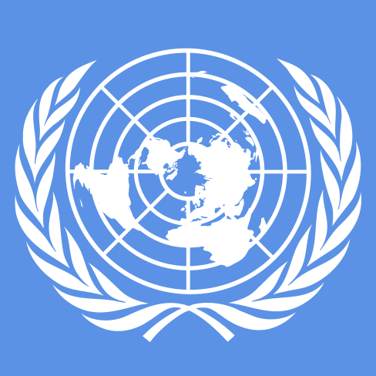

Cherokee Trail High School Model United Nations
November 11, 2017
Background Guide
Advanced European Union Crisis Council

Topic: EU’s stance on Terrorism and Environment

Greeting Delegates,
Welcome to Cherokee Trail’s 2017 Model UN Conference! We are so excited to host all of you, and watch each and every one of you diplomatically engage in this council! This year for all advanced delegates, we have planned to facilitate a European Union Crisis Council, in which delegates will be members of the Council of the EU where they will debate and resolve issues on terrorism and the environment . We have a crisis-filled day planned and advise that all delegates be ready to work on issues diplomatically and thoroughly. The purpose of the crisis council is to replicate real global issues that have been occurring these past years, and encourage that the council’s decisions reflect the best interest of the European people. This will involve thinking strategically, impulsively, and most importantly fairly. Although most of the delegates decisions will be on the spot decisions, this background guide will provide information on how the council will be facilitated and what each delegate should be prepared for. In addition, delegates should be prepared to discuss both topics in council.
Best of luck! Sincerely,
Cherokee Trail MUN

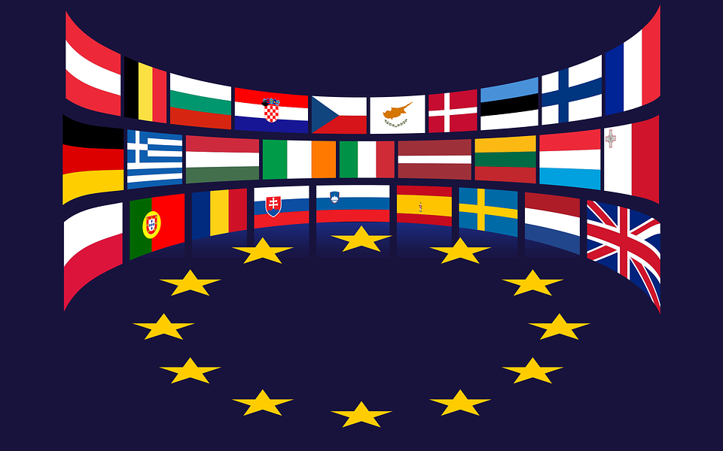
Introduction
The European Union, also known as the EU, was founded on November 1st, 1993 and includes 28 European countries. The EU was formed after World War II for the purpose of initiating economic and political cooperation. The countries in the EU believe that cooperation in these areas between countries would decrease the chance of going to war with each other, which after World War II became an imperative ideal for many countries. The original members were known as the Inner Six: which included the countries of Belgium, France, Italy, Luxembourg, the Netherlands, and West Germany. The origins of the EU can be traced back to the European Coal and Steel Community (ECSC) and the European Economic Community (EEC), that were established after the Treaty of Paris of 1951 and the Treaty of Rome of 1957. These treaties were eventually adopted by the modern day European Union, but at the time were proof of countries desires to cooperate with the intentions of reaching stability and partnership. After the establishment of the Inner Six, several other European countries joined and thus the formation of the European Union. The EU has shaped their own internal single market in which a standardized system of laws are applied that each member must adhere to. It has its own currency, the euro, which is used by 19 of the member countries, its own parliament and it now sets rules in a wide range of areas - including on the environment, transport, consumer rights and even things such as mobile phone charges.
Note: Since the EU has several different branches, for the purpose of this council delegates are to assume they are members of the Council of the European Union, in which members will have power to draft legislation on the issues that they face. Different from actual EU procedure, delegates will follow typical UN structure for resolution drafting and voting procedures. Delegates do have the power to write Directives issued to the EU. In addition, qualified majority voting method will be applied to pass resolutions.
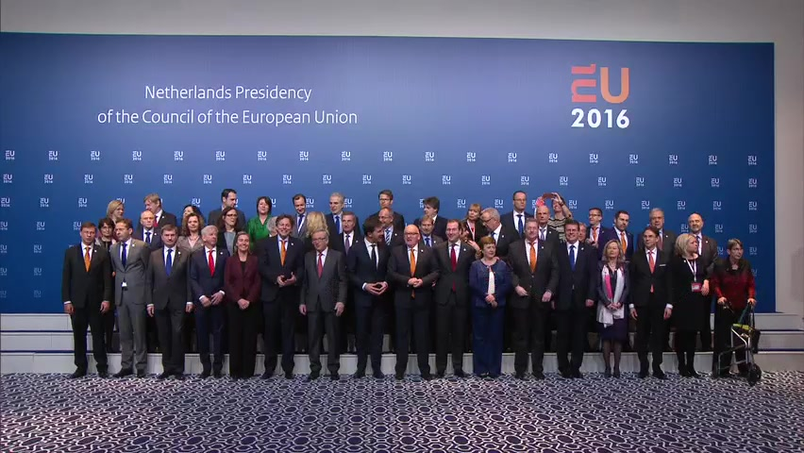
Voting Procedure and Council Structure
According to Consilium Europa, The European Union is a unique political entity, whose sovereign member countries pool authority in key areas of government in order to reach shared goals. Every national of a member country is also an EU citizen, giving them the right to participate in the democratic life of the bloc. Similar to a state, the EU has a legislative branch (Parliament + Council), executive branch (Commission) and independent judiciary (Court of Justice).
The powers of the EU institutions have been laid down by founding treaties negotiated and ratified by member countries. In policy areas not covered by the treaties, national governments are free to exercise their own sovereignty.

Institutional triangle
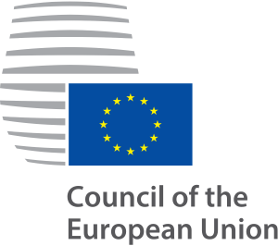
There are 3 institutions responsible for making policy and taking decisions:
- European Parliament
- Council of the European Union (Delegates will be representing)
- European Commission.
European Parliament
The European Parliament was set up to represent EU citizens directly. Its powers have been extended through successive changes to the EU's basic treaties. It was first directly elected by EU citizens in 1979. The current Parliament was elected for 5 years in May 2014 and has 751 MEPs from all 28 countries. Parliament’s principal function is to adopt, jointly with the Council, draft legislation put forward by the Commission. Another function is control and approval of the EU budget. Parliament also exercises democratic supervision of the Commission, which includes the power to dismiss the Commissioners en bloc, through a vote of censure.
Council of the European Union
It is the voice of national governments, where ministers from each country meet several times a month. It has both a legislative function, which it shares with Parliament, and an executive function, which it shares with the Commission. Relevant ministers meet to discuss and decide specific policy on external (foreign) relations, economic & financial affairs, transport, energy, agriculture, etc. It is commonly called the Council of Ministers, or just 'the Council'.
Most decisions are by qualified majority vote, although numerous issues in areas like taxation, asylum or immigration, as well as foreign & security policy require unanimity.
Qualified Majority Vote:
From 1 November 2014 a new procedure for qualified majority voting applies in the Council. Under this procedure, when the Council votes on a proposal by the Commission or the High Representative of the Union for Foreign Affairs and Security Policy, a qualified majority is reached if two conditions are met:
- 55% of member states vote in favour - in practice this means 16 out of 28
- the proposal is supported by member states representing at least 65% of the total EU population
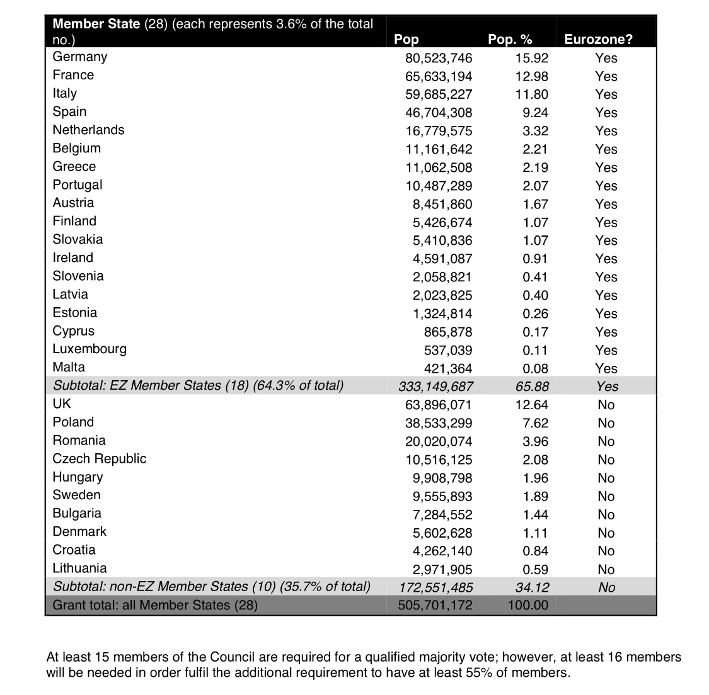
This new procedure is also known as the 'double majority' rule”

Introduction to terrorism
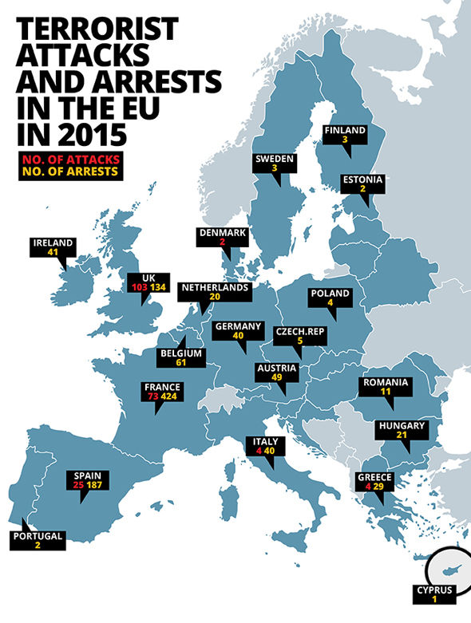
The European Union has always been negatively affected terrorism since from when it was founded although throughout history the source of it has altered. Terrorism in Europe approximately began at the start of the twentieth century and was most often associated with anarchism. The primary leading drivers in these movements included but was not limited to Chechan separatism in Russia, Irish Republican Army within the United Kingdom as well as Euskadi Ta Askatasuna as well as far left or right extremism. These events fueled terrorism within the EU for approximately 100 years (give or take). Since technology was not as advanced during the occurrence of these acts of terrorism, the death toll per event was not as large as more modern methods of terrorism. However this evolution of technology has also helped on the side of modern security leading to less attacks being successful and modern medicines keeping the spread of deaths and injuries fairly consistent. This was true until terrorism reached its peak in the early 2000s when the terrorist group Al Qaeda attacked the world with methods not seen before. This included a variety of new types of bombs as well as using many types of public transportation that incurred mass death. For example the Madrid Train bombings in 2004, these bombings occurred on March 11, 2004, exactly 911 days after the terrorist attacks in the United States. These explosions killed 192 people and injured around 2000 more. The types of bombs used were IEDs (improvised explosive devices), these deadly weapons became more popularized because of this event and are still being used in modern terrorism and still yield deadly results unless properly disposed of by a professional bomb squad. Another event of a mass terrorist bombing is the London bombings of 2005 also referred to as “7/7”. These terrorist bombings were not by IED but rather suicide bombers. This act of terrorism resulted in 56 deaths and 784 injuries making this the largest terrorist event in the UK since the 1988 Pan Am Flight 103. The type of bomb used here is known as “organic peroxide” another extremely lethal explosive. This bombing occurred on the cities public transportation system, again displaying the relevancy of public transportation systems in relation to this topic. Terrorist events as such began a long trend of the spread radical Islam throughout not only the European Union but the whole world. Due to the proximity of Middle East to members of the European Union this is topic is especially prevalent to member countries. The coincidental and overlapping refugee and terrorism crises besetting Europe pose a unique challenge to the European Union. This places exceptional stresses on two weak points in the still incomplete community. The first is the absence of legitimate and effective mechanisms for reconciling divergent national interests, and composing them in coherent policies, when important matters of a non-economic nature rise to the top of the agenda. The other is the weakness of a common identity crucial to addressing problems that involve the EU’s engagement with the rest of the world. A joint EU strategy for dealing with the refugee crisis is now in limbo with no early prospect of its regaining a firm footing. There were rudiments of a more or less comprehensive plan on the table early in November (2016). They included: a formula for distributing 160,000 asylum seekers among member states; the need to establish processing centers at points of entry for most of the migrants - Greece and Italy above all; a sifting process for differentiating between those who had a valid basis for claiming political asylum as opposed to the seeking of a better life; an improved system for the repatriation of those who failed to qualify asylum status; a strategic partnership with the principal transit countries (above all Turkey) along with countries of origin to facilitate a monitoring of refugee flows and methods of repatriation; and payments to states burdened with large concentrations of displaced persons.
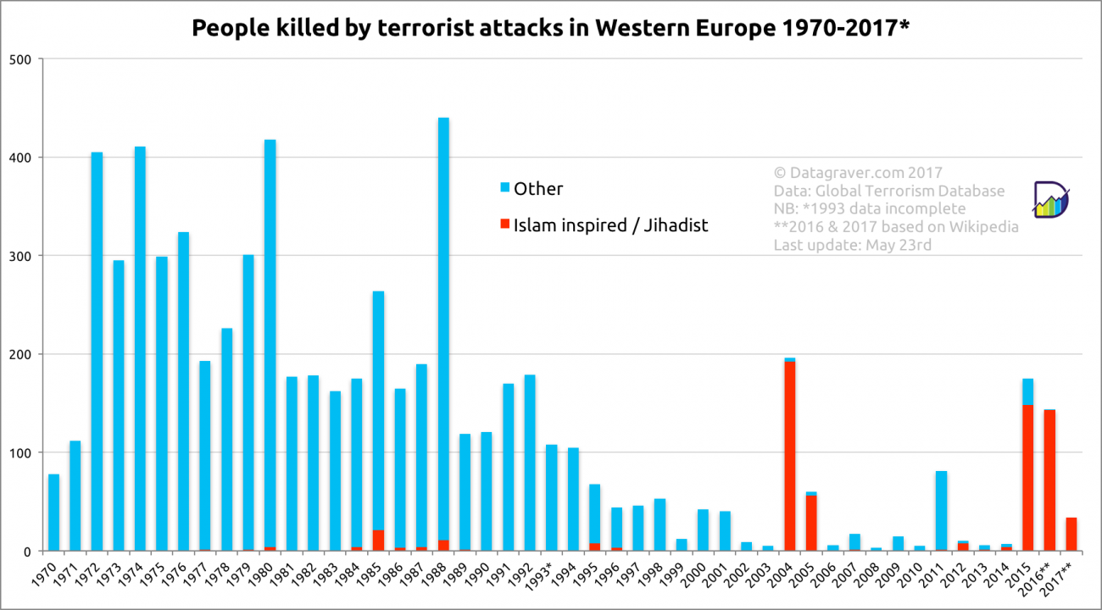
Introduction to Environment
The European Union states, “The EU has some of the world's highest environmental standards. Environment policy helps green the EU economy, protect nature, and safeguard the health and quality of life of people living in the EU.” Protecting the environment and maintaining a competitive EU presence on the global market can go hand in hand, and environment policy can play a key role in creating jobs and stimulating investment. 'Green growth' entails developing integrated policies that promote a sustainable environmental framework. Environmental innovations can be implemented and exported, making Europe more competitive and improving people's quality of life. Fairness is paramount in all this. Nature is our life support system, so we need to look after it. We share resources like water, air, natural habitats and the species they support, and we also share environmental standards to protect them.
Europe is working to safeguard these natural resources and halt the decline of endangered species and habitats. Natura 2000 is a network of 26,000 protected natural areas, covering almost 20% of the EU's land mass, where sustainable human activities can coexist with rare and vulnerable species and habitats.

Safeguarding the health and wellbeing of people living in the EU
Water, air pollution and chemicals are among people's top environmental concerns. To safeguard people from environment-related pressures and risks to health and wellbeing, EU policy aims to:
- guarantee safe drinking and bathing water
- improve air quality and reduce noise
- reduce or eliminate the effects of harmful chemicals.

Global challenges
As the world population continues to expand, with ever-greater numbers of city-dwellers, global environmental challenges become more pressing. More action is needed to ensure that
- air, oceans and other water resources are kept clean
- land and ecosystems are used sustainably
- climate change is kept to manageable levels.
As a global actor, the EU plays a key role in international efforts to promote sustainable development globally.
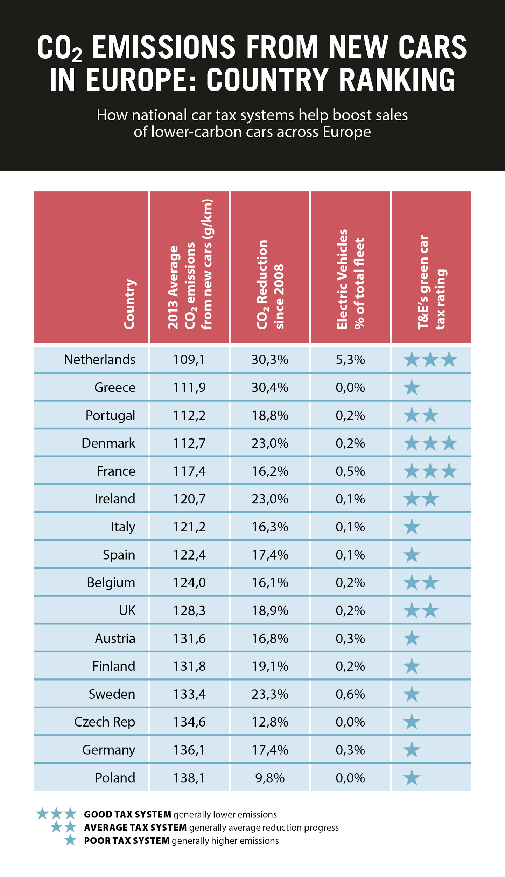
Questions to consider
- Should the amount of refugees that can enter countries be reduced in order to prevent terrorism?
- What is the best plan for preventing terrorist attacks in each European country?
- What should the European Union decide on doing if terrorist attacks keep on rising at an alarming rate? Should there be repercussions or what should be done?
- How should the European Union as a whole adopt to ensure protection of the environment?
- Should the European Union adapt repercussions for countries that put out the most Carbon emissions?
Resources
- "Defining Civil War by Examining Post-Soviet Conflicts" by Pavel K. Baev, Terrorism and Political Violence, 19(2), 247-268. doi:10.1080/09546550701246965
- "Approaches to political violence and terrorism in former Yugoslavia 1" by Florian Bieber, Journal of Southern Europe and the Balkans 2003, 5(1): 39-51
- The History of Terrorism: From Antiquity to Al Qaeda by Gérard Chaliand & Arnaud Blin
- Richard Jensen, "Daggers, rifles and dynamite: Anarchist terrorism in nineteenth century Europe." Terrorism and Political Violence 2004, 16(1):116-53
- Global Terrorism Index: Measuring and Understanding the Impact of Terrorism" (PDF). Institute for Economics and Peace. Retrieved 13 August 2016.
- "Is Terrorism in Europe at a Historical High?". World Economic Forum. Retrieved 13 August 2016.
- Europol statistics, europol.europa.eu, retrieved 15 January2015
- European Union Terrorism Situation and Trend Report 2016, europol.europa.eu, retrieved 13 August 2016
- Focus on Islamist terror plots overlooks threat from far right – report, The Guardian, retrieved 13 August 2016
- Eising, R. and Lehringer, S. (2010) ‘Interest groups and the European Union’, in M. Cini and N. Pérez-Solórzano Borragán (eds) European Union Politics, Oxford University Press, Oxford,
- Weale, A. (2005) ‘Environmental rules and rule-making in the European Union’, in A. Jordan (ed) Environmental Policy in the European Union, 2nd edition, Earthscan, London,
- Princen, S. (2012) Agenda Setting. In: Jordan, A.J. and C. Adelle (ed.) Environmental Policy in the European Union: Contexts, Actors and Policy Dynamics (3e). Earthscan: London and Sterling, VA.

