League of Nations - League Council Crises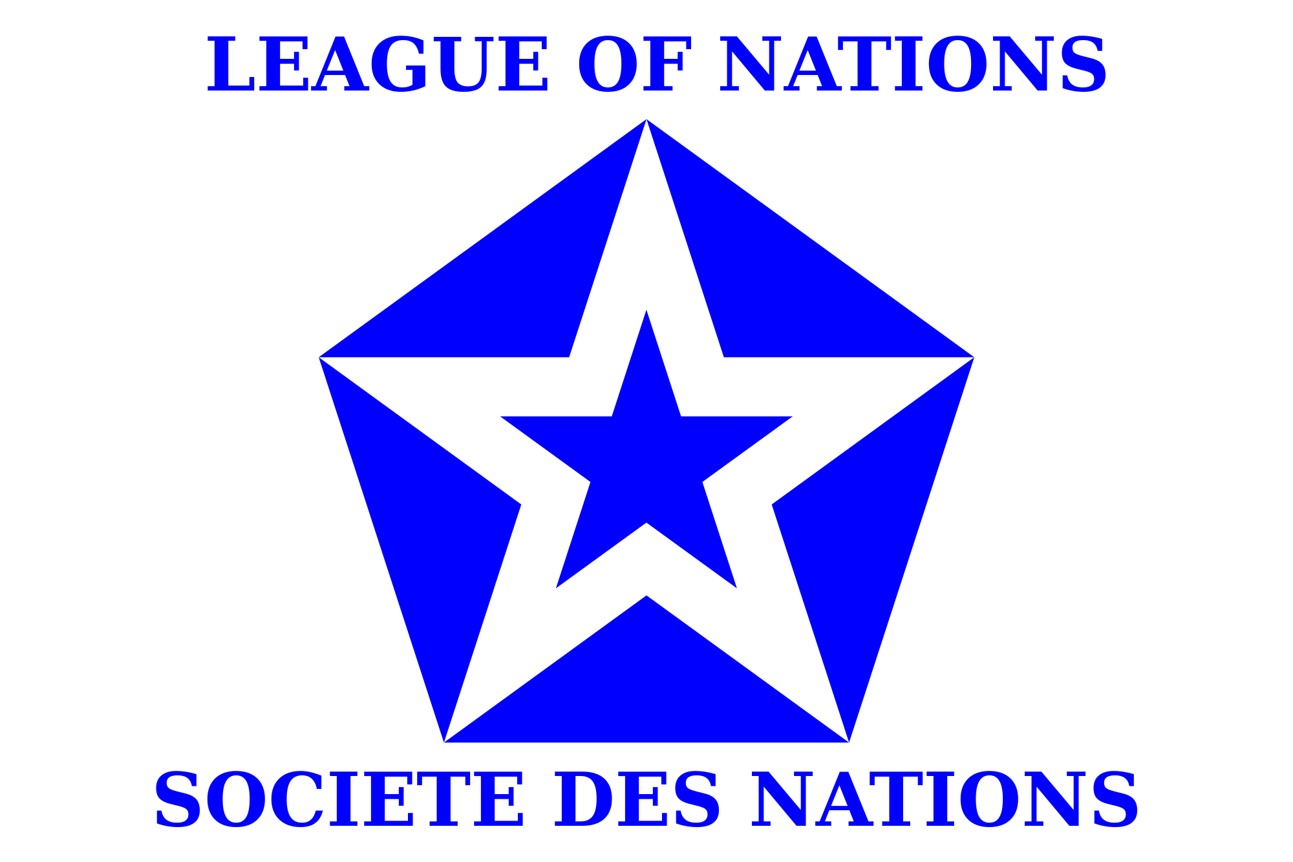 2015 Boulder-Fairview Model U.N. Conference
Audrey McClurg

Background
The League of Nations was initially proposed as part of President Woodrow Wilson’s
Fourteen Point Plan for peace in Europe. On January 18, 1918, President Wilson spoke before
congress and called for a “general association of nations” in order to encourage international
cooperation and ensure security for its members. The Covenant of the League became Part I of
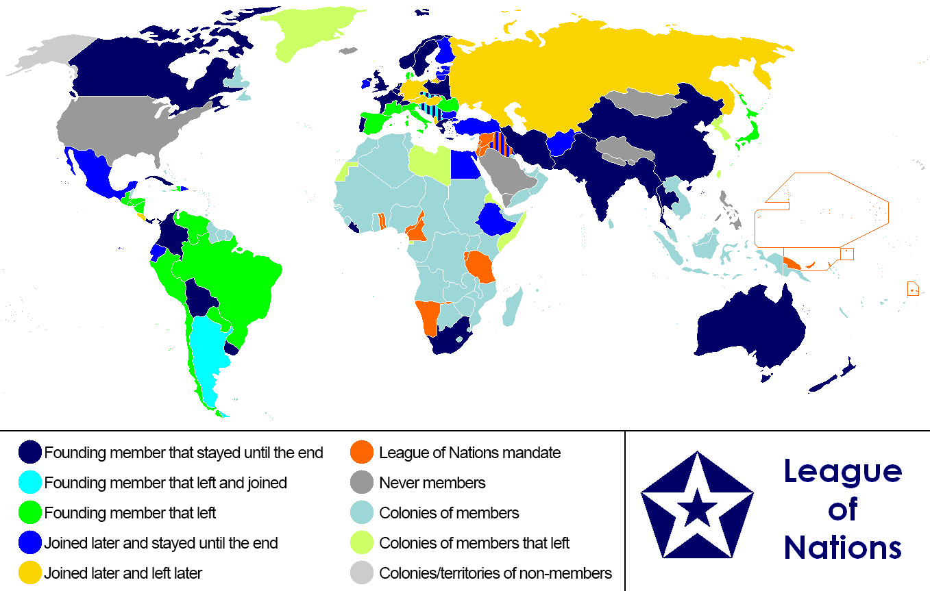
the Treaty of Versailles. It divided the League into three main parts: the Secretariat, the Council, and the Assembly. Under the Covenant, the duties of the League were to hold conferences between international states, promote disarmament, protect territorial integrity, revise treaties to prevent conflicts, and to secure peaceful outcomes in international disputes through an international justice court.
The main powers of the league were economic sanctions and the pressure of public opinion. As Lord Robert Cecil told the British House of Commons in 1917, “When...questions come up before the Council, they will be discussed and considered in public, and when, as a result of that discussion, it appears clear that
one side is right and the other side is wrong, you will get the whole weight of public opinion
behind the one side, ...the nation that is in the wrong will not persist in the course which has been publicly and overwhelmingly condemned…”
The League first met on January 16, 1920 in Paris. One of the first items established was the Mandate system where former German and Ottoman Empire colonies were mandated to various Allied powers. In theory, the European powers were supposed to acknowledge the rights of the peoples in the mandated colonial territories. In order to discuss the running of a mandate or change powers, the entire Council had to agree to discuss that mandate. The idea of the Mandate System went along with the general League purpose of preventing conflict. The first problem it dealt with was the conflict between Lithuania and Poland over the city of Vilna. The League attempted to create a report and administer peaceful negotiations, but it failed and Polish military ability decided the conflict.
However, the League experienced its first major success
when debating the nationality of an island between Sweden and Finland. The Council drew up a
report and suggested decision, and although neither country was really happy with it, both
reluctantly obeyed.
By 1922 the League was showing some hope of success in resolving
international conflict. It focused on finding “avenues of escape” for war. However, the League
began to run into problems because many of the victors of the war, especially the colonialists,
felt that they were due land as reparations. This was demonstrated in the Corfu Crisis in 1923
when Italy invaded an island off the coast of Greece as reparation. Italy was one of the Great
Powers, and a founding member of the League, however it refused to call of its aggression.
England wanted a military action, or at the very least strong sanctions, however without the U.S., France could not economically uphold such sanctions. In the end, nothing really ended up being done about the whole thing. The Corfu Crisis showed that economic sanctions may be effective against
smaller powers, but not with more powerful countries. Furthermore, the Great Powers, especially England and France, must find a way to agree and work together for there to be any decision or progress.

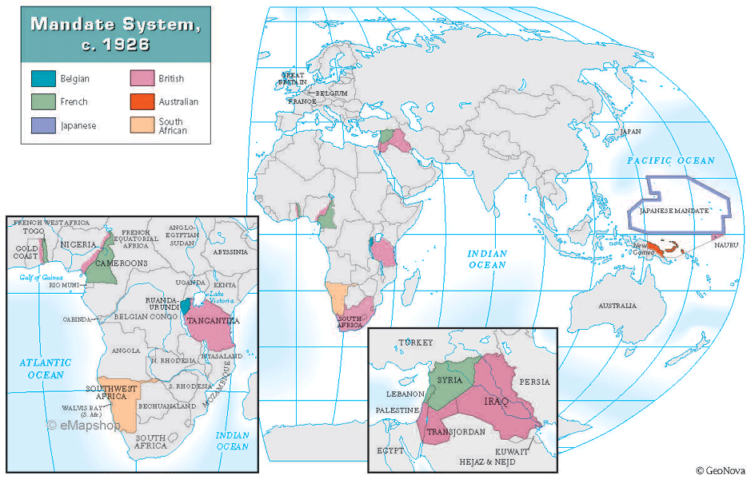

It is important to note that not all of the countries involved with the League of Nations
were in agreement of the purpose of the League. Views on the duties and powers of the league
differed greatly, dependent on the interests of each nation. In the early 1920s, colonialism was a
very strong influence in the world. Many of the founding member states controlled colonies, as
part of their overseas empires they were not willing to give up. Being a colonial power gave
certain states considerable economic and geo-strategic advantages. The countries that
did not control many or no colonies were far less enthusiastic for preserving colonialism.
Great Britain represented one side of the League. It was most definitely a colonial power at this time, and was very interested in retaining its status. Britain wanted to limit the obligations of the League and not interfere too much in the world - especially in various empires controlled by "Great Powers", such as the United Kingdom. It strongly believed the League should work to
preserve European power and and European controlled imperialism.
In regards to the “German question”, Britain was in favor of appeasing Germany and
helping her economy recover because that would in turn help the British economy. Furthermore,
when in 1924 the League approved a new Protocol that allowed for military sanctions and compulsory arbitration. Britain mainly relied on delaying conflicts with the idea that moral pressure from the public would encourage governments to do the right thing. Of course this also meant that the League would have less control over Britain itself, proving that the government was mainly concerned with it's own national interest.

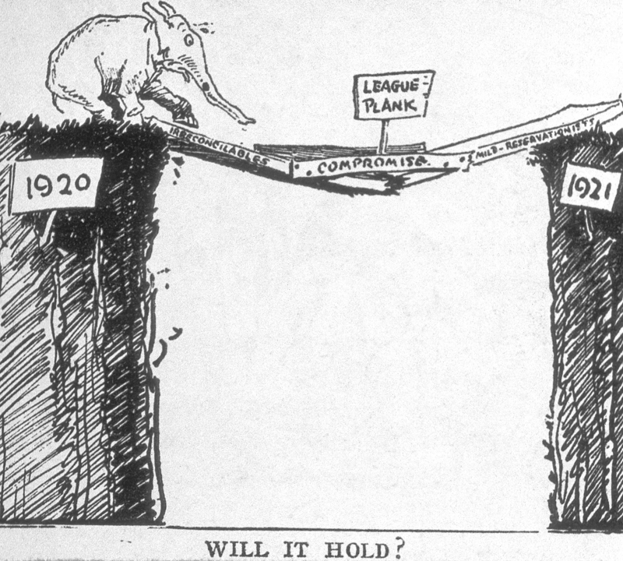
France, on the other hand, still felt very threatened in the wake of the Great War. Having been invaded and nearly
destroyed by Germany, France saw the League as a protection against future military aggression. The French called for strict enforcement of peace and military security, especially against any kind of foreign
aggression. It was not quite as much of a colonial power as G.B at this point, so its main concern was protecting itself at home - primarily from any future German threat. The French didn’t trust League officials and bureaucrats to give impartial reports as a method of resolving a crisis situation, and they most certainly didn’t trust public pressure as an effective means of influence.
France held the strong stance that wars are never accidental, and that politicians use war in order to gain power. France did not trust its neighbors nor other members of the League to necessarily protect France and come to its aid in times of crisis, and therefore was concerned by the lack of power and reliability of the League during potential conflict between states.
Other colonial powers such as Japan and Italy were strongly in favor of expanding and
consolidating their overseas territories and colonies. They felt as though the League should support them in maintaining and expanding their empires.
In contrast, the few former colonies and smaller powers felt that the League should try to protect national sovereignty and encourage freedom. Although this view was more in line with President Wilson’s initial plan, the Fourteen Points, in general the other Great Powers won out, when the U.S. Congress voted not to join the League.

Our Council
We will make a few modifications to make the League plausible for our daylong MUN
conference. This committee will act as the Council, which had varying members throughout
time, but we will keep at 15 prominent members. Although it happened during the League's time, no members will be allowed to leave the League during the conference, until the last 15 minutes of the MUN conference.
The council met four times per year in Geneva, Switzerland, as well as whenever there was an international crisis. The Council also decided which issues should be addressed by the League. We (your POs) will be the Secretariat, which gives us administrative influence. Furthermore, in the League of Nations a unanimous consent was needed to make substantive decisions. In order to move more quickly, we will have require an 80% majority.
In order to prepare for this conference, you should focus your research on three main questions:
● What is my country’s point of view on colonialism and dealing w/ colonial rebellions against the core state?
● What is my country’s attitude toward the League administering the Mandates established after World War in Paris, 1919? Should any of these Mandates be given independence or be administered by other Great Powers than those established by 1921?
● What does my country believe is the best way to prevent and resolve international conflict between states (countries)?
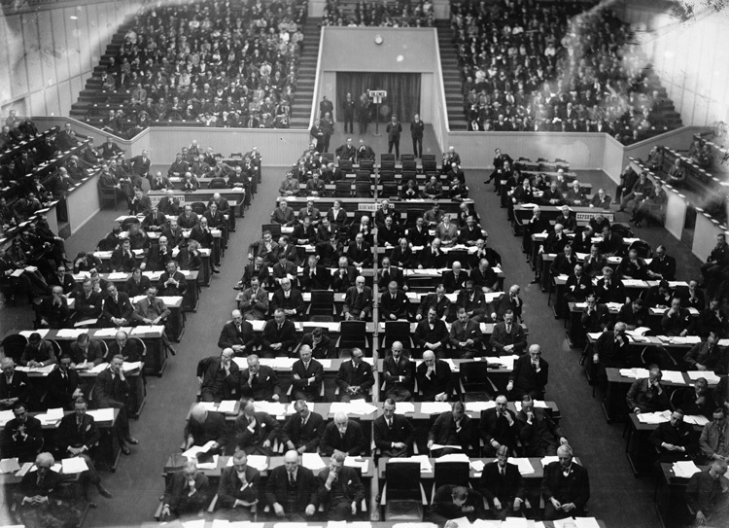
Please do your research only up until the year that this conference begins (1921). If you come prepared with knowledge about the mindset of your states in the early 1920s, you should be ready to discuss, debate, and negotiate accurately and effectively.
Works Cited
Henig, Ruth. The League of Nations. Haus Publishing, 2010.

Pedersen, Susan. The Guardians: The League of Nations and the Crisis of Empire. Oxford
University Press, 2015.

https://upload.wikimedia.org/wikipedia/commons/6/60/The_Gap_in_the_Bridge.png

http://www.indiana.edu/~libsalc/cartoons/photos/34F.jpg

https://upload.wikimedia.org/wikipedia/commons/thumb/c/c1/Flag_of_the_League_of_Nations_
(1939%E2%80%931941).svg/2000pxFlag_of_the_League_of_Nations_(1939%E2%80%931941).svg.png

http://japanfocus.org/data/3a.LeagueofNationsAssemblyin1932.jpg

https://upload.wikimedia.org/wikipedia/commons/9/9e/League_of_Nations_Anachronous_Map.
png

https://mapshop.com/classroom/HISTORY/WorldHistory/w79_Mandate_System.gif

