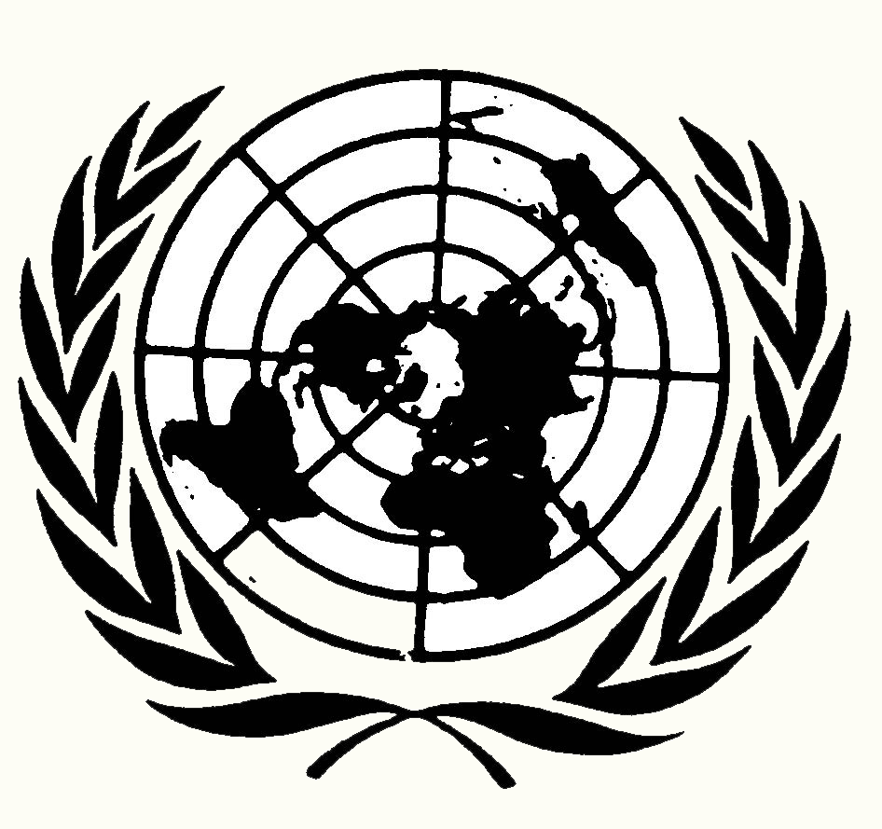
Resolution 101

ISIS Aggression and Expansion
Security Council
Submitted by: New Zealand
The Security Council:
Deploring the Islamic State’s goal of violently imposing a global caliphate,

Recognizing the persecution of minorities and innocent civilians in Syria and Iraq, displacing millions,

Supporting the freedom of democracy and fundamental rights of human beings,

Having adopted UN Resolution 1373, where member states must “prevent and suppress the financing of terrorist acts,” and prosecute those who aid or take part in terrorist acts,

Alarmed with the return of members of the Islamic State to Western countries,

The United Nations Security Council:

- Strongly urges U.N. member states (countries) to support the United States’ led coalition (temporary alliance) opposing ISIS with financial assistance, troops, defensive weapons, and food;
- Strongly affirms the continuation of coalition air strikes against ISIS in Syria and Iraq;
- Authorizes a boycott (stopping) of the sale of ISIS produced or acquired oil;
- Recommends U.N. member states put banking restrictions on all companies, states, and individuals who trade with or provide financial assistance to ISIS - similar to current international banking restrictions on Iran;
- Encourages member states to prevent potential ISIS recruits from traveling to states with ISIS military cells or military activities and take away the passports of those potential ISIS recruits;
- Suggests states cooperate with Interpol and other international police organizations to share information on potential ISIS recruits who may attempt to travel by land to ISIS regions of conflict;
- Calls for the arrest and jailing of returning ISIS recruits, and taking away their passports.
Resolution 102

ISIS Aggression and Expansion
Security Council
Submitted by: Nigeria
The Security Council:
Deploring the large scale murder of innocent civilians by ISIS in Syria and Iraq,

Deeply disturbed with the rapid expansion of the Islamic State,

Noting the Islamic State receives its funding from a variety of sources to engage in terrorist activities,

Noting with deep concern Islamic terrorism within Nigeria and other West African states,

Recognizing that any actions made by this council may not infringe upon the national sovereignty (independence) of any state/country,

Noting with alarm that 3.5 million people have lost or fled their homes due to Islamic State aggression,

The United Nations Security Council:

- Condemns the actions of the Islamic State in the Middle East in murdering innocent civilians;
- Reminds the international community to uphold the national sovereignty of Iraq and the Syrian Arab Republic so that these states may: a. ask the international community for humanitarian or military aid, if needed; b. combat ISIS with forces native and loyal to their separate states;
- Calls upon U.N. member states to work with the United Nations High Commission for Refugees to finance refugee camps in the neighboring states of Turkey, Jordan, and Lebanon - and provide quality shelter, food, drinking water, sanitation, and medical care in the camps;
- Strongly urges robustly (heavily) armed U.N. peacekeepers protect U.N. refugee camps in neighboring states threatened by ISIS;
- Approves appropriate steps to stop the sale of ISIS oil and stolen antiquities (ancient art);
- Recommends the U.N. Human Rights Council continue to write reports of ISIS actions, atrocities, and further human rights violations to accurately inform the international community.
Resolution 103

ISIS Aggression and Expansion
Security Council
Submitted by: Jordan
The Security Council Deeply disturbed by vicious terrorist actions carried out by ISIS against civilians, without regard for international law, Alarmed that the number of ISIS caused civilian deaths in Iraq grew from 9,743 in 2013 to over 14,000 in 2014, Deeply concerned that 2.2 million refugees fleeing ISIS migrated to Jordan, Lebanon, and Egypt, with another 1.7 million migrating to Turkey, Recognizing that British, French, and U.S. drawn borders after World War I of new states in the Middle East, created from the Ottoman Empire, failed to respect historic ethnic and religious boundaries,
The United Nations Security Council:
1. Strongly recommends that Europe, the United States, Canada, New Zealand, and Australia accept more refugees fleeing ISIS controlled areas;
2. Calls for U.N. member states to donate more to the U.N. High Commission for Refugees for more tents, permanent structures, food, water, and medical supplies for refugees fleeing ISIS to neighboring states;
3. Proposes the League of Arab States initiate peace talks between ISIS, Syria, Iraq, Turkey, Jordan, and Lebanon leaders, along with leading Sunni and Shia Imans (Islamic religious leaders);
4. Suggests the League of Arab States create new states in the Middle East that reflect current ethnic majorities of Shia Arab Muslims, Alawite/Shia Syrians, Sunni Arab Muslims, and Sunni Kurds;
5. Further recommends that individuals and families currently living in the Middle East wishing to migrate to a new state of their choosing have one year to do so without restrictions;
6. Authorizes the U.N. Peacebuilding Commission to assist in planning and rebuilding roads, water and sewage treatment plants, railroads, port facilities, irrigation systems, desalinization plants, solar farms, other infrastructure, and schools in the newly created states.

