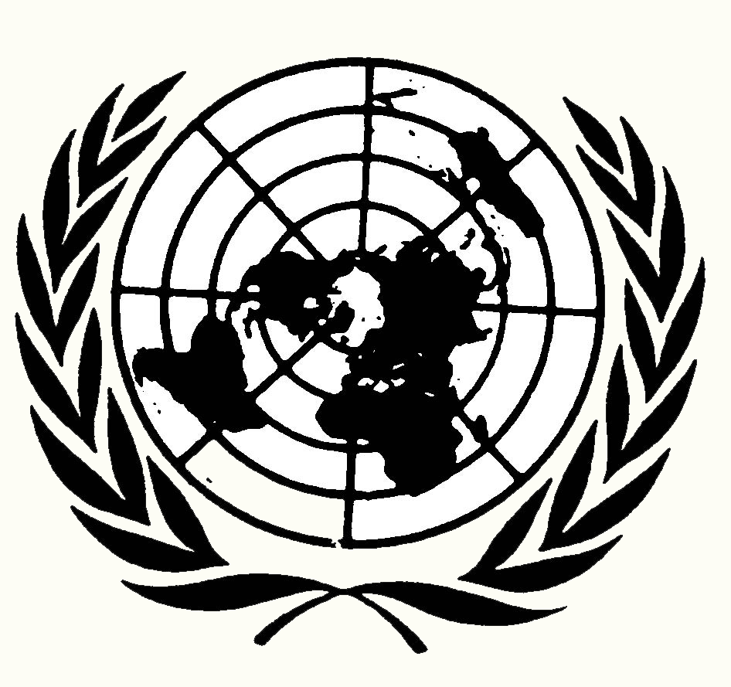
ISIS Aggression in Iraq and Syria
Background Document

Boulder H.S. Model United Nations
Academic Team

The self-proclaimed Islamic State is a radical, militant; Sunni Islamic movement that has conquered territory in western Iraq and eastern Syria, where it is attempting to establish a state (country or larger political unit, in this case, an Islamic empire or caliphate). It uses conventional military tactics; violent, highly publicized public executions and beheadings; ransom payments; terrorism; intimidation; and other strategies, to expand its area of control. It hopes to re-establish a caliphate (Islamic cultural region and territory based empire), like several that existed in the centuries following the origin of Islam in the 600's C.E. (A.D.).
ISIS stands for the "Islamic State of Iraq and al-Sham". Al-Sham refers to land to the east of the Mediterranean Sea including: Syria, Jordan, Lebanon, Israel, and the Palestinian State and territories. This region was the core, key area, with the capital cities of the early Islamic caliphates. ISIS followers refer to ISIS as il-Dawla (“the State”) and its opponents (including U.S. Secretary State John Kerry) as Daesh, the Arabic equivalent of ISIS.

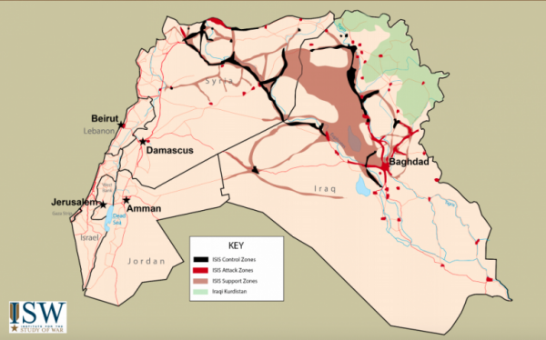

This recently proposed and developing, Sunni Islamic state or caliphate would theoretically include all devout Sunni Muslims from west, north, and east Africa through the Middle East/Southwest Asia to Pakistan, India and Southeast Asia. It would be more centrally controlled than earlier, historic caliphates and organized under the policies of the most extreme interpretation of Sharia, Islamic law.
Sharia law is the Islamic legal system, based on commands in the basic texts of Islam, the Quran (Koran) and Hadith. It is moral and religious law from Islamic beliefs and prophecy (predictions), as opposed to human creation of laws. In various Muslim countries, Saudi Arabia, Sudan, Iran, Brunei, United Arab Emirates and Qatar, harsh physical punishments such as flogging and stoning are said to be legally acceptable, according to Sharia law. 1
Abbasid Caliphate
الخلافة العباسية 750 to 1258 C.E. (A.D.)

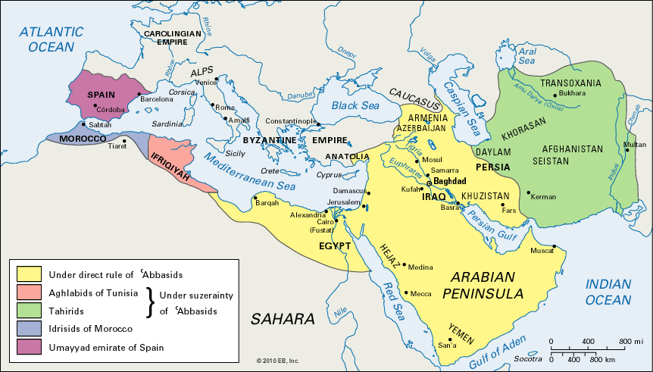

ISIS is a reaction against Shia Islamic governments in Iraq, Syria, and Iran and reflects the long-standing and violent split in Islam between Sunni and Shia Muslims. It is also a reaction against recent U.S. and other western military actions and occupations - and historic European imperialism in the Muslim majority Middle East and Muslim majority regions of Africa, South Asia, and Southeast Asia.

Current Sunni (light green) and Shia (dark green) majority populations
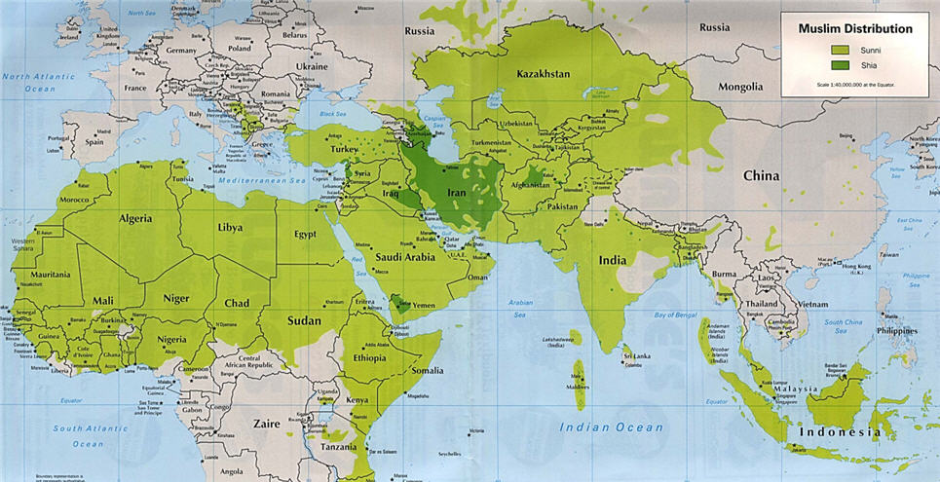
2

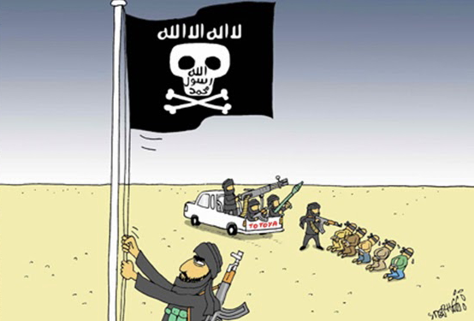
Originally part of al-Qaeda ("the Base") in Iraq,
ISIS split with Osama bin Laden’s organization in 2006.
Al-Qaeda focuses more on large-scale acts of terrorism
in the West (European oriented regions), such as the
9/11 World Trade Center attack in New York City.
Unlike al-Qaeda, ISIS' focus is more on expanding
its' territorial control in the Middle East and terrorizing,
fighting, killing, and/or converting others who are not Sunni
Muslims.
In June 2014, after rapidly seizing territories in
Iraq’s Sunni heartland, the so-called Islamic State
proclaimed itself a caliphate, claiming exclusive political
and religious authority over the world’s Muslims. In its
efforts to re-establish an Islamic caliphate however,
ISIS has focused more on extreme violence than institution
(government and social organizations) building.
Beheadings of Western hostages and other provocative (attention gaining) acts, circulated by well-produced videos and social media, led to calls by some in the United States and Europe for military intervention.
Mass ISIS violence against local civilians is justified by references to the Prophet Mohammed’s early followers and warriors expanding the earliest Islamic region or caliphate. This interpretation of "Jihad" as "offensive holy war" has been a tool for establishing Islamic territorial control then and now. Widely publicized ISIS battlefield successes have attracted thousands of foreign recruits, a serious concern for Western states/countries.
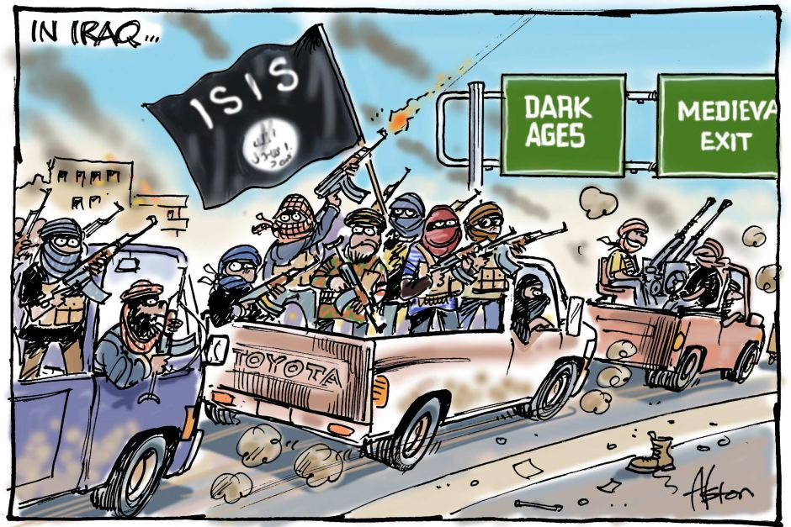
Fundamental, extremist, Sunni based, ISIS beliefs include:
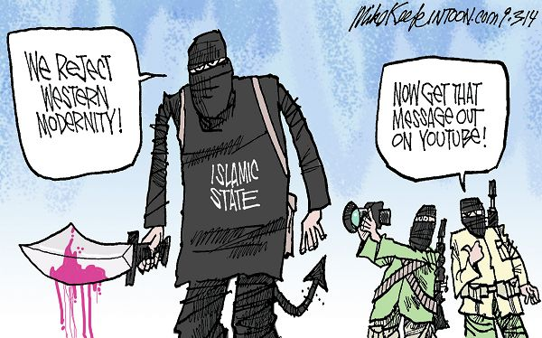
• ISIS is "following the prophecy and example of the prophet Muhammad, in detail".
• A traditional, 7th through 13th century style caliphate is now established by ISIS, with Abu Bakr al-Baghdadi declared the caliph (combined religious, political, and military leader), with the ISIS capital at Raqqa, northern Syria.
• Devout Sunni Muslims should migrate to and live in the ISIS established caliphate.
• Sharia law should be strictly enforced, including the beheading, crucifixion, stoning, or amputation of limbs (hands, arms, legs) of women, children, and men not following Sharia law or for being non-believers.
• "Jihad" is most accurately interpreted as "offensive holy war" to protect and extend the caliphate, not as "internal struggle," to lead a devout life, based on the Five Pillars of Islam (as practiced by the large
majority of moderate Muslims worldwide).
• ISIS must purify the world by killing or converting large numbers of non-believers, including Shia Muslims, who are not considered true Muslims for complex differences in interpreting the Quran (Koran) and the selection of early caliphs. ISIS regards Shia Islam as innovation (change) of the Quran, which is to deny its initial perfection.
• The Jewish state of Israel must be eliminated.
• Shia Muslims from Iraq, Iran and Syria are conspiring with the United States, other western countries, and secular (non religion practicing) Arab rulers to limit Sunni power in the Middle East.
• Devout Muslims should prepare for the "End of Days" (end of the world or apocalypse).

ISIS believes in a medieval (@500-1500 C.E. time period), apocalyptic, end of the world. They anticipate within their lifetime, the arrival of the Mahdi—a messianic figure (savior) destined to lead Sunni Muslims to victory before the end of the world. The armies of "Rome" will mass to meet the armies of Islam in northern Syria. The armies will be on horseback and carrying ancient weapons.
3
An anti-Messiah leader (Dajjal) will come from of eastern (Shia) Iran and kill a large number of the caliphate’s fighters, until just 5,000 Sunni caliphate warriors remain, cornered in Jerusalem. Just as the anti-Messiah warriors prepares to finish them off, Jesus—the second-most-revered prophet in Islam—will return to Earth, spear Dajjal, and lead the Sunni Muslims to victory. In a 2012 poll, 72% of Muslims in Iraq believed this would happen in their lifetime.
"Rome" could mean the Eastern Roman empire, with its capital in what is now Istanbul, Turkey. "Rome" could also be the Republic of Turkey—that ended the last self-identified caliphate, 90 years ago. Other Islamic State sources suggest that Rome might mean any infidel (foreign, non-Islamic) army - preferably Americans.
In Iraq, a Sunni minority was sidelined from national politics after the U.S. executed Saddam Hussein (a Sunni) in 2003. Shia, Iraqi Prime Minister (top political leader) Maliki increased his own power from 2006-2104, as U.S. forces pulled out in 2010. Maliki practiced what was widely criticized as divisive politics that denied power and influence to Sunni political leaders and gave Shias political and economic aid and benefits far beyond those given to Sunnis in Iraq. Maliki's pro-Shia policies and actions were a key reason for the establishment of ISIS in Iraq and elsewhere in 2006.
The non-Arab, Sunni Kurds in northern Iraq, gained effective control over their own region and natural resources, fighting both ISIS and Iraqi national forces. As the world's largest nation (ethnic group with its own language, culture, religion, and perceived/imagined homeland) without its own state (country), the Kurds continue to demand and fight for its own state independent from Iraq, Syria, Turkey, and ISIS.
In Syria, a civil war started in 2011 against the ruling minority Alawites, a Shia subgroup, led by President Assad. President Assad started and continues extreme violence and chemical warfare against majority population Sunni civilians and militias. Assad is supported with military and financial aid by Shia majority Iran. ISIS became the best organized and effective Sunni military group opposed to the Shia/Alawite rule. However, ISIS also fought other rebel/opposition Sunni militias (local military groups), attempting to extend ISIS territorial control in eastern Syria. The United Nations Human Rights Commission investigated ISIS rule in eastern and northern Syria in areas not available for most Western journalists to travel to in 2014. Its summary of human rights violations committed as part of a widespread and systematic attack against the civilian population includes:
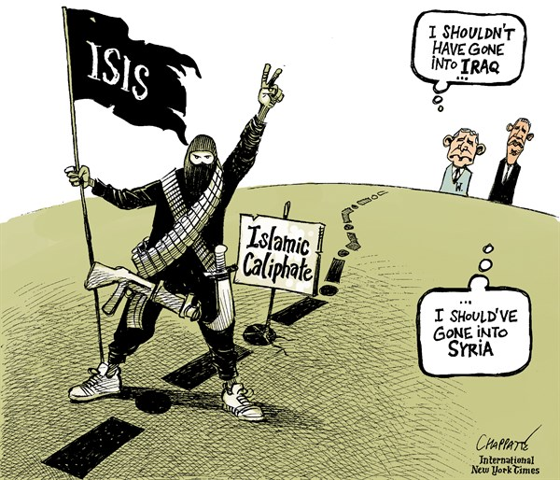
* torture, mutilations, murder, and executions
• rape and sexual enslavement of girls and women
• forced displacement and exile of non-believers
• Dozens of Syrian journalists and human rights
activists captured, tortured and executed
• takeover of schools and indoctrination of students.
Parents of unmarried girls are terrified of their daughters being forced to marry ISIS fighters as young as 13 years old. Some women have been sold to individual ISIS men in public auctions, others are held in ISIS rest houses in urban areas, suffering rapes by multiple fighters returning from the battlefront. This systematic sexual violence and enslavement is continuing. ISIS has executed women, as well as men, for unapproved contact with the opposite sex, resulting in being stoned to death - charged with adultery (unfaithful toward a husband). Others interviewed indicated that the women executed had been discovered helping fighters from other armed militias. According to footage released by ISIS, the women were made to stand, while veiled with their hands bound to their sides, in a shallow grave, while men threw large rocks at their heads until they collapsed and eventually died from their injuries.
How is the so-called "Islamic State" financed?
Oil extraction (drilling and refining) is the Islamic State’s largest source of income. ISIS is estimated to produce 44,000 barrels a day from Syrian wells and 4,000 each day from Iraq, making about $1 to $3 million a day.
ISIS extorts (requires money payments from) businesses in controlled areas and cities, bringing in $8 million a month. Christians who have not fled the cities face an additional tax on religious minorities. Trafficking (buying and selling) in antiquities (ancient art) also contribute to the Islamic State’s income. Wealthy supporters donate millions $.
Ransom payments provided the Islamic State $20 million in 2014, including large sums for kidnapped European journalists and other captives. The U.S. maintains a no-ransom policy, differing from European states.
The Islamic State pays its fighters monthly wages estimated to be up to $350, more than rival rebel groups or Iraqi government soldiers, and over five times earned by ordinary Syrians in territory controlled by the Islamic State.
4
Current Situation
After rapid expansion through Iraq in much of 2014, the so-called "Islamic State" expansion slowed as it pushed up against majority Kurdish and more moderate, Sunni Arab regions, facing greater resistance from Iraqi forces and local populations, along with U.S.-led air strikes. ISIS militants failed to advance on Baghdad or the Kurdish capital, Erbil, and lost some territory to Iraqi-government-aligned forces by early 2015.
A 2015, United States led coalition (temporary alliance) has engaged in over 16,000 airstrikes and bombing missions in Iraq and Syria to try to roll back the self-proclaimed Islamic State’s advances. The mostly Shia-led, Iraqi national security forces have allied with both Iraqi and Iranian Shia militias to push ISIS back on the ground in some areas, but have lost ground in other areas. The U.S. currently has 4,500 military trainers in Iraq to better train anti-ISIS military units.
Meanwhile, militant, Sunni Islamic groups from North and West Africa to South Asia have professed allegiance to ISIS. ISIS is estimated to have a current army of about 20,000, including about 3,000 foreign fighters.
As well, Turkey has recently begun allowing the United States to use their military bases for air support and continued bombing missions, as it has realized the increased presence and danger of ISIS nearby. They are also not allowing armaments and fighters to cross their borders to or from Syria, even as the Kurds and the Iranian sponsored Hezbollah have been seen as the most effective fighters against ISIS.

Introduction to Model U.N. (Sept. 19) and Boulder-Fairview H.S. MUN Conference (Oct. 10)
For your Sept. 19, 2015 “Introduction to Model U.N.” you will be representing one of the countries/states below in a mock United Nations Security Council. You will be led by two members of the Boulder HS Model U.N. team, serving as volunteer, Presiding Officers. This will also be one of the Security Council issues for the Oct. 10 MUN Conference
For the Intro 2 MUN, you will choose one of the 17 countries to represent and will be given a paragraph that describes your country's attitude towards ISIS and international terrorism in general. You will have 3 possible Security Council resolutions (proposed actions) that attempt to find the best international solutions to multiple problems related to the rise of ISIS. After reading the paragraph on your country's point of view on ISIS, you will decide which one of the three proposed resolutions best represents your country's point of view in attempting to resolve this very serious issue.
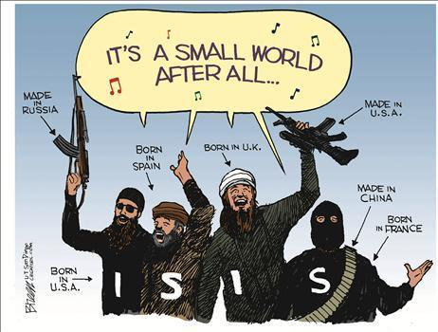
You may read the paragraph as your first speech in the Security Council and use it as a guide to later informal discussions with delegates from other countries, amendments to the resolution selected to discuss, and your votes. 2015 U.N. Security Council members
Angola, Chad
- Chile, *China
- *France, #Jordan
- Lithuania, Malaysia
- #New Zealand, #Nigeria
- *Russia, Spain
- *United Kingdom (Gr. Brit.)
- *United States, Venezuela
(*permanent, veto power states)
(#authors of possible resolutions)

Invited, non-voting states (who are involved
in the conflict, with important
information to share with the
Security Council. They may vote on
procedural issues, but not
amendments or resolutions.)
Iraq
Syria
Bibliography

Bunzel, Cole. From Paper State to Caliphate: The Ideology of the Islamic State. Brookings Institute, 2015.
Cockburn, Patrick. The Rise of the Islamic State: ISIS and the New Sunni Revolution. Verso, 2015.
Laub, Zachary and Johnathan Masters. "The Islamic State", April 1, 2015. Council on Foreign Relations.
Online: www.cfr.org/iraq/islamic-state/p14811
Stern, Jessica and J.M. Berger. ISIS: The State of Terror. William Collins, 2015.United Nations Human Rights Commission. "Rule of Terror: Living under ISIS in Syria". Nov. 14, 2014. Online: www.ohchr.org/Documents/HRBodies/HRCouncil/CoISyria/HRC_CRP_ISIS_14Nov2014.pdf
Wood, Graeme. "What ISIS Really Wants". Atlantic Magazine, March, 2015. Online: http://www.theatlantic.com/features/archive/2015/02/what-isis-really-wants/384980/

Andy Aiken, Boulder H.S. Model U.N. Sponsor, John Harrington BHS MUN Officer 5

