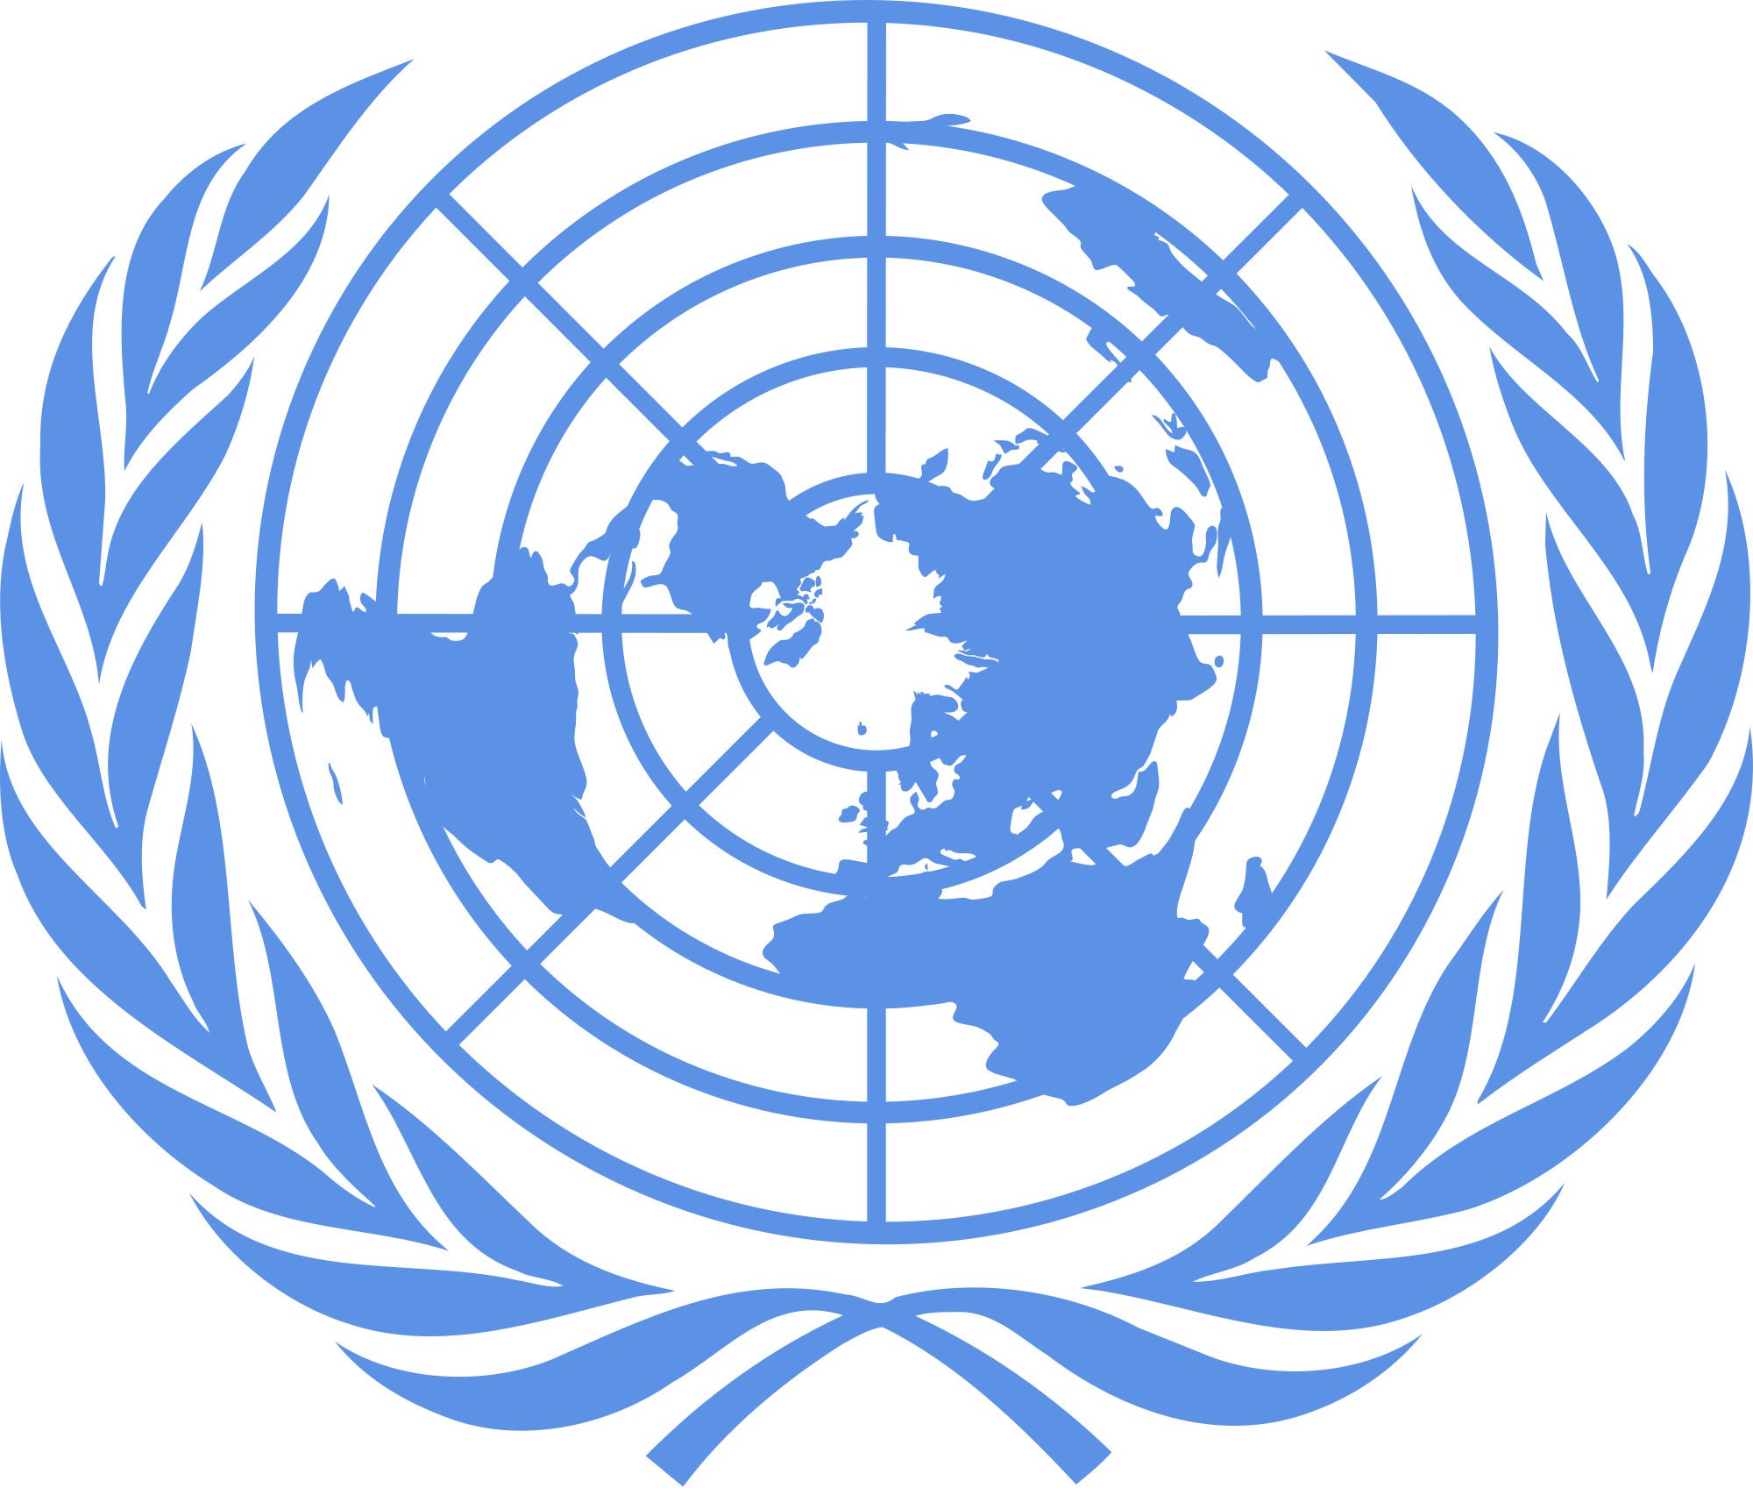

The Denver Center for International Studies and East High School
Model United Nations Conference
January 28, 2017

Background Guide
Beginner Security Council
Topic: Israel Palestine and the Yemen Situation
Presiding Officer

Note to the Delegates
Greetings Delegates,
Welcome to this year’s Colorado High School Model United Nations Conference at East High School and hosted by the Denver Center for International Studies (DCIS) and Denver East High School! I hope you find this background guide useful as it serves to bring your attention to the United Nations Security Council’s decision making power and introduce the pressing matter of the usage of children in armed conflict. We fully hope that you will explore member states positions and policies further. This background guide will provide you with an abundance of starting points for your research, but you should not research using this background guide alone. Each delegation should prepare a written position statement and present it at the day of the conference. We can’t wait to host the conference this January and see what you all bring to the table on January 28, 2017.

About the SECURITY COUNCIL
- Open Debate- Open discussion of the agenda items between Members of the United Nations
- Debate- Open discussion of the agenda items between Members of the UN Security Council and Member States directly involved with the agenda item
- Adoption- Member States will either adopt or reject Draft Resolutions brought before the Council
- Veto power-Veto power is held solely by the five permanent members of the United Nations Security Council China, France, Russia, United Kingdom, and United States. This enables them to prevent the adoption of any substantive resolutions.
In council, the delegates will discuss their countries’ views on the conflicts. Delegates will aim to pass resolutions through diplomacy and compromising with other members of the UN for the best interests of the involved countries.
ISRAEL PALESTINE CONFLICT
HISTORY
The disputed region has been battled over for millennia. The nations and people in charge of it keep shifting. Certain sects in Islam believe that once a region has been under Muslim control, it is forever a Muslim nation. The idea of non-muslims governing part of a former Caliphate is untenable. This is a major root of the Israel-Palestine conflict. Jews view Israel as the Jewish homeland, because in the Torah (Jewish religious text) God gives the land of Israel to the descendents of Abraham. Both the Jews and the Muslims view themselves as descendants of Abraham because Abraham had two sons. First Ishmael by his handmaiden, then Isaac by his wife Sarah. The Jews wish to return to their ancestral homeland, the Arabs want to restore their former Caliphate.Israel believes that the Israeli people view the conflict as a matter of security and defense. They believe in their right to the land of Israel due to their history and identity tied to it. Israel is constantly defending themselves from attacks produced by the Hamas terrorist group and Palestinian people. Due to this, they view themselves in a constant state of defense for the security of their citizens, sovereignty, land, and identity.Palestine believes that since the land was one owned by them that it should continue to be owned by muslims.
In the late 1800s, a group in Europe, calling themselves the Zionists, began colonizing Palestinian land. The Zionists represented a minority of the Jewish population. Their goal was to create a Jewish homeland. At first, this immigration to Palestine created no problems. However, as more and more Zionists immigrated to Palestine–many with the wish of a Jewish state-the native Palestinian population became alarmed. Eventually, fighting broke out between Zionists and native Palestinians, with escalating waves of violence. In 1947, two years after the end of the Second World War, Britain drew the attention of the newborn United Nations to the desirability of an early settlement in Palestine, which lead to the creation of a special committee, the UNSCOP (United Nations Special Committee on Palestine). The disagreement between Israel and Palestine has been one of most violent conflicts over the past several years. This has not only put the two nations in extreme disagreement, but also forced other nations, such as the allies of Israel and Palestine to take sides, ultimately causing the world to divide in two: pro-western and anti-western. Many countries in the world are separated because of this conflict.

TIMELINE
Date | Event
1900-1917 | The conflict has been going since about the 1900s when the mostly Arab, mostly Muslim region was a part of the Ottoman Empire starting in 1917 ‘mandate’ run by the british empire. Then the Jews starting moving down into the area part of a movement called Zionism.
June 1916 | World War I changed the political geography of the Middle East. The Ottoman Empire had been the ‘Stick man of Europe’ then lost control of all European possessions.
1933 | Around 154,300 Jews to fled to Palestine when the Nazi’s gained power.
1939 | The British government released a policy paper which sought to implement a one-state solution in Palestine. The policy established a quota for Jewish immigration significantly reducing the number of Jewish immigrants allowed to enter Palestine.
1950-1967 | Mass-casualty attacks on Israeli civilians carried out by Palestinian militants (usually called Fedayeen at the time). Included the Yehud attack, the Ma'ale Akrabim massacre, and many others. After Israel's raid on an Egyptian military outpost in Gaza in February, 1955 killed 37 Egyptian soldiers, the Egyptian government began to actively sponsor, train, and arm the Palestinian volunteers from Gaza as Fedayeen units which committed raids in Israel..
1956 | The infamous Suez Crisis: Israeli leadership grows increasingly weary of aggression from the Egyptian-controlled Gaza Strip as well as Egypt's attempts to block Israeli shipping in the Suez Canal. Egyptian President Nasser nationalizes the Suez Canal on July 26, 1956. Britain, which owns nearly half of the Suez Canal Company, seeks to prevent the nationalization by joining with France and Israel. Israel attacks the Sinai Peninsula, which in turn allowed Britain and France to condemn the fighting and demand that both sides withdraw from the region. The United States calls for a ceasefire in November 1956. A UN peacekeeping force occupies the area in March 1957 and reopens the canal on April 24, 1957.
1967 | In June 1967, Israel launched a preemptive strike against Egypt, Syria, and Jordan, after Nasser had declared his intention to annihilate the Jewish state and forged military alliances with Syria and Jordan for that purpose, building up troop concentrations along his border with Israel and blockading shipping to the Israeli port of Eilat. The six-day war that followed Israel's surprise attack ended with the Israeli army occupying Egypt's Sinai Peninsula, Syria's Golan Heights, and Jordan's West Bank.
1969-1970 | In October 1968, the IDF attacked for the first time in Upper Egypt and destroyed the power station in Nag Hammadi.
1973 | The Yom Kippur war begins. Egypt launches a sudden attack on the Israeli forces on the east bank of Suez Canal.
1974 | Arab league recognizes PLO as the legitimate representatives of the Palestinian people. PLO leaders threatened a walkout if their demands for unconditional recognition were not met. The PLO required a statement from the conference that any Palestinian territory liberated by Arab forces would be turned over to the 'Palestinian people' as represented by their organization.
1978 | In response to the PLO attack Israel invaded Southern Lebanon
1978-1980 | President Anwar Sadat of Egypt, Prime Minister Menachem Begin of Israel and President Jimmy Carter of the United States sign the Camp David accords. Israel agrees to hand back the Sinai Peninsula to Egypt in return for peace and normalization. This was significant because it was the first time an Arab country signed a peace treaty with Israel and thus accepted the state’s existence. Signing the Camp David accord made Sadat unpopular among many Egyptians as well as Arabs living outside Egypt. Egypt is expelled from the Arab League as a reaction to the peace agreement with Israel. Yet in 1980, Egypt and Israel establish diplomatic relations. This led directly to the assassination of President of Egypt Anwar Sadat on October 6, 1981, by 3 soldiers of the Egyptian Army. The hitherto unknown organization, the Liberation of Egypt, claims responsibility.
1987 | The first Palestinian intifada begins. In mid-January the intifada broke out in the heart of Arab Jerusalem itself, as Israeli security forces used tear gas around the two especially sacred mosques in the Haram al-Sharif, trying to disperse Palestinian demonstrators. Accustomed to thinking of Jerusalem and its Arab population as an integral part of Israel, Israelis were shocked by the solidarity with the intifada being demonstrated in East Jerusalem.
1993 | Oslo peace accord is signed by Israel and the PLO
1994 | Massacre at the tomb of the Patriarchs. Baruch Goldstein walked into the Ibrahim Mosque at the Cave of the Patriarchs in Hebron... As he entered, Goldstein opened fire at the kneeling worshipers, killing 29 and wounding at least 125 unarmed Palestinians. After finally running out of ammunition, he was hit over the head with a fire extinguisher and beaten to death by survivors of the massacre.
1994 | Israel and Jordan sign peace treaty which states; An international boundary will be delimited within 9 months. Each party will refrain from threats or use of force against the other and from joining alliances hostile to the other and will remove restrictions from normal economic relations and terminate economic boycotts. Problems of displaced persons (from 1967) will be resolved with Egypt and the Palestinians and of refugees (from 1948) in the multilateral framework. Israel respects Jordan’s role in the mosques in Jerusalem and will give it high priority in permanent status negotiations. Annexes called for Jordan to lease one sq. mi. to Israelis for a renewable 25-year period and for Israel to provide Yarmuk River water and desalinated water to Jordan; dams will be built on the Yarmuk and Jordan Rivers to yield more water.
2000 | Beginning of the second Intifada

UN ACTIONS
At the start of the Israel/ Palestine conflict the United Nations was largely excluded from the politics of the issue. Besides establishing the United Nations Refugee Works Agency(UNRWA) and stationing UN peacekeepers on the Israeli-Egyptian border, the UN had little involvement in the conflict. The process of establishing these resolutions was mainly controlled by the US, France, the UK and the Soviet Union by the time the 1967 war broke out. In the same year, Egyptian president Gamal Abdel Nasser asked the UN to move their troops out of Egypt, the UN responded saying the only form of that would be to remove the troops. After much pressure from surrounding Arab countries, Nasser demanded that the troops to be removed. The two-state solution is considered the most realistic solution to the Israel/Palestine conflict. Proposed by the UN security council on November 27, 1948, the two-state solution reads that the land would be divided into two states: Israel and Palestine. The divide would be on the pre-1967 armistice line or ‘green line’ which gives Israel more land than Palestine. This sparked conflict between the Israelis and Palestinians which resulted in the independence of Israel.

CURRENT SITUATION
Conflict has escalated quickly between Israel and Palestine after another round of peace negotiations in the spring of 2014 failed. The chance of more widespread and sustained violence looms, and political and social dynamics in both societies challenge the prospects for a successful solution. Violent incidents have sparked retaliatory attacks from both directions, including over access to the religious site Temple Mount or Haram al-Sharif. The international community has not yet found an effective and sustainable diplomatic solution to the ongoing problem, which is also affecting many of the countries bordering Israel/Palestine. The 1967 borders continue to be violated, primarily by Israel’s military.

SAMPLE POSITIONS
United States of America:
The United States have been long supporters of Israel. Although The United States does not have a military presence in the area, they have made their position very clear with funding and military supplies being given to the Israelis. The U.S. has also been used as a deterrent for the Palestinian forces.
United Kingdom:
The United Kingdom has no official alliance with either of the proclaimed states in this conflict.
France:
France has an alliance to both the Israelis and Palestine, so they can’t officially chose a side and don't have a dedicated allie.
Russia:
Russia backs Palestine. Russia refuses to support Israel because the U.S. is such a strong
supporter of Israel.
Yemen:
Yemen does not have diplomatic relations and relations between the israeli are very tense. People with an Israeli passport or any passport with an Israeli stamp cannot enter Yemen.
Saudi Arabia:
Saudi Arabia believes that the situation between Israel and the Palestinians is “dire.” Saudi Arabia needs to find peace with Israel since it would be the strategic position.

QUESTIONS TO CONSIDER

- Is your country dependent on Israel’s oil trade?
- Has your country offered, or given military assistance to either group?
- What is your country’s main religion? Is it Judaism? Or Islam? Or something else?
- Is your country affected by this conflict?
- How should the international community respond to the apparent lack of coherent solutions?

Sources:
https://www.parliament.uk/business/publications/research/key-issues-parliament-2015/foreign-affairs/israeli-palestinian-conflict/
http://www.counterpunch.org/2016/07/25/the-us-role-in-the-israeli-palestine-conflict/
http://www.diplomatie.gouv.fr/en/country-files/israel-palestinian-territories/peace-process/article/israel-palestine-understand-france-s-position-in-nine-points
https://www.quora.com/What-is-Russias-position-on-the-Israel-Palestine-conflict
http://www.usip.org/publications/the-current-situation-israel-the-palestinian-territories-and-the-arab-israeli-conflict
http://www.cnn.com/2016/12/23/politics/israel-official-rips-obama-un-settlements/
http://www.ifamericansknew.org/history/
https://jewishvoiceforpeace.org/israeli-palestinian-conflict-101/
http://israelipalestinian.procon.org/view.timeline.php?timeline=000031
http://pov-tc.pbs.org/pov/pdf/promiese/promises-timeline.pdf
http://tari.org/index.php?option=com_content&view=article&id=14 &itemid=15

YEMEN SITUATION

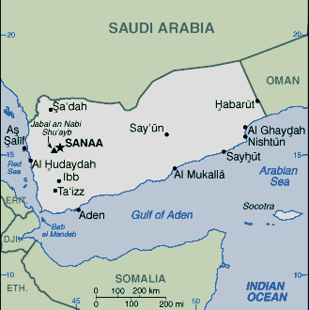
HISTORY
The beginnings of the civil war in Yemen can be traced back to November 2011, the president, Ali Abdullah Saleh, was forced to hand over power to his deputy, Mr. Hadi. After President Hadi gained power, he struggled to maintain stability in the country, facing many problems including attacks from al-Qaeda, continuing military loyalty to former President Saleh, a separatist movement in southern Yemen, and corruption. At this time, the Yemeni people faced unemployment and job insecurity. It was from this political instability that the current, ongoing conflict began.
The Houthi group, officially known as Ansar Allah, focuses on the rights of the minority of Zaidi Shia Muslims in Yemen. The group has been politically active since 2003, when they rebelled against former president Saleh. The Houthi group seized the moment of instability to take action against the Yemeni government. Many Yemeni , including some Sunni Muslims, supported the Houthi movement because of the disillusioned by the ineffective transition of political power to Hadi. With this support, the Houthis entered Sanaa, the capital of Yemen and set up roadblocks and camps in September of 2014. They continued to reinforce their power by surrounding the presidential palace and other important government locations, eventually forcing Hadi to evacuate to Aden, a city in southern Iran.
In March of 2015 the Houthis, with assistance from military forces who were still loyal to former President Saleh attempt to take over the country. They effectively pressured Hadi, making him leave the country. At this point, Saudi Arabia and multiple other states, most of whom were Sunni Arab nations, were concerned as they believed that the Houthi rebels were supported by Iran, a Shia nation.These states began an air campaign on Yemen in an attempt to restore Hadi to power. March of 2015 is widely considered the true beginning of the civil war as it was when the conflict escalated.

TIMELINE
Date | Event
November 2011 | President Saleh hands over power to Hadi.
September 2014 | Houthi forces enter the capital, Sanaa. They set up roadblocks and camps.
January 2015 | Houthis surround presidential palace and other important areas.
February 2015 | President Hadi escapes to the city of Aden in southern Yemen.
March 2015 | Houthis and those who are still loyal to former President Saleh make an attempt to take over the country. President Hadi must flee to another country.
April 2015 | Russia proposed a resolution called “Humanitarian Pauses.”
May 2015 | Secretary General calls meeting referring the geneva talks
June 2015 | Security council members issued a press statement expressing disappointments from the May 28th Geneva talks were postponed.
July 2015 | Council members issued a press statement supporting the implementation of an unconditional humanitarian pause by all parties set to begin at the end of the same day
January 2016 | On 5 January, Council members were briefed on Yemen in consultations under “any other business” by Under-Secretary-General for Political Affairs Jeffrey Feltman.
June 2016 | On 6 June, following publication of the annual report on Children and Armed Conflict (S/2016/360), the Secretary-General removed the Saudi Arabia-led coalition from the listing in Annex 1 of the report, where it had been included for the first time.
August 2016 | On 3 August, the Secretary-General’s Special Envoy for Yemen, Ismail Ould Cheikh Ahmed, briefed Council members in consultations on peace talks in Kuwait
October 2016 | In an October press statement, Council members strongly condemned an attack by Houthi forces by a UAE vessel operating near Bab al-Mandeb strait on October 1st

CURRENT SITUATION
As of October 2016, it is estimated over 6,800 people have been killed and 35,000 injured since the beginning of the civil war. According to a statement by Emergency Relief Coordinator O’Brien of the UN Office of the Coordination of Humanitarian Affairs (OCHA), 80% of Yemeni’s are in need of some form of humanitarian aid. The United Nations estimates that at least 1,400 children have died and 2,140 have been injured as of January 2017 since the conflict escalated in March of 2015. The actual death toll is believed to be higher.
In Yemen, a food crisis leaves millions at risk of starving. The World Food Programme has provided food for more than 3 million people since February, but is beginning to struggle to do so. The number of rations given out have been split in half so that six million people can be reached with food each month, but resources are beginning to run out. Because of the fighting in Yemen, the World Food Programme is struggling to keep up with demand.

UN ACTIONS
As of the 9th of January 2017, the UN and the EU have partnered together to address the serious concern that over 14 million people in Yemen are lacking access to sufficient, nutritious food and have committed 12 million euros to assist the efforts of the United Nations Food and Agricultural Organization (FAO).

QUESTIONS TO CONSIDER
- Has your country been involved in the Yemen situation? If so, how?
- What should be done in response to the humanitarian crisis in Yemen that has resulted from the civil war?
- What has your country done in response to other humanitarian crises? How could these be applied in Yemen?
- What has your country proposed in the past in regards to this situation?
- Has your country accepted Yemeni refugees? If not, what is reasoning against so?

SOURCES
http://www.bbc.com/news/world-middle-east-29319423
http://time.com/4552712/yemen-war-humanitarian-crisis-famine/
http://www.unocha.org/top-stories/all-stories/yemen-%E2%80%9Cone-step-away-famine%E2%80%9D
http://www.un.org/apps/news/story.asp?NewsID=55941#.WHensvkrK00 http://www.securitycouncilreport.org/chronology/yemen.php?page=2
http://www.cfr.org/yemen/yemen-crisis/p36488
http://www.cnn.com/2016/10/27/middleeast/yemen-world-food-program/
http://www.un.org/apps/news/story.asp?NewsID=55927#.WHq12ogrLnA

