 | Boulder High School  Model United Nations  Conference | 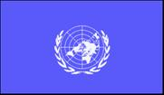

Background Guide

Beginner Security Council
North Korean Military And Nuclear Threats
Written by Andy Aiken
October 5th, 2013

Pertinent Data

- North Korea (Democratic People’s Republic of Korea/DPRK) is one of the poorest countries in the world. It’s per person income is $1,800, compared to South Korea’s $34,000.

- North Korea has one of the largest militaries, relative to its total population, in the world – 1.4 million soldiers and 6.3 million reservists.

- “Military First” and “Self Reliance” are the national mottos and philosophy of the DPRK.

- Over 3 million Koreans died in the 1950-53 Korean War. By comparison, about 330,00 Americans died in World War II.

- The three mile wide Demilitarized Zone (DMZ) separating North and South Korea is the most heavily fortified border in the world today.

- Over a million North Koreans starved to death in the 1990’s due to an inefficient, centrally planned, communist economy; floods; and droughts.

- About one fourth of North Korean children currently are stunted from malnutrition and the average North Korean teenager is 2.5 inches shorter than the average South Korean teen.

- About 200,000 North Koreans currently are in prisons for criticizing the government or being a family member of a suspected political dissident/opponent.

- North Korea has nuclear warheads and is testing newer, more accurate, longer range missiles.

- In March, 2013, Kim Jong-un, the erratic, 29 year old North Korean leader threatened 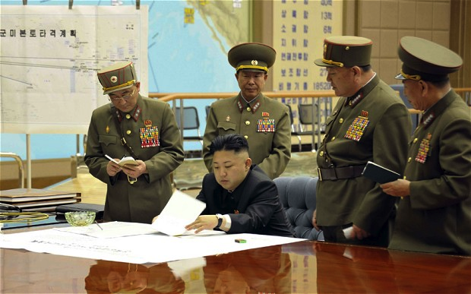

to “rain nuclear missiles” on Guam, Hawaii, and the west coast of the United States;
declared a state of war with South Korea; and threatened to attack the 28,500
U.S. troops stationed in South Korea.
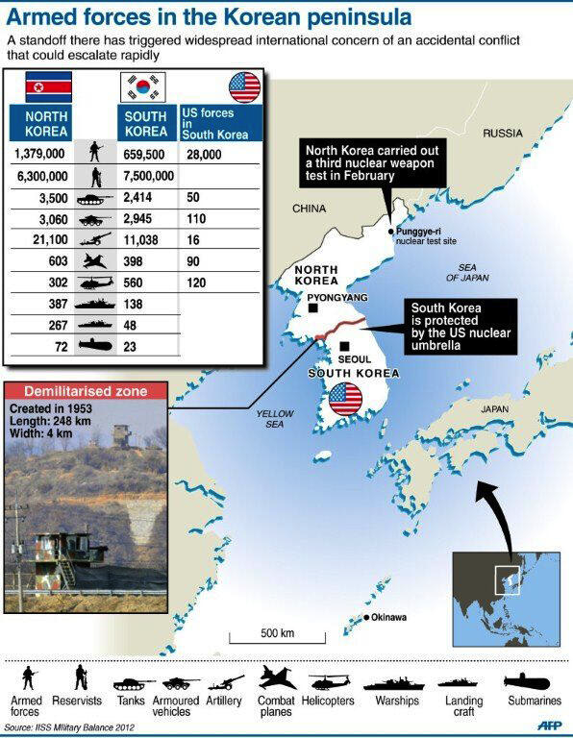

History

The current crisis is rooted in both recent and distant Korean history. For about a thousand years (since 918 C.E.), Korea was a single, unified, sovereign (independent) state (country). Heavily influenced by Chinese language, culture, and Confucianism, Korea acknowledged China as the great power of East Asia. Korea paid tribute to its neighbor; in exchange Korea was often protected from foreign invasions by China. For example, China came to the aid of Korea during a Japanese invasion in the late 1500’s.
In the early 1600’s, Korea was invaded by the Manchu from NE Asia, leaving Korea in ruins. As a result, it became isolationist. It limited interactions with Japan and China, closed its borders to all other foreigners, and was called the “Hermit Kingdom.”
In the late 1800’s, western states (from Europe and U.S.) were forcing Asian countries to open up to trade, missionaries, diplomatic relations, and western economic control. Of the Asian states, Korea resisted outside imperialistic control the most 11/24/2026vigorously. However, Korea was forced to give special trading rights to newly industrialized Japan in 1876. Korea reluctantly signed similar, forced, and unfair trade agreements with Europeans and the U.S. These countries all wanted access to Korean gold, coal, iron ore, forest products, other natural resources, and ocean ports.
Japan won wars with China (1894-95) and Russia (1904-05) to gain more control over Korea, and then made Korea a colony of Japan from 1910-45. The Japanese colonial rule of Korea was one of the most brutal and repressive in world history. Due to northern Korea’s variety and greater amount of natural resources, the Japanese built many mines, factories, railroads, roads, and port facilities there. Southern Korea had some light industry, but more rice farming than in northern Korea.
At the end of World War II in the Pacific, the Soviet Union accepted the defeat of the Japanese in northern Korea. The United States accepted the Japanese defeat in southern Korea, with the 38th parallel (latitude line) as a temporary boundary between northern and southern Korea in 1945. This three mile wide Demilitarized Zone (DMZ) is the most heavily fortified border in the world today.

Korean War – 1950-53
After WWII, the U.S. and USSR failed to agree on a plan to unify Korea – ending up in 1948 with a Soviet influenced, communist state in the north (DPRK) and an
authoritarian, capitalist state in the south (The Republic of Korea/ROK or South Korea), supported by the U.S.
Both new Korean states wanted to unify Korea under its style of political and economic systems.
The DPRK leader, Kim Il-Sung, spent his early adult life as a guerilla, resistance fighter against the Japanese occupation of Korea. He received military and communist political training in the Soviet Union, and later their support to become the first North Korean, communist leader. Seen as the father of the DPRK, he is called the “Great
Leader” and a cult of personality of unquestioned loyalty and obedience to him was established through propoganda (exaggerated and emotional descriptions of him), the media, and school instruction.
Kim Il-sung believed the only effective way to unify Korea was through conquest, so with the initial support of the USSR and later, reluctant support of China, he launched an effective surprise attack on South Korea (ROK) in 1950.
As South Korea’s main and most powerful ally, the U.S. pushed the U.N. Security Council to authorize a U.S. led, U.N. armed force to help the ROK repel the North Korean attack.
1950-53 Korean War
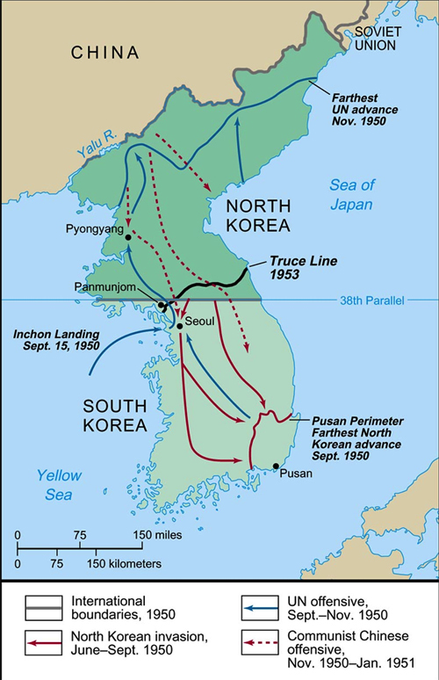

Taiwan in 1950 represented China in the Security Council, rather than the communist, mainland, People’s Republic of China. When the U.N. Security Council was discussing the DPRK attack on South Korea, the USSR ambassador was boycotting the Security Council, protesting the communist People’s Republic of China not representing China in the U.N. and Security Council. So the USSR was not present to veto the Korean War resolution leading to a U.S. led, multi-national armed forces fighting communist North Korea.
Initially the North Koreans nearly defeated the ROK, but the U.S. led U.N. army landed at Inchon. Along w/ the South Korean army, they pushed the DPRK army almost to the Chinese border, the Yalu River. U.N. and U.S. commander General Macarthur talked of using nuclear weapons and possibly crossing the Yalu River into China, before he was relieved of command by President Truman. The Chinese would not accept a U.S. presence on its southern border, so they entered the war, pushing the U.N/U.S. forces south to near the 38th Parallel. After much terrible fighting and the deaths of about 3 million Koreans, almost a million Chinese, and 37,00 Americans, the war ended in a stalemate and armistice (cease-fire agreement.) No permanent, war-ending treaty was signed.
Post 1953 Cease-fire Developments
The U.S. Air Force destroyed much of North Korea’s Japanese built factories, roads, ports facilities, railroads, and other economic infrastructure during the Korean War.
Economic aid from the Soviet Union, China, and communist, Eastern European states helped the DPRK rebuild its centrally planned, socialist economy fairly rapidly. Having large amounts of valuable natural resources, good natural harbors/ports, and earlier Japanese industrialization also helped. By the late 1950’s, North Korea had one of the fastest growing economies in the world. Farmers were generally pleased that very large farms owned by a few wealthy landowners were turned into collective farms, worked by groups of farm families living and working collectively.
Most of South Korea’s infrastructure was also devastated during the Korean War. At the end of the war in 1953, it was one of the poorest countries in the world. The ROK economy was more agriculture based, with fewer natural resources and less Japanese economic development before WWII.
North Korea developed a highly authoritarian, repressive political system centered on one charismatic, appealing, individual, Kim Il-sung, who was supported by Stalin, the USSR, and China. A cult of personality developed around the “Great Leader.” Large images of him “hung from almost every shop, home, and subway car.” The North Korean government told its people that Korea was a chosen land and the site where civilization first developed.
His philosophy was based on “Self Reliance,” “Military First,” and nationalism. The PDRK legislature has been a rubber stamp for the three Kim family, hereditary dictators and the judicial system essentially has no power to check the PDRK leader’s actions or decisions.
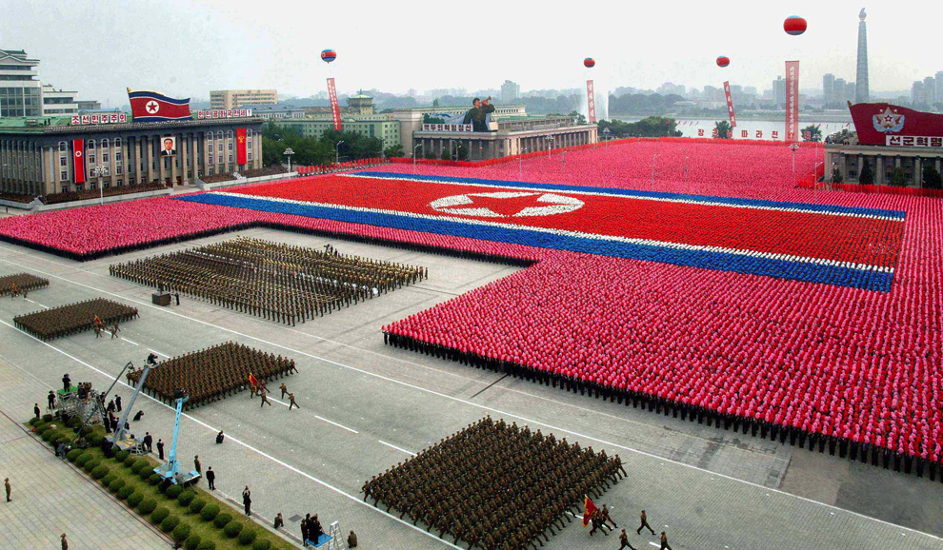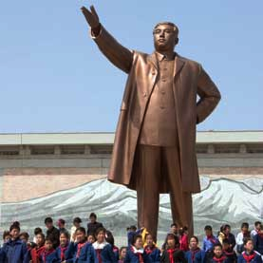
Military parade in Pyongyang, DPRK North Korean school children at the
statue of “Great Leader” Kim Il-sung

No dissent or criticism was permitted in North Korea. One could be imprisoned for simply sitting on a piece of newspaper with a photo of Kim or his son. Today, about 200,000 dissenters and political prisoners live in brutal concentration camps and prisons. Refugees and defectors tell stories of abuse, torture, and public executions of those who do not conform to Kim’s policies.
In the 1970’s the economic fortunes of the Koreas reversed. South Korea began rapid industrialization, building quality infrastructure and education systems – becoming one of the Asian economic “Tigers” and one of the top 12 economies in the world. In 2012, North Korea’s per capita gross national income was @ $1,800, compared to $34,000 in South Korea.
Extensive Soviet Union economic aid to the DPRK was cut when the USSR collapsed in 1989. Terrible floods and droughts in the late 1990s, along with centrally planned economic inefficiencies, led to mass starvation of about a million Koreans in the north.
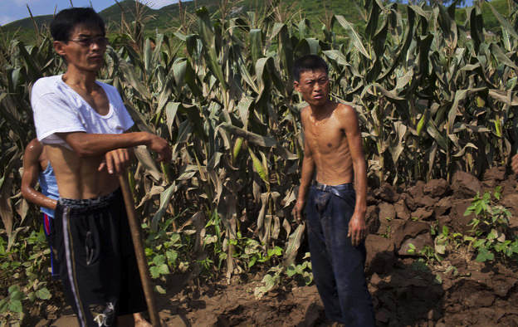

North and South Korean Interactions
Since division in 1945, the two Koreas have had a complex relationship with periods of conflicts and attempts to find peace – cycles of highs and lows for over 65 years.
In 1958, the U.S. sent and deployed nuclear weapons to South Korea. This move threatened North Korea, the USSR and China in the midst of the Cold War. Ten years later, 31 North Korean special forces commandos nearly assassinated the South Korean president.
Relations improved in 1972 when leaders of both countries signed an agreement emphasizing their common desire for reunification.
North Korean agents again attempted to assassinate the South Korean president on his trip to Burma in 1983. The explosion killed 21 people, including eight ROK cabinet members.
Heavy rain and landslides in 1984 killed 190 people and left 200,000 people homeless in Seoul, the South Korea capital, and destroyed crops. The North Korean Red Cross delivered rice, clothes, and medical supplies, warming relations between both states. In 1985, 50 families divided in the war were re-unified in an emotional, official event.
Two North Korean agents planted a time bomb on a civilian Korean Air Lines flight, killing all 115 people on board in 1987. The one surviving agent apologized, claiming her orders came from the “Great Leader’s” son, Kim Jong-Il, who wanted to destabilize the 1988 Seoul Olympics.
Athletes from both countries competed as one team, under a unification flag, at the 1991 World Table Tennis Champions. Table tennis (ping pong) is a major sport in the Koreas
1991-92 agreements included: no aggression; economic, social and cultural exchanges; a non-nuclear Korea; no testing or use of nuclear weapons; and U.S. nuclear weapons removed from the South.
Enriching uranium is a very technical, complex, and expensive process. 5-12% enriched uranium is used to produce nuclear powered electricity and is used for medical purposes. To be used for nuclear warheads, uranium must be enriched to 85-90%, and even more challenging, technically difficult process. The United Nation’s International Atomic Energy Agency (IAEA) inspects uranium enrichment processing world wide to guard against the proliferation of nuclear weapons.
In 1993, the DPRK threatened to go back on its 1985 agreement not to enrich uranium to weapons grade and stopped IAEA inspections in North Korea. U.S.- DPRK negotiations and talks led to the
1994 Agreed Framework. North Korea agreed to stop uranium enrichment in exchange for U.S. financed nuclear power plants.
In 1997, new South Korean president Kim Dae-Jung moved away from past, ROK, hard-line, military opposition to the North and started to interact and cooperate with North Korea on a regular basis, called the “sunshine policy.” He hoped for a gradual and peaceful process of reunification.
South Korea opened economic/business zones and factories across the border in the DPRK, where thousands of North Koreans were employed and paid well. The ROK also established a well-run tourist area in North Korea’s most beautiful mountain park. More families were re-united.

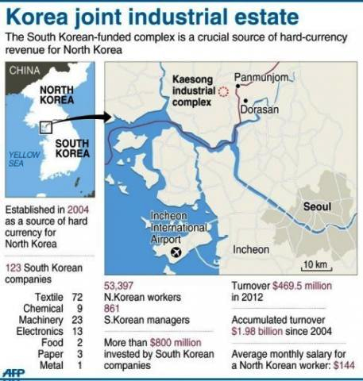
http://www.afp.com/en/news/topstories/n-korea-urges-foreigners-south-evacuate

North Korea tested, launched, and sent medium range missiles over Japan in 1998.
In 2000, ROK president Kim Dae-Jung met North Korean leader Kim Jong-Il (son of the “Great Leader, who died in 1994) in North Korea– the first meeting of North and South leaders. South Korean president Kim Dae-Jung received the 2000 Nobel Peace Prize for his “sunshine policy.”
At the 2000 Olympics, both teams competed separately, but under the same unification flag.
In 2002, the U.S. accused North Korea of again developing nuclear weapons, breaking their 1994 agreement. North Korea expelled U.N. IAEA inspectors in the DPRK. U.S. President Bush called North Korea a part of the world’s “axis of evil” (along with Iran and Iraq). The U.S. worried that the DPRK would sell nuclear weapons technology to terrorists.

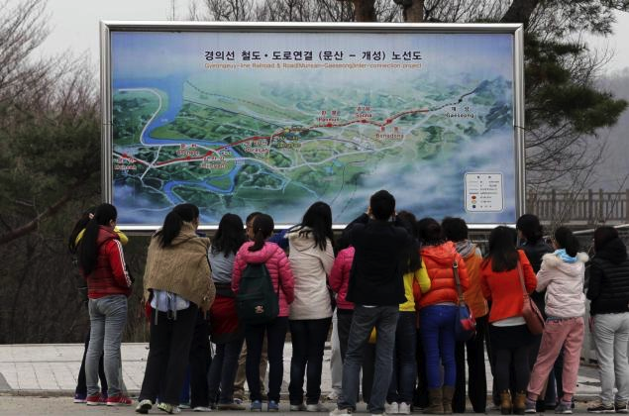

Chinese tourists look at a map of railroad between two Koreas cities, South's Munsan and North's Kaesong, which the two Koreas hope to reconnect as part of an agreement reached at a historic summit of Kim Dae-jung and Kim Jong Il in 2000.

From 2003 to 2009, Six-Party talks were held to negotiate an end to North Korea’s nuclear weapons program. The six states were: North Korea, South Korea, China, Japan, Russia, and the U.S.
In 2006 North Korea conducted its first nuclear weapons test underground and also tested more missiles. In response, the U.N. Security Council unanimously passed a resolution for significant economic and diplomatic sanctions.
In exchange for fuel and other economic aid in 2007, North Korea destroyed a weapons grade nuclear reactor.
In 2009, the DPRK held its second nuclear weapons test and launched a new, longer range missile. South Korea’s president announced that future ROK economic aid to the North would depend on the DPRK ending its nuclear weapons program – angering North Korea. The PDRK quit the Six-Party talks and expelled U.N. sponsored IAEA inspectors. Support in South Korea for the “sunshine policy” declined.
2010 – A torpedo sank a South Korean naval ship, killing 46 ROK sailors. The torpedo most likely was from a North Korean submarine, but DPRK officials denied responsibility. Later that year, North Korean artillery killed four South Korean soldiers and civilians near the border.

Present Situation

North Korean Actions and Crisis under Kim Jong-Un - 2011-2013
2011 - 27 year old Kim Jong-un took charge of North Korea. Experts believe that he ordered the sinking of the ROK naval ship in 2010 to improve his status among older, hard-line military leaders.
2012 – North Korea successfully tested a long range missile capable of carrying a nuclear warhead, worrying East Asian states and the U.S. The U.N. Security Council strengthened more economic and trade sanctions (punishments). The DPRK responded by stating that it would continue its nuclear weapons and missile program so that they could reach the U.S.
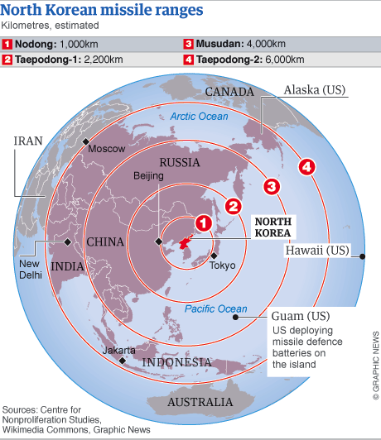
April, 2013 – The DPRK conducted it third test of a smaller, more powerful nuclear weapon. The U.N. Security Council unanimously strengthened sanctions against the DPRK. They placed painful new constraints on North Korean banking, trade and travel; and pressured countries to search suspect North Korean cargo. China helped write the resolution, suggesting it may be losing patience with the PDRK. North Korea responded by declaring it was on the brink of nuclear war with South Korea and the U.S. The PDRK pulled all it workers out of the South Korean run factories established under the “sunshine policy,” closed the military phone “hot line” with the South and moved missiles to its coast.
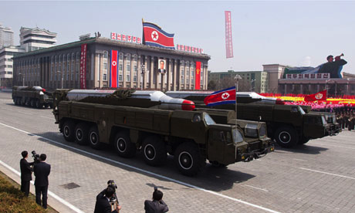
North Korean Musudan-class missiles
Observers think DPRK leader Kim Jong-un may be using the same tactics as his father and grandfather to create crisis scenarios as a way to force the U.S., South Korea, and Japan to make concessions and provide economic aid. As a young leader, he may be trying to unify North Korea against a perceived common enemy and prove that he is a legitimate leader. He wants bi-lateral talks with the U.S. possibly to show the world North Korea should be recognized as a serious state and nuclear power. Kim is aware that after Libya gave up nuclear weapons under international pressure, its dictator Ghadaffi was overthrown and executed by opposition rebels. Some believe Kim Jong-un is erratic and unpredictable by nature; others think it may be a tactic to keep North Korea’s enemies off balance. The U.S. announced it will send anti-missiles defense systems to Guam and sent nuclear capable B-2 Stealth bombers for flyovers of South Korea to show its commitment to defend its ally. Aug. 13, 2013 - North and South Korea agreed to reopen the ten year old, joint, Kaesong industrial complex in a sign that the two sides are inching toward a thaw after months of high tension earlier this April, 2013 Pyongyang has long relied on the factory complex for much-needed hard currency and for tens of thousands of jobs. South Korea also recently promised $7.3 million worth of humanitarian aid for its impoverished neighbor. In recent months, China has pressied the DPRK to stop provoking South Korea and the U.S. The United States warned China that a failure to rein in the North would lead to a further buildup of American military in the region, which would worry and anger the Chinese. Sept. 2013 – North Korea has also very recently called for re-establishing the military hot-line between North and South and has encouraged several meetings of Korean families split apart by the DMZ.

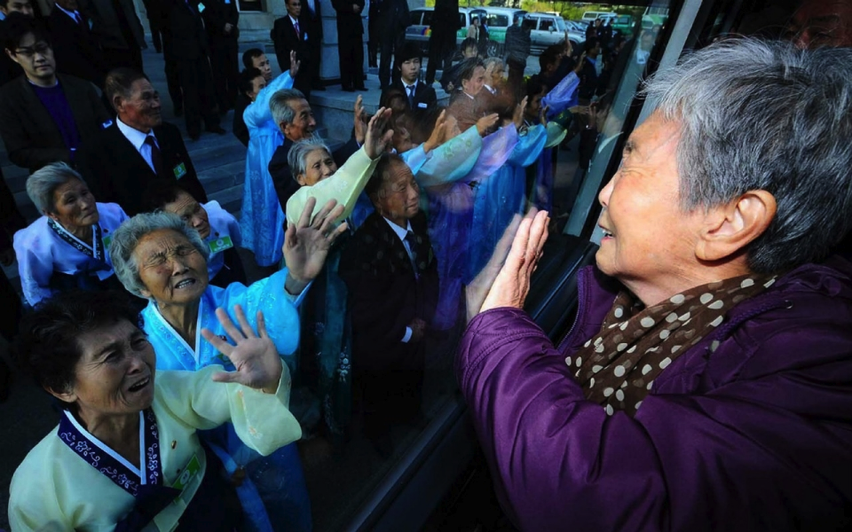
South Koreans in a bus bid farewell to their North Korean relatives – separated for 60 years following the Korean War – before they return to their home after a family reunion.
Some observers believe this came about because the dissatisfaction of China and unwillingness of the U.S. to over react to spring, 2013 DPRK statements and threats may have taken North Korea by surprise. This broke the familiar pattern of fence-mending responses. In the end, North Korea was left with an even more tarnished reputation and a defunct industrial complex which until then had benefited the North far more than the South. For hereditary dictator Kim Jong-un, only 30 years old and surrounded by skeptical veterans, this disastrous outcome must have felt like a dangerous blow to his credibility as a leader. As inter-Korean trade plummeted to its lowest level since the Sunshine Policy was enacted some 15 years ago—despite a new South Korean president who was actually willing to deal with North Korea on relatively friendly terms—the leadership in Pyongyang belatedly realized their mistake. Pyongyang’s atonement attempts have been reflected almost daily in the official state newspaper articles.
UN History

In 2006, the U.N. Security Council unanimously passed a resolution for significant economic and diplomatic sanctions (punishments and restrictions) against North Korea.
2012 - The U.N. Security Council added and strengthened more economic and trade sanctions against the DPRK.
2013 - The U.N. Security Council unanimously strengthened sanctions against the DPRK. They placed painful new constraints on North Korean banking, trade and travel; and pressured countries to search suspect North Korean cargo. China helped write the resolution, suggesting it may be losing patience with the PDRK.

Key Concerns

How erratic and unpredictable is North Korea? Will the DPRK always be bluffing when it threatens nuclear and conventional military attacks?

North Korea has provided nuclear weapons technological assistance to both Iran and Syria.
How can the U.N. address this and prevent future nuclear weapons and technology proliferation/spread?

Is the DPRK pattern of strong threats, followed by South Korean and western economic, food, and oil assistance an appropriate and sustainable strategy?

How successful have the 2012 and 2013 U.N. sanctions been?

If North Korea continues to improve relations with the ROK, should those sanctions be reduced?

Is an increase in trade, family reunions, cultural exchanges, sporting events and other South and North Korean interactions the best way to reduce DPRK sporadic, but aggressive
threats?

Key Opinions

China - The reason North Korea keeps running nuclear tests is related to the development of its own nuclear weapons to protect national security and diplomatic independence. It fears that the U.S. and its allies will threaten or violate its territory, which is not without precedent. In 2003, the U.S.-led occupation of Iraq overthrew Saddam Hussein's government and caused massive amounts of damage to the local economy and national infrastructure. Hussein was eventually executed. North Korea will not let the same possibility happen to them. North Korea is also quite aware that after Libya’s dictator Ghaddafi gave up nuclear weapons, due to international sanctions and pressure, he was overthrown by NATO and Libyan rebels, then executed. In North Korea's neighboring states, the U.S. has supplied weapons to South Korea and Taiwan for many years, interfering with China's sovereignty and national unity. If Washington feels comfortable trying to influence nuclear countries such as China, Pyongyang feels even more pressured by U.S. actions in the Asia-Pacific. However, after China exploded its first atomic bomb in 1964, the U.S. ordered Taiwan to stop Project National Glory, a military attempt to recapture the Chinese mainland. It was helpful for China to obtain the nuclear weapons after all. It is the same for North Korea, who will benefit from stronger military capabilities.
North Korea experts suggest that recent nuclear weapons and missile tests were meant to lift the sagging morale of an impoverished public or for the regime to gain favor with the military. Others think Pyongyang tested a nuclear device for the same reason it has been testing long-range missile designs: to see what works. It is an attempt to master the technical capabilities vital to its nuclear deterrent. During the Cold War, 1945 to 1992, the U.S. conducted 1,054 nuclear tests and fired an untold number of missiles. The U.S needed its ultimate deterrent against the Soviet Union to actually work, and because the technical requirements of the nuclear mission continually changed. Like the U.S. during the Cold War, North Korea has decided that nuclear weapons are central to its national security strategy. With few friends, its conventional military forces outgunned, an economy in tatters, and facing off against a superpower prone to deposing dictatorships across the globe, North Korea is building nuclear arsenal to defend itself, should war erupt on the peninsula, by threatening U.S. regional allies and targets in the United States. During the Cold War the U.S. understood that the ability to conduct nuclear operations was the foundation of a credible deterrence strategy. North Korea believes in a similar policy that the U.S once considered rational and routine. North Korea is also quite aware that after Libya’s dictator Ghaddafi gave up nuclear weapons, due to international sanctions and pressure, he was overthrown by NATO and Libyan rebels, then executed.

Pakistan has a long lasting defense treaty with North Korea. It believes North Korea has a sovereign right and duty to defend itself from its enemies that have nuclear weapons. In 1958, the United States deployed nuclear weapons in South Korea to threaten and intimidate the DPRK. Recently, the U.S. flew nuclear capable B-2 bombers over South Korea – also to threaten North Korea. Like North Korea, Pakistan has nuclear weapons and missiles to defend us from India and its nuclear warheads. In 1990, highly sensitive centrifuge technology for enriching uranium to 90% weapons grade was exported from Pakistan to North Korea in exchange for missile technologies Pakistan needed for our nuclear defense. In 1993, downloaded secret information on uranium enrichment was delivered to North Korea in exchange for information to Pakistan on developing ballistic missiles capable of launching nuclear warheads.

Russia – In 2012, Russia joined the United States in condemning former Soviet ally North Korea's test launch of a ballistic missile. Russia, North Korea's longtime ally, warned the communist regime not to withdraw from an international agreement to halt the spread of nuclear weapons, a blow to the North's efforts to cast the nuclear issue as a dispute strictly with the United States. North Korea is raising tensions in an effort to frighten and force the United States and South Korea into negotiations and concessions. The pressure was also aimed at China and Russia in an effort to push them to mediate on North Korea’s behalf.
South Korea - North and South Korea agreed in August, 2013 to reopen the troubled joint industrial park at Kaesong, a symbol of economic cooperation, raising hopes of possible improvement in political ties. South Korean President Park Geun-hye welcomed the decision, saying she hoped "today's talks will be the beginning of a new start of South and North Korea relations." On the other hand, the March and April, 2013 barrage of threats from North Korea has sparked talk from within South Korea of the need to develop its own nuclear weapons. According to a February poll conducted by South Korea's private think tank, Asan Institute, 66% of South Koreans said they support developing a nuclear weapons program. The poll suggests that just under half of South Koreans in 2012 believed that the United States would provide South Korea with what's known as the "nuclear umbrella" in the case of a North Korean nuclear attack. Under the nuclear umbrella, the U.S. is to provide South Korea with defensive means to ensure deterrence against a nuclear threat. In recent times, South Korea has been known for little if no reaction on North Korea's provocations and threats. Its attitude changed after the 2010 attack on its battleship That killed more than 40 sailors -- North Korea was blamed. That same year, there was also outrage after the North shelled Yeonpyeong Island. South Korea returned fire and also began responding to North Korea with its own strong words.

United States The risk of North Korean nuclear war stems NOT from weakness on the part of the United States and South Korea but from their strength. If war erupted, the North Korean army, short on training and armed with decrepit equipment, would prove no match for the U.S.–South Korean Combined Forces Command. Make no mistake, Seoul would suffer some damage, but a conventional war would be a rout, and U.S.-So.Kor. combined forces would quickly cross the border and head north. North Korea’s saber rattling today represents only the most recent episode in a long history of unpunished provocation. In 1968, North Korean forces seized a U.S. Navy ship and its crew, in 1983, North Korean operatives planted a bomb in Rangoon that killed several South Korean cabinet members and other government officials. Four years later, agents bombed a civilian airplane, killing all 115 aboard. More recently, the North Korean military torpedoed the South Korean frigate Cheonan and shelled South Korea’s Yeonpyeong Island in 2010. In every instance, the joint U.S.-South Korean command, Combined Forces Command (CFC), has let North Korea get away with its misbehavior. Multiple sets of economic sanctions has not deterred aggression. The U.S. and South Korea must make every effort to avoid war in the current crisis. The U.S. is undoubtedly (and appropriately) quietly reinforcing U.S. forces in the region, and the U.S.-So. Kor. CFC is understandably considering what red lines might trigger a pre-emptive conventional strike. But the fact that war with North Korea probably means nuclear war should temper any consideration of limited pre-emptive strikes.
Pyongyang continues to blackmail wealthier countries into handing over economic aid that the state needs to survive. Kim’s behavior this past spring seems to fit the pattern: “First make a crisis, then escalate tensions, and finally extract payments and concessions for the restoration of the status quo.” The strategy may work in the short run, but it is ultimately unsustainable

The Security Council

The United Nations Security Council deals with issues related to maintaining the security and safety of the international community. The Security Council is the only U.N. council or committee that may initiate economic sanctions, peacekeeping operations, military actions, or any other direct intervention in a state. When states join the United Nations, they agree to abide by the resolutions passed in the Security Council.
The Security Council’s has a wide range of options to insure international security. They include:

• Acquire additional information about a conflict or potential conflict
• Request information from other U.N. related agencies (ie. IAEA, Human Rights Council)
• Investigate the presence of banned weapons or weapons of mass destruction
• Request states or parties provide information about war crimes or attempts at genocide in disputed territories or states
• Investigate possible violations of international humanitarian law
• Call for an immediate cease-fire between combatants in a conflict (civil war or war between countries)
• Call for negotiations, suggest a peace plan, and/or provide a trained peace negotiator/diplomat
• Invite the logical, regional transnational organization (ie., African Union, Arab League, European Union, NATO, ASEAN, OAS) to provide expertise, negotiators, peace keepers, aid workers, financial or military assistance
• Impose a no fly zone patrolled by a regional military alliance
• Impose a trade embargo on one or several states or parties in the dispute
• Authorize a naval blockade by a regional military alliance
• Establish a U.N. peacekeeping force – lightly armed to preserve a peace agreement
• Establish “safe areas” for refugees and provide relief services to refugees fleeing the conflict, with the assistance of various international aid organizations
• Authorize military force against one or both parties in the dispute or conflict, reflecting the U.N. “Responsibility to Protect” doctrine
• Establish an international criminal tribunal to try persons responsible for war crimes and crimes against humanity in the disputed area
• Establish a compensation commission to give money to the victims of the conflict
• Call upon the U.N. Peacebuilding Commission to work with international
non-government organizations to help rebuild war torn states and territories.

Sources

Korean Peninsula Crisis Guide: 1945-2011– Council on Foreign Relations
Overview, Historical Timeline events, including photos
www.cfr.org/northeast-asia/crisis-guide-korean-peninsula/p11954

North Korea Nuclear Weapons Program & Foreign Relations: 1991-2013 - NY Times
photos, videos and event descriptions
www.nytimes.com/interactive/2013/02/05/world/asia/northkorea-timeline.html?ref=asia&_r=0#/#time238_7085

Six Party Talks on No. Korea’s Nuclear Program: 2003-09 – Council For. Relations
article on temporary successes, failures of negotiations involving U.S., Russia, China, Japan, No. Korea, and So. Korea
www.cfr.org/proliferation/six-party-talks-north-koreas-nuclear-program/p13593

North Korea’s Nuclear Threats – New York Times, Apr. 16, 2013
in depth, key questions and answers with excellent maps and photos
www.nytimes.com/interactive/2013/04/12/world/asia/north-korea-questions.html?ref=asia

North Korea’s Inherited Tactics – 5 min. video interview with Georgetown U. Korea expert/scholar and No. Korea video clips– New York Times, April 3, 2013
www.nytimes.com/video/2013/04/03/world/asia/100000002152807/inherited-tactics.html?ref=asia

