 | Boulder High School  Model United Nations  Conference | 

Background Guide

India and Pakistan Joint Crisis Cabinet
India and Pakistan: 1965 Kashmir Crisis
Written by Vamshi Arugonda and Annemarie Parsons
October 5th, 2013

Pertinent Data
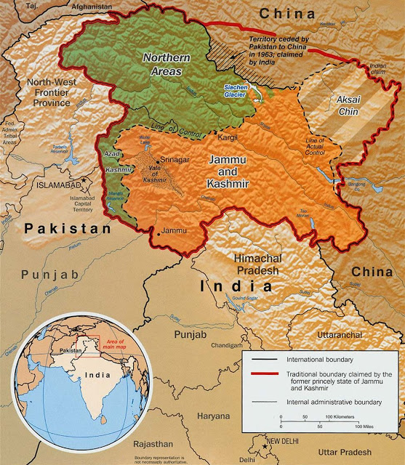
- The disputed region is divided into four main territories: Jammu and Kashmir, Azad Jammu and Kashmir, Northern Areas, and Aksai Chin.
Image 1: The Kashmir region’s four main territories, and who controls them. Orange: India, green: Pakistan.
  - Jammu and Kashmir is the 85,806 southern square miles of the region. It is further divided into the Kashmir valley (upper left-hand corner of the territory), Jammu (lower left-hand corner), and Ladakh (right-hand side). It considered India’s northernmost state; however it has more autonomy than the other states.
  - Azad (Free) Kashmir, or free Kashmir, is 5,134 square miles of land (“Kashmir Profile”) to the west and north of Indian Jammu and Kashmir. It is under Pakistani control; however it is not constitutionally a part of Pakistan.
  - Aksai Chin is a piece of the region that Pakistan ceded to China in 1963. India, however, still lays claim to it.
  - The rest of the region is made up of the Northern Areas (Gilgit-Baltistan) - the 27,990 square miles to the north controlled by Pakistan.
  - Both India and Pakistan lay claim to the entire territory of Jammu and Kashmir and consider the other country’s area of the territory to be theirs. (Jamal)
- Religious Populations of Jammu and Kashmir territories
Country in Control | Region | Buddhism | Hinduism | Islam | Other
India | Kashmir Valley | - | 4% | 95% | -
India | Jammu | - | 66% | 30% | 4%
India | Ladakh | 50% | - | 46% | 3%
Pakistan | Azad Jammu and Kashmir | - | - | 99% | -
Pakistan | Northern Areas | - | - | 99% | -

- Indo-Pakistani War of 1947
  - Pakistani tribesmen invaded Kashmir on October 22, 1947.
  - Maharaja (ruler) Hari Singh acceded Jammu and Kashmir to India on October 26, 1947.
  - First ceasefire on the issue was arranged January 1, 1947 by the
United Nations.
  - Troops lost:
    - India: ~1,500
    - Pakistan: ~6,000 (“India-Pakistan: Troubled relations”)
- Sino-Indian War of 1962:
  - China invaded India on October 16, 1962 - 11 years after invading Tibet.
  - ~4,500 were killed as China expanded south. (Tawang)

History
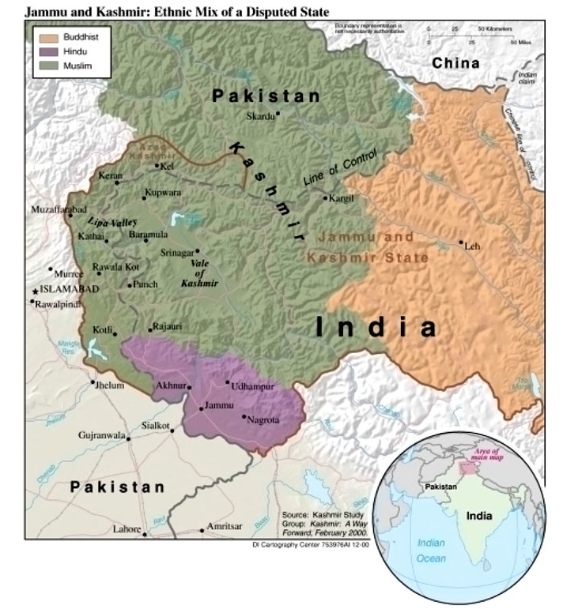
The Indian subcontinent has a long history of rocky relations between Hindus and Muslims. The first 500 years C.E. brought a golden age of literature, art, and science to India, during the Mauryan and Gupta Empires - nearly a thousand years before the arrival of similar systems in Europe. The diffusion of Islam into the region began in 700 C.E, when Muhammad Ibn Qasim conquered Sind in northwest India (now Pakistan), imposing a tax on non-Muslims. Over the next thousand years, strong religious beliefs, the importance of territorial expansion, and the promise of great wealth motivated repeated invasions by Muslims from Central and Southwest Asia - themselves often pushed east by Mongol armies.
Image 2: Religious majorities in Kashmir.
Orange: Buddhism, green: Islam, purple: Hindu.
Beginning in the 1500s, the Muslim Mughal Empire ruled India for over 200 years. While the Mughal Empire consisted of a Hindu majority ruled by a Muslim minority, relations between the two groups were remarkably good. Both Muslim and Hindu leaders attempted to foster unity and cooperation between religions following centuries of tension. However, the last major Mughal emperor, Aurangzeb, was unfortunately anti-Hindu. He reinstated the non-Muslim tax, destroyed Hindu temples, and soured Hindu-Muslim relations in the early 1700s (Gilmartin et al.).
While Muslim conquerors had been largely impressed by the scientific and artistic accomplishments of Hindu majority and Buddhist minority India, major differences in religious practices fueled criticism by both Muslims and Hindus of the other’s beliefs. To followers of Islam, a monotheistic religion that forbids the creation of images of Allah or the prophet Mohammed, Hindu worship of thousands of gods and prayer to idols seemed a terrible blasphemy. Hindus, on the other hand, resented Muslim slaughter of cows, a sacred animal in their religion, for food. In general, the tolerance practiced and encouraged by most Muslim rulers allowed the two groups to coexist peacefully until the intrusion of Europeans into the Indian subcontinent.
The European presence in India was, for the most part, restricted to coastal, port cities until the 1700s. The Portuguese and Dutch, the two major maritime powers in the region, had little interest in establishing land-based colonial empires. In 1655, a new player entered the Indian trade scene as Great Britain acquired the port city of Bombay from Portugal as part of a royal dowry. By 1773, Great Britain had taken over more extensive territories in the region and appointed India’s first Governor-General, Warren Hastings. Hastings used a combination of military force and diplomacy to expand British control of India, either through conquest, bribing, or buying the influence of local rulers (Gilmartin et al.).
By the mid-nineteenth century, the British controlled eleven provinces and 582 princely states in India, making it the wealthiest empire in the world. Both Hindus and Muslims were angered by British arrogance, as the British considered native Indians inferior in intelligence, courage, race, and religion. Indians however, showed remarkable patience for independence, as they believed Great Britain to be sincere in its repeated statements that it would one day grant freedom to the Indian people. By the end of World War I, Britain announced its intent to lead India towards self-governing institutions in the near future - but Indians quickly lost patience with British rule.
After 379 unarmed, peaceful protesters were killed when British Brigadier-General Dyer ordered his troops to shoot into a mass meeting in Amritsar, the Punjab province on April 12, 1919. The British government’s refusal to punish the general sparked intense animosity and anger among native Indians. (Gilmartin et al.).
Under the leadership of Mohandas Gandhi, the Indian National Congress enacted a non-cooperation policy with the British government and changed from a small group of India’s elite into a massive organization, recruiting thousands of peasants. Gandhi aimed to unite both Hindus and Muslims under the Congress to protest British rule, but many Muslims saw a religious leaning to the organization and believed the Congress to be not only pro-Hindu but also anti-Muslim. In opposition, Muslim leaders formed the Muslim League in 1906.
The Indian National Congress refused an amendment that would have, upon the granting of India’s commonwealth status, provided for separate electorates between Muslim and Hindu communities. The amendment would’ve also reserved 1/3 of the seats in the central government for Muslims (who made up about ¼ of India’s population). Failure to pass those amendments led the Muslim League to believe it should no longer try to work with the Congress Party (Gilmartin et al.).
The idea of Pakistan was born following a weak showing by the Muslim League in the 1937 provincial elections. While the name “Pakistan” was not created until later, Muslim leaders had begun to support the idea of the division of India into two separate federations upon independence, while allowing the voluntary migration of populations between the two states.
In 1940, the Muslim League declared its belief that regions in northwest and east India, where Muslims made up a majority of the population, should be made into independent Muslim states. When Great Britain finally withdrew from India and granted its independence on August 15, 1947, the Congress Party and the Muslim League agreed to divide the territory according to religious lines.
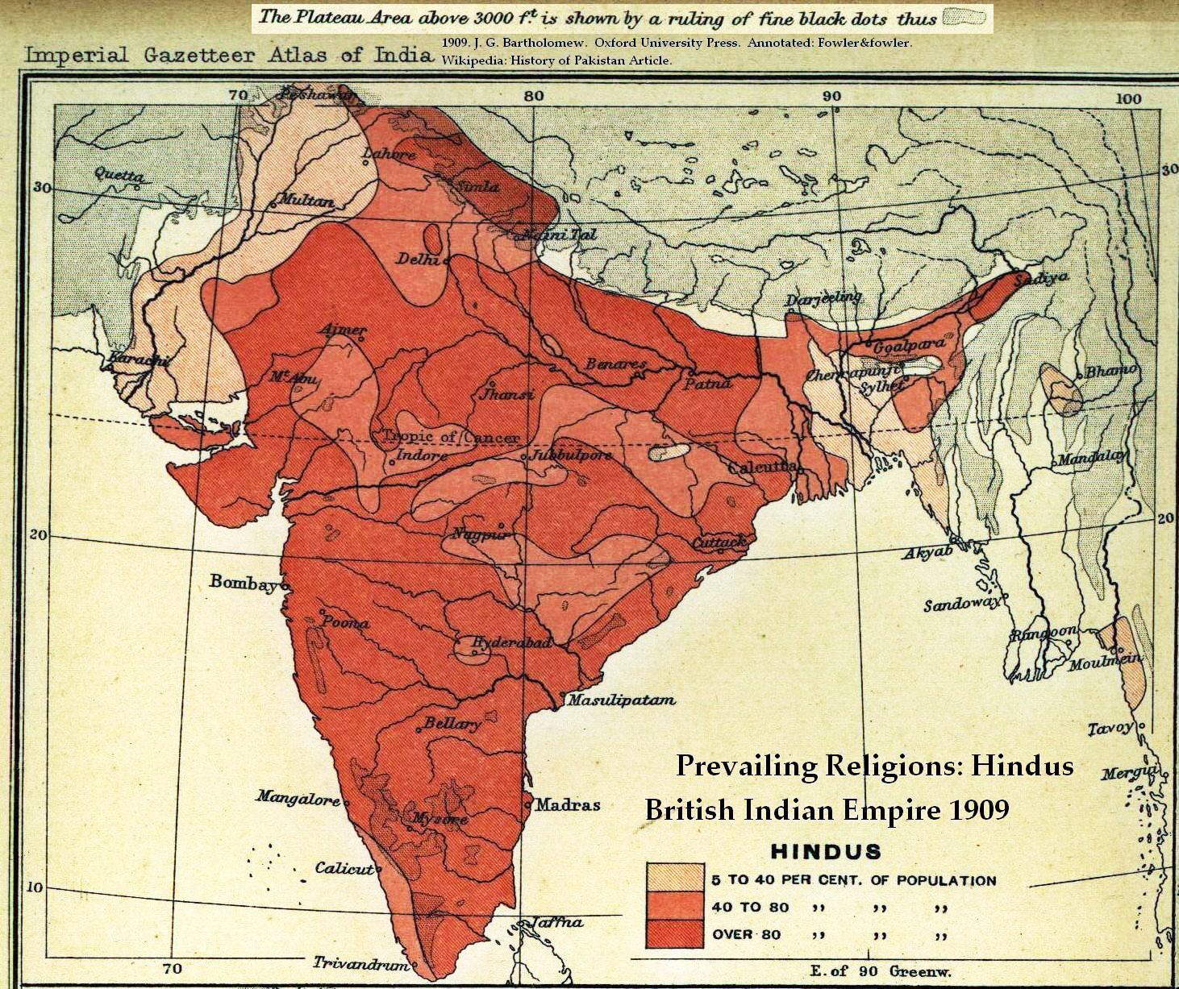
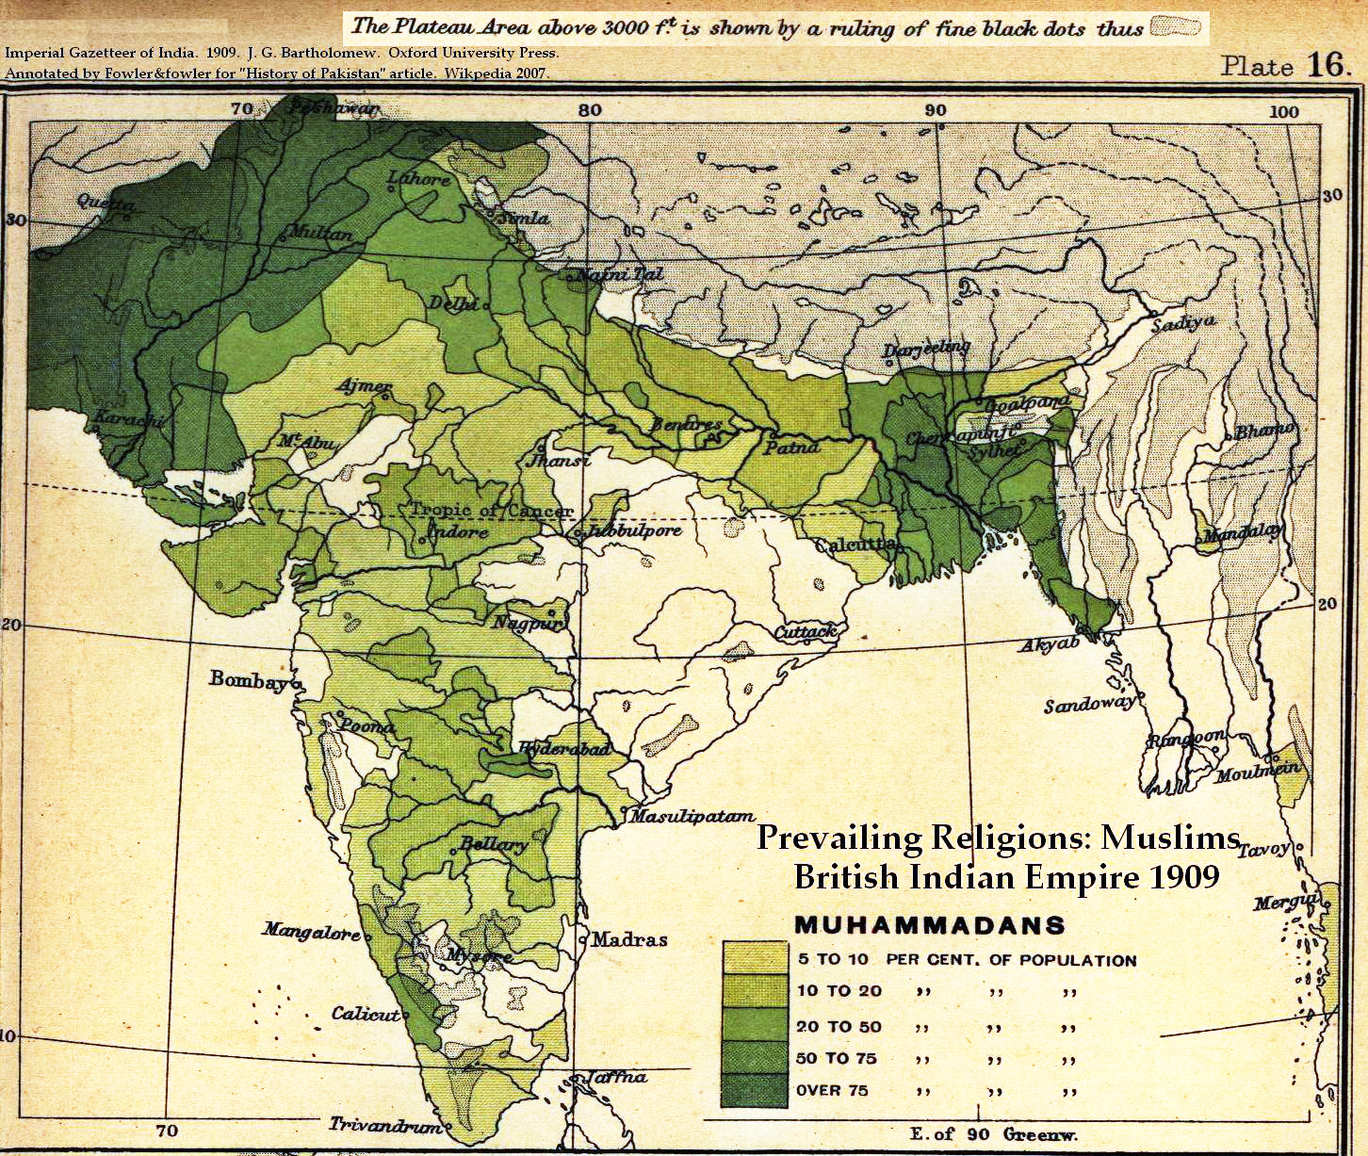
While princely states were not included in this division and allowed to self-determine their allegiance, any area with a population that was 75% or more Muslim would become a state independent of India (“Troubled Relations”). By the end of the partition, India consisted of the majority of both Great Britain’s provincial holdings and of the princely states, northwest India became the state of West Pakistan (now simply “Pakistan”), and from eastern India rose East Pakistan (present-day Bangladesh).
Image 4: Percent Hindu population in 1909 India.
Light pink: 5-40%, red: over 80%.
Image 3: Percent Muslims population in 1909 India.
Light green: 5-10%, dark green: over 75%.
With the sudden British withdrawal, however, India and Pakistan were left to govern ruined economies without an established, experienced governance system (“Partition of India”). An enormous migration of populations followed as millions of people flowed across the new borders from one state to another, often abandoning ancestral homes. Riots broke out in cities and along the border, killing anywhere from 500,000 to over 1 million people as bitterness developed between the new states over the violent migrations and the stormy division of the princely states (Branger).
The princely states of Jammu and Kashmir, embedded along the border of India and West Pakistan, quickly became one of the greatest and most dangerous sources of contention between the two states. While Kashmir was 85% Muslim, its Hindu maharaja, or ruler, had not decided which state to join by the time of the partition. When a Muslim military insurgency arose in Kashmir in October of 1947, the Pakistani army invaded to offer its support to the insurgents. The Indian army agreed to the maharaja’s request for armed assistance in exchange for the accession of Kashmir to the state to India, but to this day historians have argued over whether the maharaja was forced into the agreement under duress.
The war ended on January 1, 1949 with the establishment of a cease-fire line by the United Nations that became the de facto border between India and Pakistan within Kashmir. While Jammu and Kashmir’s accession to India was ratified by the state’s constituent assembly in 1954, the territory’s status remains in question because an agreed referendum to confirm the accession was never held. West of the cease-fire line, Pakistan controls roughly 1/3 of the state, directly administering all but a small region the Pakistanis call Azad (Free) Jammu and Kashmir and is semi-autonomous. Since 1957, when Kashmir ratified its own constitution modeled after India’s, India has considered the section of the state that it controls as part of its own union (“Troubled Relations”).
The 1962 Sino-Indian war sparked a new period of heightened tension between Pakistan and India. Eleven years after its invasion of Tibet, Chinese troops swarmed over the Himalayan border with India, quickly advancing south and killing ~4,500 people before suddenly declaring the war over and pulling out (Tawang). China had proven its point, though; the war revealed the weakness of India’s army. A close ally of China, Pakistan saw an opportunity in India’s weakness to move once again on a territory that it had always considered its own by right: Kashmir.
Present Situation
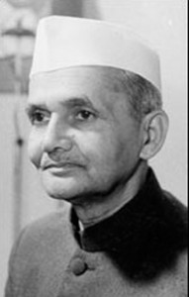
On May 27, 1964, the Indian Prime Minister Jawaharlal Nehru died after agreeing to a summit with Ayub Khan, the military ruler of Pakistan. After his death Lal Bahadur Shastri became prime minister and India-Pakistan relations worsened. Rather than attending the summit, Shastri increased plans to fully integrate Jammu and Kashmir into India.
When Jammu and Kashmir first became a part of India through the Instrument of Accession of 1947, the Maharaja of Kashmir at the time, Hari Singh, made sure to maintain as much of Jammu and Kashmir’s sovereignty as possible. In the Instrument of Accession, Singh stated that “nothing in this Instrument affects the continuance of my Sovereignty in and over this State” (“Instrument of Accession”). These sentiments were echoed in Article 370 of the Indian Constitution that limited the laws that the Indian Parliament could make for Kashmir.
Image 5: Lal Bahadur Shastri
However, the new Prime Minister Shastri began to undo these arrangements and Article 370 by applying Articles 356 and 357 to the situation. Article 356 stating that if a situation in a state makes it no longer possible for the state to follow the Indian Constitution, then the President of India can declare that the legislature of that state will now be controlled by the Indian Parliament. Article 367 adds onto this by stating that the Indian Parliament will then grant the Indian President the power to make laws for the state in question and the right to share this power with any authority the President chooses (“The Constitution of India - in English”). In short, this made it possible for the Indian governor to rule without consent from the local government in Kashmir.
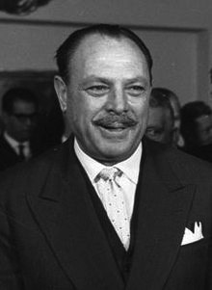
Alarmed by these developments, Ayub Khan created a “Kashmir cell” with the purpose of keeping an eye on the Kashmir situation. The cell (which consisted of the foreign secretary, the director of the intelligence bureau, the chief of general staff of the army, and the director of military operations) believed that India was in a vulnerable position due to the Sino-Indian War and a feeling of revolt among the Muslims within the Valley of Kashmir. The cell believed the Muslims would revolt as soon as Pakistani troops reached them. Pakistani intelligence infrastructure created a military plan to instill a revolt in Kashmir based on the cell’s beliefs. The plan, which was code-named Operation Gibraltar, was presented to Ayub Khan in December 1964.
Image 6: Ayub Khan
Training troops for Operation Gibraltar started in late 1964. Troops were organized into ten forces of about 500 men. Training ended in July 1965, and after much hesitation Khan gave the green-light for Operation Gibraltar and the operation was launched on August 8th. Overall the operation was a failure. By August 16th, the Indians had overcome all of the forces except for one Pakistani military unit. The Indian army then launched its biggest attack on Bedori Bulge.
On August 28th, Pakistani General Musa Khan asked the Foreign Minister to get Ayub Khan’s permission to launch Operation Grand Slam to aid Operation Gibraltar.
This council will take place on August 28, 1965, soon after General Musa Khan’s request. It is important that all delegates do not mention any events past August 28, 1965. We would also like to emphasize that this is an opportunity for delegates to change history, and delegates need not repeat the actual events of the Indo-Pakistani War of 1965.
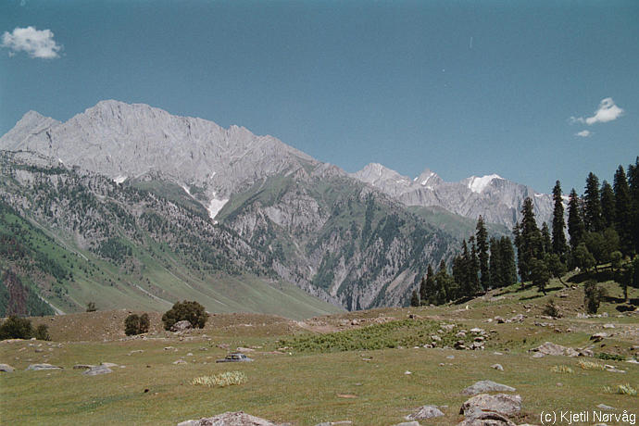
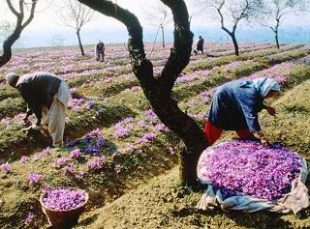
Image 7: Kashmir mountains.
Image 8: Kashmir agriculture
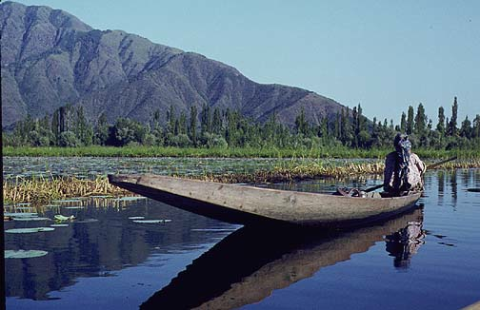
Image 9:
A Kashmir fisher and a Kashmir river.
Key Concerns
- Should Pakistan aid the failed Operation Gibraltar with another operation?
- How should India proceed now that Pakistan has invaded Jammu and Kashmir?
- Should a plebiscite be held throughout the region of Kashmir to determine its status?
- Should the United Nations or another multi-national organization be invited to facilitate a peace agreement?
- What should be done with Aksai Chin?
- How should other border and statehood decisions be made?
- Should people within Jammu and Kashmir be encouraged (or allowed) to migrate to majority areas of their religion?
- What role, if any, should adjacent states play in any decisions or peace agreements?
- What are key natural resources (including fresh water) in Jammu and Kashmir? How should they be distributed?
- How can decisions and agreement be made that will be stable and sustainable over time?
Council Members
Indian Members:
- President of India: Sarvepalli Radhakrishnan
  - Sarvepalli Radhakrishnan is a scholar, philosopher and revered statesman. He served as the first ever Vice President for India and was the second President. He was also an avid believer in building a bridge between the East and the West through similar philosophical systems. By interpreting Indian thought in western terms and showing that it is inbued with reason and logic, he was able to give Indians a new sense of esteem. (Govt of India)
- Prime Minister: Lal Bahadur Shastri
  - Lal Bahadur Shastri was the second Prime Minister of India and a highly revered politician throughout Indian history. He was considered a great scholar and was deeply impressed and influenced by the teachings of Gandhi. He was an active member of the Indian Independence Movement in 1921 and was even briefly jailed for his beliefs and actions. As Prime Minister, he played a key role in the war of 1965; his famous words, “Jai Jawan Jai Kisan” (hail the soldier, hail the farmer) still ring through India today. Shastri also followed Nehru’s policy of non-alignment, but at the same time maintained and built relations with other states, which helped in the war with Pakistan.
- Chief of Army Staff: Joyanto Nath Chaudhuri
  - Chaudhuri served as the Chief of the Army Staff for India for four years and was a distinguished commander. He studied in an English based high school and later went to London to further his studies. Chaudhuri also was a key leader of the military evacuation of Pakistan and was in charge of organizing the Kashmir war effort up to May of 1948. Due to his strategic prowess and military supremacy, he was promoted to the rank of Major General in 1948. (Bharat Rakshak, Land)
- Chief of the Air Staff: Arjan Singh
  - Arjan Singh currently serves as Marshall of the Air Force and has been active member of the Air Force since 1938. Although only 44 at the time of his promotion to Chief of Air Staff, he is considered to have handled the conflict with considerable flamboyance. It is said that his defining moment during the war of 1965 is when he was summoned to the Defense Minister’s office with the intention of bombing and responded with “…in an hour”. Sure enough, a successful air strike occurred near Akhnur, Pakistan. He has been awarded numerous awards for his leaderships and effort. (IAF)
- Cabinet Secretary: Dharam Vira
  - Dharam Vira, a member of the Indian Civil Service, served as Cabinet Secretary of India from 1964 to 1966. He was educated in London and has had a long career in politics and the Indian Government. Vira served as an Ambassador, a Joint Secretary, and numerous other Secretarial positions.

- Minister of Finance: Sachindra Chaudhuri
  - Sachindra Chaudhuri served as Minister of Finance for India for two years; under Lal Bahadur Shashtri and Indira Ghandi. His experience in finance stems from his terms acting as a director for several companies and as a member of the Central Board of the State Bank of India.
- Minister of Defense: Yashwantrao Chavan
  - Yashwantrao Chavan served as Minister of Defense (Defense Minister) in 1962 and began his service at the wake of the India-China Border conflicts. Chavan did not have a long career in politics before he back the Minister of Defense; he became the first Chief Minister of Maharashtra and served that position for two years before Politicians such as Jawaharal Nehru saw potential in him and included him in their congress party. With the support of politicians like Nehru, Chavan quickly became the Minister of Defense.
- Minister of External Affairs: Sardar Swaran Singh
  - Sardar Swaran Singh grew up in a small farming village and attended a government college. Through a strict work ethic and holding himself to a high standard he was able to graduate with a degree in physics with honors. He only discovered his love for politics and government once he quit his job as a lecturer of physics to pursue other things. To this day he holds the record for the longest-serving union cabinet minister in India. He is renowned for his love of serving India and his position as the Minister of External Affairs.
- Minister of Home Affairs: Gulzarilal Nanda
  - Nanda is considered to be one of the most politically experienced members of the Indian cabinet. He has served as the Minister of External Affiars, Home Affairs, and as the interim Prime Minister twice. He was also an ardent follower of Gandhi and his principles. Nanda was very involved in the struggle for freedom and independence from the British as well. He quit his job as a professor in order to join the Indian Non Cooperation Movement; this acted as a catalyst for his future career in politics.
- Minister of Science and Technology: Ramachandra Ayyangar (Not a real person)
  - This is not a real person but you are expected to research the Ministry’s opinion.

Pakistani Members:
- President of Pakistan: Ayub Khan
  - Muhammad Ayub Khan served as the second President of Pakistan and its first military dictator. His rise to power however, was considered controversial by some. After fighting as British Indian Army officer in WWII he was appointed as Pakistan’s first native commander-in-chief; he was promoted over many other senior officers. Soon after he declared Marshall Law, undercut President Mirza in a bloodless coup, assumed the position of President. Even after the formation of the Constitution of Pakistan it is rumored that Ayub Khan rigged the elections to further continue his presidency.
- Chief of Army Staff: Muhammad Musa
  - In 1965, officialy, Muhammad Musa was only the Commander-in-Chief of the Pakistan Army, serving effectively as the Chief of Army Staff. His most notable accomplishment in his career with the Pakistan Army includes blunting the Indian Offensive in the Battle of Chawinda. However, he was blamed for not anticipating the assault by India on the International Border. Most importantly however, is he is fully responsible for the concept of sending infiltrators into the Indian held portion of Kashmir (aka Operation Gibraltar)
- Chief of Air Staff: Nur Khan
  - Nur Khan is highly respected for his strategic prowess due to the fact that he was able to hold off Indian forces despite them out numbering Pakistani forces three to one. He is well known for his sharp intelligence and management abilities since they so greatly benefited Pakistan in its war with India. Khan also has had a long history with the military, attending military school as a child and attended the Indian Military Academy for college.
- Minister of Finance: Muhammad Shoaib
- Minister of Foreign Affairs: Zulfikar Ali Bhutto
  - Bhutto was a very well educated man, studying at Oxford and USC Berkley. His majors were Law and political science - inspired by his father, who served as a Prime Minister. His political career took off when he became the youngest member of Pakistan’s delegation to the United Nations. The same year he became the youngest member of the Pakistani cabinet. He served several different ministry positions throughout his career and became very close to Ayub Khan. Also, having some socialist ideals and through Ayub Khan’s friendship with the Chinese government, Bhutto signed the Sino-Pakistani Agreement that gave 750 square miles of Northern Kashmir to China. This was highly criticized by the Pakistani people and eventually lea to his unpopularity in his own country.
- Interior Minister: Chaudhry Ali Akbar Khan
- Science Advisor: Mohammad Abdus Salam
  - Mohammad Abdus Salam was one of the most intelligent men who took part in the Pakistani Crisis Cabinet. He received the Nobel Prize for Physics in 1979, but his accomplishments date long before that. At the age of 14 he received the highest score ever recorded on the Matriculation Exam at the University of Punjab. After graduating from college with honors he taught math and physics in both India and London. He also served as a member of the Pakistani Atomic Commission. Salam also was the Chief Scientific Advisor to the President of Pakistan for more than a decade.
- Minister of States and Frontier Regions: Munawar Ibrahim (Not a real person)
  - This is not a real person but you are expected to research the Ministry’s opinion.
- Advisor to the Minister of Defence: Abdul Patel Bhatkal (Not a real person)
  - This is not a real person but you are expected to research the Ministry’s opinion.
- Minister of Religious Affairs and Inter-Faith Harmony: Yousuf Fakruddin (Not a real person)
  - This is not a real person but you are expected to research the Ministry’s opinion.

Jammu and Kashmir:
- Chief Minister of Jammu and Kashmir: Ghulam Mohammed Sadiq
  - Ghulam Mohammed Sadiq served as the Prime Minster of Jammu and Kashmir from February 29th, 1964 to March 30th, 1965 and immediately took office as the Chief Minister that same day and continued to serve until 1971. He acted as a representative of the Indian National Congress Party during his time as a Chief Minister. Sadiq was always regarded as an honorable man who was well educated, cultured, and sophisticated. He had a reputation for strictly avoiding and disparaging corruption and a bribery as a means of amassing wealth. He was revered by all hues of politicians as a Marxist and tried to spread those ideals within the Indian National Congress as well. (KIN)

The Council
Rather than writing resolutions, this council will be writing directives. Within the cabinet, each minister has certain powers within their jurisdiction. These powers can be implemented through directives. If a minister wishes to do something that falls in their area of authority, they can do so by writing a directive - a few quick sentences stating what they are doing and why. These actions only need the approval of the ministers of the jurisdictions that the action takes place in or affects, and the president or prime minister. So while delegates might need to pair up with other ministers to write a directive, they will not need to seek the approval of the entire council. For example: the Minister of Science and Technology and the Minister of Finance can write a directive to allot more funds to the space program, and the Minister of External Affairs cannot stop them.
Another unique aspect of this council is that you will be placed in two separate rooms and will not be able to directly communicate between the two cabinets. There is one exception however; the Chief Minister of Jammu and Kashmir can travel between the councils via ‘train’. You can however communicate through your respective Presiding Officers.
Throughout the council you will be presented with crisis situations that will arrive spontaneously and may even completely alter the course of discussions, negotiations, and debate. It is important to remember that the ‘crisis situations’ will be based on your discussions and the course it is taking. You are also representing people and it will be appropriate for you to refer to yourself as ‘I’. Make sure to research your respective positions thoroughly so that your ministry or department’s (or state’s) point of view is represented accurately.

Sources
"Abdus Salam - Biographical." Abdus Salam - Biographical. N.p., n.d. Web. 31 Aug. 2013. <http://www.nobelprize.org/nobel_prizes/physics/laureates/1979/salam-bio.html>.
"Bharat Rakshak :: Land Forces Site - General Joyanto Nath Chaudhuri OBE." Bharat Rakshak :: Land Forces Site - General Joyanto Nath Chaudhuri OBE. N.p., n.d. Web. 31 Sept. 2013. <http://www.bharat-rakshak.com/LAND-FORCES/Personnel/Chiefs/127-JN-Chaudhuri.html>.
Branger, Alejandro. "India-Pakistan Partition." The Legacy Project. The Legacy Project, n.d. Web. 31 Aug. 2013.
"The Constitution of India - in English." Constitution of India. Govt. of India - Ministry of
Law and Justice, 2011. Web. 01 Sept. 2013. <http://lawmin.nic.in/olwing/coi/coi-english/coi-indexenglish.htm>.
Dharma Vira - Raj Bhavan, Karnataka." Dharma Vira - Raj Bhavan, Karnataka. N.p., n.d. Web. 31
Aug. 2013. <http://rajbhavan.kar.nic.in/governors/DharmaVira.htm>.
"Do You Think President Zardari Has Been a Positive Influence on His Party and Democracy?" The
Nation. N.p., n.d. Web. 31 Aug. 2013. <http://www.nation.com.pk/pakistan-news-newspaper-
daily-english-online/islamabad/23-Feb-2012/air-marshal-r-nur-khan-remembered>.
"DR. SARVEPALLI RADHAKRISHNAN - THE PHILOSOPHER PRESIDENT." Feature. N.p.,
n.d. Web. 31 Aug. 2013. <http://pib.nic.in/feature/feyr98/fe0898/f2808981.html>.
Gilmartin, David, Sumit Guha, John C. Hudson, and Ayesha Jalal. "Indian Independence and the Question of Pakistan." Choices for the 21st Century Education Program (2005): n. pag. Web.
"Gulzarilal Nanda." Biography. N.p., n.d. Web. 31 Aug. 2013. <http://www.iloveindia.com/indian-heroes/gulzarilal-nanda.html>.
"India-Pakistan: Troubled Relations." BBC News. BBC, n.d. Web. 02 Sept. 2013.
"Indian Air Force :: Arjan Singh." Indian Air Force :: Arjan Singh. N.p., n.d. Web. 31 Aug. 2013.
<http://www.bharat-rakshak.com/IAF/Personnel/Chiefs/256-Arjan-Singh.html>.
"Instrument of Accession." Jammu & Kashmir. Ed. Muhammad Sadiq. N.p., n.d. Web. 01
Sept. 2013. <http://www.jammu-kashmir.com/documents/instrument_of_accession.html>.
Jamal, Arif. "The Politics of Plebiscite." Shadow War: The Untold Story of Jihad in Kashmir.
Brooklyn: Melville House, 2009. 66-86. Print.
"Kashmir Information Network (KIN): A Paradise Turned into Hell." Kashmir Information Network
(KIN): A Paradise Turned into Hell. N.p., n.d. Web. 29 Aug. 2013. <http://www.kashmir-
information.com/pastpresent/chapter12.html>.
"Kashmir Profile." BBC News. BBC, 14 Mar. 2013. Web. 01 Sept. 2013.
"Marshal of the IAF." Marshal of the IAF. N.p., n.d. Web. 31 Aug. 2013. <http://indianairforce.nic.in/show_page.php?pg_id=14>.
"Members Bioprofile: Chaudhuri Sri Sachindra." Members Bioprofile. N.p., n.d. Web. 31 Aug. 2013. <http://164.100.47.132/LssNew/biodata_1_12/1453.htm>.
"Muhammad Ayub Khan." Story of Pakistan RSS. N.p., n.d. Web. 31 Aug. 2013. <http://storyofpakistan.com/muhammad-ayub-khan/>.
"Partition of India." Emory.edu. Postcolonial Studies @ Emory, n.d. Web. 31 Aug. 2013.
"The Power Game." Lecture. YB Chavan Inaugaral Memorial Lecture. Institute for Defense Studies and Analysis. 22 Nov. 2010. Web. 31 Aug. 2013. <http://www.idsa.in/event/InauguralYBChavanMemorialLecture>.
"Special Report, NOS, The News International." Special Report, NOS, The News International. N.p., n.d. Web. 31 Aug. 2013. <http://jang.com.pk/thenews/jan2013-weekly/nos-20-01-2013/spr.htm>.
"SuSanskrit." Lal Bahadur Shastri. N.p., n.d. Web. 31 Aug. 2013. <http://susanskrit.org/lal-bahadur-shastri.html>.
"Swaran Singh (1907 - 1994)." Biography of Sardar Swaran Singh. N.p., n.d. Web. 31 Aug. 2013. <http://www.sikh-history.com/sikhhist/personalities/swaransingh.html>.
Tawang, Arunachal P. "India and China: Unsettled for a Long Time Yet." The Economist. The Economist Newspaper, 20 Oct. 2012. Web. 31 Aug. 2013.
"Unsettled for a Long Time Yet." The Economist. N.p., 20 Oct. 2012. Web. 23 Aug. 2013. <http://www.economist.com/news/asia/21564861-fifty-years-after-nasty-high-altitude-war-border-dispute-remains-unresolved>.
"Zulfikar Ali Bhutto." Story of Pakistan RSS. N.p., n.d. Web. 31 Sept. 2013. <http://storyofpakistan.com/zulfikar-ali-bhutto/>.

Images
Image 1: http://2.bp.blogspot.com/-VdrTgpa4LW4/UQ_P_CazNUI/AAAAAAAAFcQ/3AnXlIKN6j4/s640/Kashmir_map.jpg
Image 2: http://www.lib.utexas.edu/maps/middle_east_and_asia/jammu_kashmir_ethnic_2000.jpg
Image 3: http://en.wikipedia.org/wiki/File:Muslim_percent_1909.jpg
Image 4: http://en.wikipedia.org/wiki/File:Hindu_percent_1909.jpg
Image 5: http://www.teluglobe.com/tg-roundup/a-pm-who-paid-when-sons-used-official-car
Image 6: http://en.wikipedia.org/wiki/Ayub_Khan_(field_marshal)
Image 7: http://www.idi.ntnu.no/~noervaag/travel/kashmir96/kashmir/kashmir_mountains6.jpg
Image 8: http://m5.paperblog.com/i/59/598420/farm-tourism-and-cultivation-in-kashmir-L-WTAUlr.jpeg
Image 9: http://votebits.com/wp-content/uploads/2011/08/321.jpg

