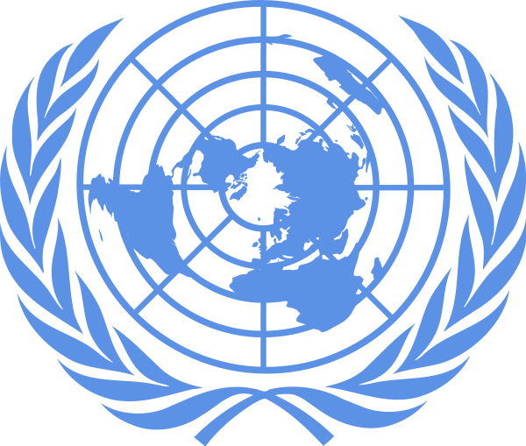
Denver Center for International Studies and East High School
Model United Nations Conference
January 28th, 2017

Background Guide
Beginner/Intermediate European Union Council
Topic 1: Brexit’s Effects on the EU
Topic 2: Assessing the Rise of Nationalism in Europe

Lukas Lopez-Jensen
A Brief History of the European Union
The European Union is a supranational organization focused on political and economic issues. The Union features 28 member states, each of which are able to internally trade without going through customs or paying tariffs. The EU also regulates several dimensions of their member states’ economics, most notably through the creation of the Euro, which 19 member states have adopted. The European Union as we know it came to be in 1993, with common policies for transport and agriculture as well as the reduction of customs being implemented through the Maastricht Treaty. This treaty gave more power to what was formerly known as the European Economic Community, adding policies for judicial practices, foreign policy, and member states’ militaries to the Union’s capabilities. The Maastricht Treaty also implemented universalized policies surrounding asylum, immigration, and criminal justice.

The Union’s latest reform policy came in 2007, with the Treaty of Lisbon. This treaty brought changes to the EU’s policies surrounding major economic variables such as currency, intergovernmental bodies such as itself, and several subcommittees. The treaty also included various changes to the procedure around entering and leaving the union. This process will be crucial in implementing the logistics of Britain’s exit, which has yet to become official. The Treaty of Lisbon empowered the European Parliament by expanding its jurisdiction, created the position of President of the EU, and made the Charter of Fundamental Rights legally binding in all member states. It was at this point that the EU’s opponents pointed to its universalizing nature, claiming that it was becoming tyrannical with its power.

Members of the European Union have extreme ease in trading with each other. Trade hurdles and sanctions (most notably tariffs) are abolished within the Union, making all goods and services travelling within it much more affordable. These regulations and lack thereof brought increased competition and decreased prices in the statewide market. This brings us to one of the principle downsides of Brexit: Britain will no longer be exempt from tariffs on European goods, and everything the UK imports from Europe will see a significant price increase.

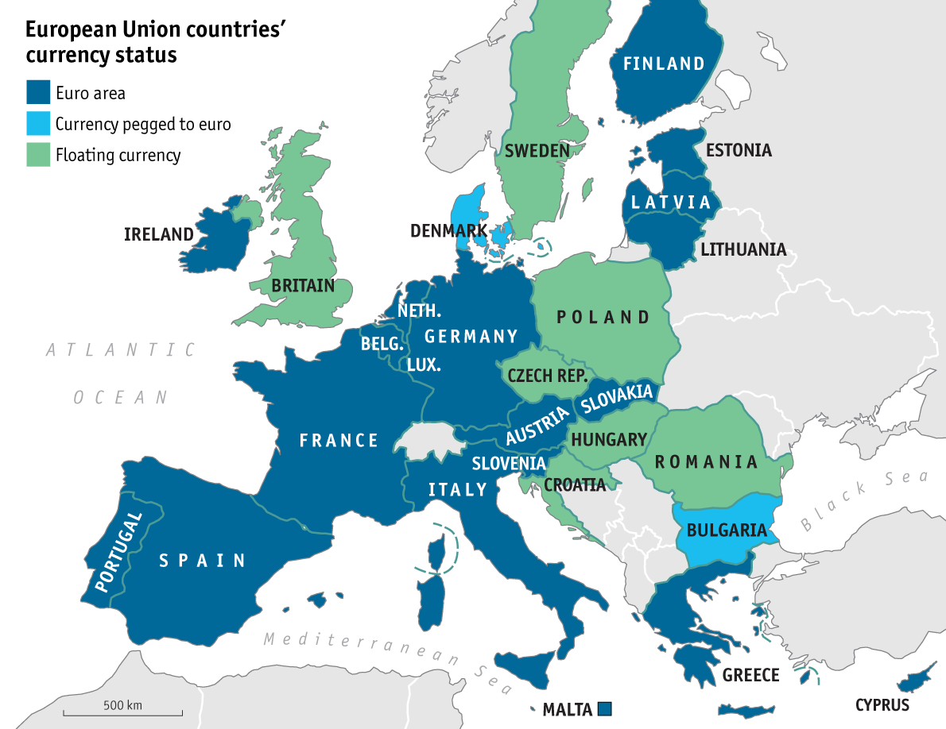

All highlighted countries are current EU members. Blue countries use the euro, while green countries don’t.

Altered Voting Procedures
To pass a substantive matter in the EU, 55% of countries voting must vote in favor of it. In our council of 21 delegations, at least 12 must be in favor. In addition, 65% of attending countries’ populations must be represented by those in favor. To block a substantive matter, 3 countries must oppose it and these countries must represent 35% of attending countries’ populations.
Country | Population | Percentage of Voting Nations
Austria | 8700000 | 1.8%
Belgium | 11290000 | 2.3%
Bulgaria | 7265000 | 1.5%
Croatia | 4253000 | 0.9%
Czech Republic | 10554000 | 2.1%
Denmark | 5707000 | 1.1%
France | 66662000 | 13.4%
Germany | 82162000 | 16.5%
Greece | 10794000 | 2.2%
Hungary | 9830000 | 2.0%
Ireland | 4595000 | 0.9%
Italy | 60666000 | 12.2%
Netherlands | 16979000 | 3.4%
Poland | 37967000 | 7.6%
Portugal | 10460000 | 2.1%
Romania | 19960000 | 4.0%
Slovakia | 5414000 | 1.1%
Slovenia | 2060000 | 0.5%
Spain1 | 46438000 | 9.3%
Sweden | 9851000 | 2.0%
United Kingdom | 65340000 | 13.1%
Total | 496947000 | 100.0%

A Brief History of Brexit
On February 20th, 2016, Britain’s Prime Minister David Cameron announced a referendum of the country’s membership in the EU. This sparked several government ministers voicing their support or opposition towards the newly named Brexit movement, explaining why Britain should remain in or leave the European Union. Cameron, for instance, did not support the exit, but several prominent British politicians did. These politicians, namely Nigel Farage, the head of the UK Independence Party, were able to establish and popularize their movement quite successfully, and against heavy odds. When it was announced, the chances of Brexit’s success were incredibly low, but several factors pushed the British further against the Union over time. The Syrian refugee crisis and resulting EU protocol to take in refugees was met with British disdain. The country had to send increasing amounts of money towards the EU. Euroscepticism established a strong presence in Britain, as politicians claimed that the European Union would destroy the United Kingdom through overregulation.
The Syrian refugee crisis had timing perfect for Brexit. An increasing amount of Syrian refugees poured into Europe since 2012 because of the civil war in their home country. As they did so, islamophobia and xenophobia skyrocketed in the UK, with claims that these refugees were ultimately destructive to Britain and had to be deported. However, under the binding EU regulations surrounding asylum, this couldn’t be accomplished. Syrian refugees had to be kept in the country, despite the growing claims of their pejorative impact on Britain. Those expressing contempt towards the refugees for their perceived crimes against the country (terrorism, the elimination of Christian culture, and general disorderly conduct were high on the list of complaints) would support leaving the EU, believing that it would allow the UK to expel these harmful refugees.
Economically speaking, many believed that the United Kingdom would be stronger outside of the European Union. With independence from the EU, Brexit backers would hypothetically be able to secure trade deals outside of Europe and have a better say in international affairs. Britain would also no longer have to send financial aid to the EU and would be able to restructure their budget towards more domestic needs. However, both of these upsides come at the cost of worsening relations with Europe, since the UK will lose access to the EU perks of easier trade regulations. Economic effects of Brexit will be tremendous in the coming years, as Britain will either sink without the help of European countries or rise without the trade restrictions implemented by them.
Finally, Euroscepticism, the ideology headed against the European Union, has become rampant in the United Kingdom. The UK Independence Party is highly Eurosceptic, believing that the Union’s regulations are destroying its member states. The requirements surrounding aforementioned issues like refugee policy and monetary contribution are some of the most powerful examples, but EU regulations around agriculture, trade, health care, and many more issues are seen as incredibly restrictive to the British. Supporters of Brexit believe that once the UK has left the European Union and these regulations no longer apply, they will be freer and more able to do what they feel they must do. At its core, Brexit was a movement set to obsolete these regulations and deeply change the United Kingdom as a country, and that’s exactly what it’s done.

EU Reactions to Brexit
Brexit has had a profound impact on the European Union’s member states, raising questions of the European Union’s efficacy, and whether or not being a member state is good for a country. EU member states have reacted to Brexit in a variety of ways, with some taking the opportunity to begin their own “independence” movements and others defending the benefits of the European Union.
Germany, for example, has become one of the biggest backers of the Union in recent years. As an incredibly major source of asylum for refugees and an economic powerhouse of Europe, Germany has stayed in full support of the EU. Chancellor Angela Merkel has remained dedicated to the EU since she’s been in office, leading the country in total compliance with the European Union.

France has grappled with the concept of leaving on an immense scale, with an increase of citizens and political parties shifting against the Union. Despite this, the current French government is in favor of remaining in the EU. Although the possibility of “Frexit” remains strong in the future, the current French government would likely oppose it.
Poland, although not an incredibly powerful player in the EU, has released statements surrounding their own EU exit referendum. Poland’s exit wouldn’t be nearly as major of an event as Brexit was for the union, but the Eurosceptic sentiments of the Polish people don’t bode well for the Union. Like many other countries, (Belgium, Hungary, or the Netherlands, for example) Poland would be ready to leave the EU soon, and a series of smaller exits would be heavily detrimental to the EU’s ability to function.

Questions to Consider
- Should the European Union more actively try to prevent future exits in order to preserve itself?
- What impact has Brexit had on other EU member states? Is this impact positive or negative?
- Is it too late to keep Britain in the European Union? Should the EU try to keep Britain in after the results of its referendum?
- What should the responsibilities of the EU ultimately be? Is the current EU overstepping these ideal boundaries?
- What is the likelihood of your country leaving the European Union?
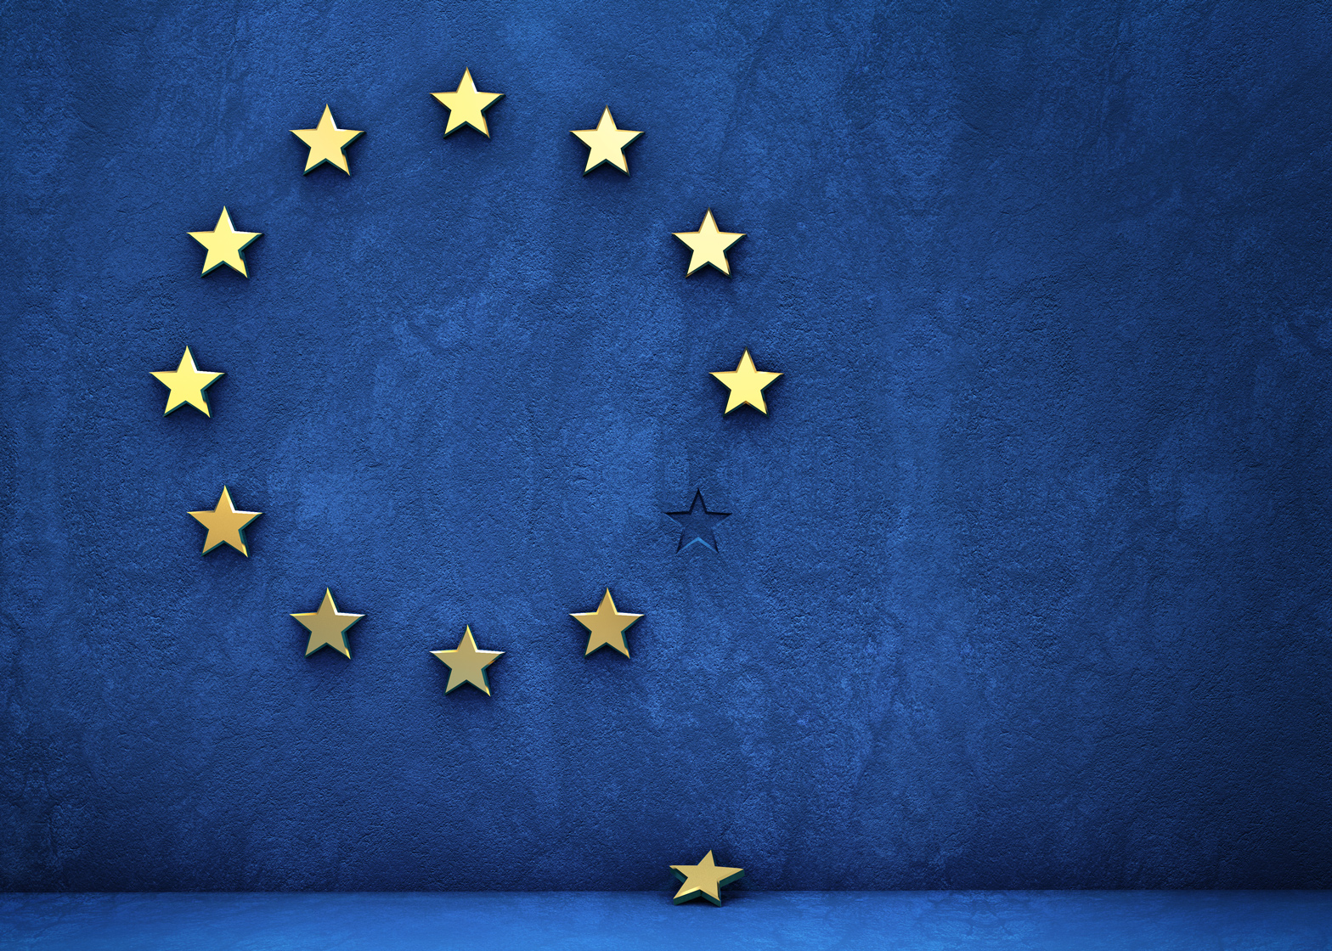
A Brief History of Modern European Nationalism
In the previous section, European nationalism was lightly covered in relations to the United Kingdom, where nationalist sentiments are far from unique. All throughout Europe, there are political groups of varying popularity that hold beliefs similar to those of Nigel Farage and the UK Independence Party. Every delegation attending this council likely has some nationalist influence in their country’s government, although the extent of this influence certainly changes by country. Lots of these nationalist groups are gaining power and popularity rapidly, with many of them gaining more support than ever before. Why are these parties suddenly taking over so effectively?
Refugees and the fear built around them have been crucial to the rise of European nationalism. Just like the UK, countries throughout Europe are stigmatizing Syrian refugees, spreading nationalist messages of isolating Syrians and removing them from their host countries in response to violence caused by a small percentage of them. Terrorists coming into Europe through refugee channels have lead infamous attacks in Paris, Brussels, and Nice, and these attacks have been the heart of several nationalist campaigns. A strong example is in France’s National Front, lead by Marine Le Pen. The party has gained significant attention in recent years, after a successful campaign based heavily on a zero tolerance refugee policy that would greatly restrict the number of Syrians coming into France. European nationalism is gaining ground because Europeans are feeling threatened by the influx of a new and different culture brought by refugees, and many modern nationalists feel they need to protect their country from these outsiders. Several far right nationalist parties have instigated violence of their own against refugees and European Muslims. Members of nationalist parties in Europe have violently protested the refugees and immigrants in their countries, and some are saying that these groups are becoming as dangerous as the terrorists that they are protesting. A study done by Britain’s Royal United Services has found that Islamic terrorist attacks were much more highly investigated and drew much more suspicion than the equally common far right nationalist attacks. Violence is a serious issue on both sides of this debate, but violence caused by Islamic terrorists is focused on much more than violence caused by nationalist groups.
Although threats originating from outside of Europe are dominant among nationalist rhetoric, there’s also a significant focus on the functionality of the European Union as a whole. As one might notice from the table at the start of this background guide, very little power is given to smaller countries in the EU. The population based system of influence causes countries with lower populations to feel under represented, and this leads to tension between the people of these countries and the Union. French, German, and Italian interests might be well protected when these 3 countries alone can block a resolution, but Croatian, Irish, and Slovenian interests are hardly accounted for when these 3 countries combined make up only 2.3% of the EU’s population. This is translated into EU policies, which these countries believe only reflects the needs of populous western Europe. Due to this, smaller countries are showing a decreasing amount of support for remaining in the EU. Conversely, nationalist parties in larger countries claim that since their countries provide so much monetary support and general aid to the EU, they can’t be paid back. French and German nationalist groups capitalize on how much of a financial strain the EU puts on its populous, economically successful member states. Nationalists from all of Europe take some issue with the way the Union functions.

EU Reactions to Nationalism
Nationalism is received differently in each member state of the European Union, and nationalist parties have incredibly varying levels of support and power. While some countries are already lead by nationalism, others see it gaining rising support, and still others see these groups remain an obscure minority of the political scene. Below is an example of each.
The United Kingdom’s UK Independence Party, although previously mentioned, is among the most successful nationalist groups in Europe. After commandeering the successful Brexit campaign, they’ve changed the course of British history, and will likely continue to do so considering their domestic support and success in recent elections in the UK.
The Austrian People’s Party currently holds roughly a quarter of the seats in Austrian parliament, and shows numerous nationalistic viewpoints around immigration and foreign policy. Although their influence is limited, it is still notable, and the party has guided some conservative and nationalistic policy changes in Austria, although these aren’t quite as radical as we’ve seen in other countries.
Holding next to no political power but embodying perfectly the idea of European nationalism is the Greater Romania Party. Members of the sparsely populated party enforce the exact euroscepticism, isolationism, and nationalism discussed earlier, but the party has yet to gain much ground. The Greater Romania Party doesn’t pose as much of a threat to the EU as anything mentioned earlier, but it still reminds us of the universal nature of European nationalism.

Questions to Consider
- Should the European Union attempt to quell the violence instigated by right wing extremists? If so, how?
- How can the EU motivate less populous countries with less influence to remain in the Union?
- How can the EU motivate more populous countries with more EU related obligations to remain in the Union?
- Is Euroscepticism a serious threat to the EU’s existence?
- What importance does the Syrian Refugee Crisis have to European nationalism? Would solving this crisis appease European nationalists?
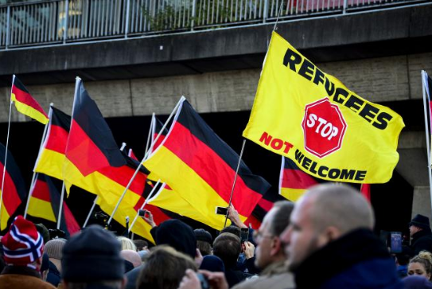

Bibliography

Data Team, the Economist. "A Background Guide to Brexit from the European Union." The Economist. The Economist Newspaper, 24 Feb. 2016. Web. 01 Jan. 2017.
Data Team, The Economist. "European Economic Guide." The Economist. The Economist Newspaper, 18 Feb. 2016. Web. 01 Jan. 2017.
European Commission. "Common European Asylum System." Migration and Home Affairs - European Commission. European Commission, 06 Dec. 2016. Web. 01 Jan. 2017.
Armstrong, Martin. "Six More Countries Want Referendums to Exit EU." Six More Countries Want Referendums to Exit EU. Armstrong Economics, 26 June 2016. Web. 01 Jan. 2017.
Peter, Laurence. "Schengen: Controversial EU Free Movement Deal Explained." BBC News. BBC, 24 Apr. 2016. Web. 01 Jan. 2017.
Foster, Alice. "Brexit: How Long Will We Be Shackled to the EU after We Voted to Leave Months Ago?" Express.co.uk. Express.co.uk, 03 Nov. 2016. Web. 01 Jan. 2017.
Berton, Elena. "Far-right National Front Riding Anti-establishment Wave Ahead of French Elections." The Washington Times. The Washington Times, 12 Oct. 2016. Web. 06 Jan. 2017.
Laville, Sandra. "Rightwing 'lone Wolves' Kill More than Islamic Terrorists Acting Alone, Says Report." The Guardian. Guardian News and Media, 22 June 2016. Web. 06 Jan. 2017.
Web-Redaktion, ÖVP. "The Austrian People's Party." ÖVP. ÖVP, 2013. Web. 06 Jan. 2017.
Terry, Chris. "Greater Romania Party (PRM)." The Democratic Society. The Democratic Society, 19 May 2014. Web. 06 Jan. 2017.

