Organization of American States: Drug Trafficking
2015 Boulder-Fairview H.S. Model U.N. Conference
Emilia Van Buskirk, John Harrington
What is the OAS?
The Organization of American States is the World’s oldest, regional organization, originating at the First International Conference of American States, held in Washington, D.C between 1889 and 1890. This conference established the International Union of American Republics (also known as the Pan-American Union) and set the stage for the connecting provisions and institutions now known as the Inter-American system, the oldest international institutional system.
The modern-day OAS came into being in 1948 when the Charter of the OAS was signed in Bogota, Colombia. With many amendments, beginning with the Protocol of Buenos Aires in 1967, and ending with the Protocol of Washington in 1997, an organization in the Western Hemisphere had been established to achieve, as stipulated in Article 1 of the Charter, "an order of peace and justice, to promote their solidarity, to strengthen their collaboration, and to defend their sovereignty, their territorial integrity, and their independence."
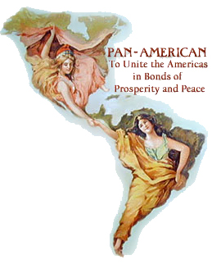
Today the OAS is composed of 35 independent states, and constitutes the main political, juridical, and social forum in the Hemisphere. Using a four-pronged approach consisting of democracy, human rights, security, and development, the OAS strives to fulfill its charter, which states that their purpose, among others, is “to strengthen the peace and security of the continent” and “promote and consolidate representative democracy”. The OAS also works to eradicate poverty and achieve an effective limitation of conventional weapons, which are considered some of the largest obstacles to the full democratic involvement of the peoples of the Hemisphere. Similar to the United Nations, the OAS begins its actions through political dialogue, and serves as a stage for debate among its member-states. Additionally, the OAS has Follow-Up Mechanisms, comparable to UN sub-committees, which are instruments in enforcing decisions and implementing plans made by the OAS.

Topic One: Drug Trafficking in Latin America
History of Drug Trafficking in Latin America
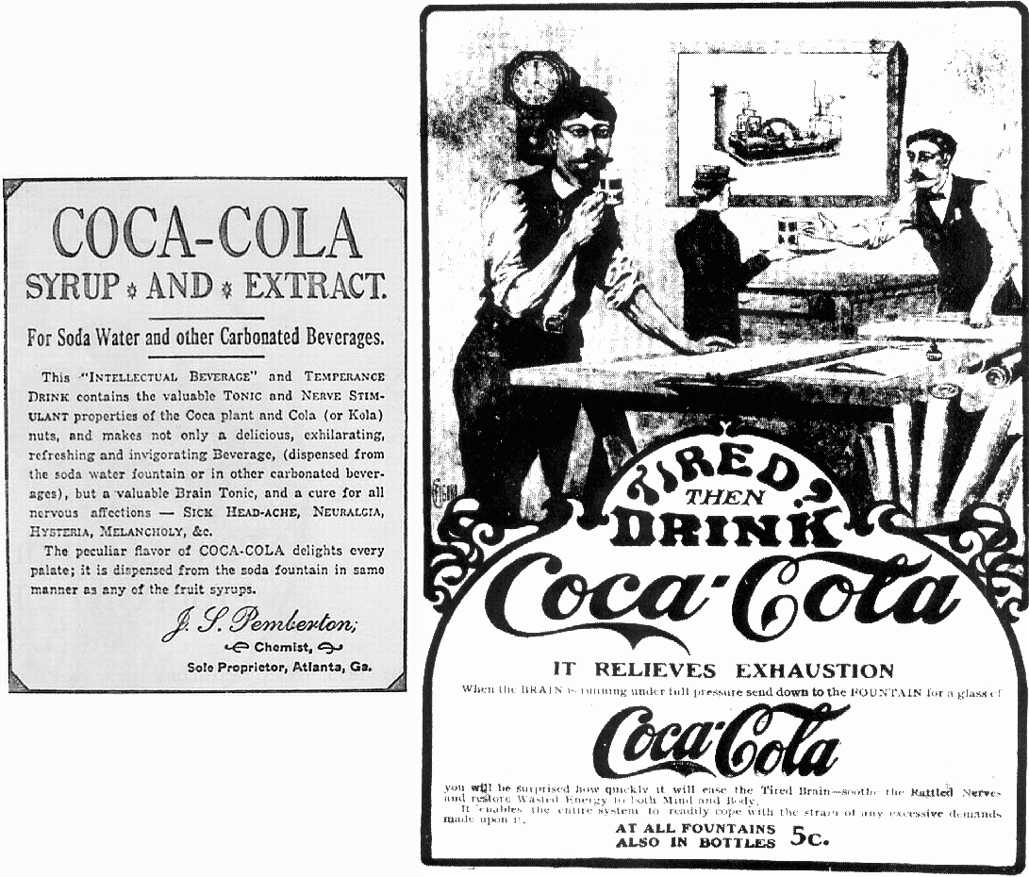
While human drug use and trade has existed for thousands of years, the first major example of the illegal trafficking of an illicit substance began after the Chinese government passed edicts in the 18th century banning the addictive drug opium. However, when Britain, sensing a trade imbalance between the two states, began smuggling opium to China. This dramatically increased opium addiction to approximately 10% of the population, (approx. 10,000,000). This spurred China to ban the import of the drug altogether, sensing a large impact upon the society due to the drug. However, due to the lucrative nature of opium for both the VIC (Dutch East India Company) and the British government, the trade continued through smuggling and force, as seen in the First and Second Opium Wars in the 1840's. By the end of the 19th century, more than 6,500 tons of opium was imported into China per year.
In Latin America, the consumption of coca leaves, the plant endemic to Latin America and from which cocaine is created, had occurred as early as 500 AD/CE among the Moche and Inca empires. From first colonial contact in Latin America to around 1825, Spanish conquistadors were largely disdainful of the practice of chewing coca leaves. However, coca’s properties as a stimulant piqued scientific interest, and by the 1860s it had been distilled into “energy drinks” and used as a surgical anesthetic. Large-scale, legal narcotics trading began, primarily from Peru to the United States. In 1886, John Pemberton created the coca-infused beverage Coca-Cola, and Peru’s cocaine-dependent economy flourished. Meanwhile, Mexico slowly began developing its illegal opium and marijuana production.
However, in the United States, the beginning of the 20th century ushered in the Progressive Era, the advocates of which strongly disapproved of intoxicating substances like alcohol and narcotics. Drugs like cocaine, marijuana, and opium were linked with undesirable behavior, and the United States government began to crack down on their use with legislation. This included: the Harrison Act of 1914, which taxed the production, sale, and consumption of cocaine; the 1909 Smoking Opium Exclusion Act; the 1922 Narcotic Drug Import and Export Act; and the 1930 Heroin Act. China and the United Kingdom also took steps to limit the Sino-Indian opium trade. Many narcotic producers such as Japan, Peru and the Netherlands resisted the criminalization of various narcotics, but eventually the global atmosphere became extremely hostile. The legal Peruvian drug trade was crippled, while illegal Mexican production of opium and marijuana flourished, and marijuana was introduced to Colombia.
Several decades later, in the 1960s, the consumption of illicit drugs became an important factor in an evolving counterculture movement in the United States. This surge of demand prompted the creation of coca plantations in countries like Bolivia, Peru, and Colombia, as cocaine was seen to be much more profitable than its “softer” alternative, cannabis.
Cartels soon formed, spurred on by political instability due to civil wars and guerilla fighting. Soon, these cartels, primarily based in Colombia, became more sophisticated and widespread, developing an almost fully vertically integrated business model. They received raw materials and controlled production and shipping, but not local distribution. While initially using major ports such as Miami to import product, soon the cartels were forced to find more unorthodox methods, such as working with the Mexican Mafia, as the borders and imports became more tightly controlled, thanks to a change in United States drug policy in the 1960s that has continued to the present.
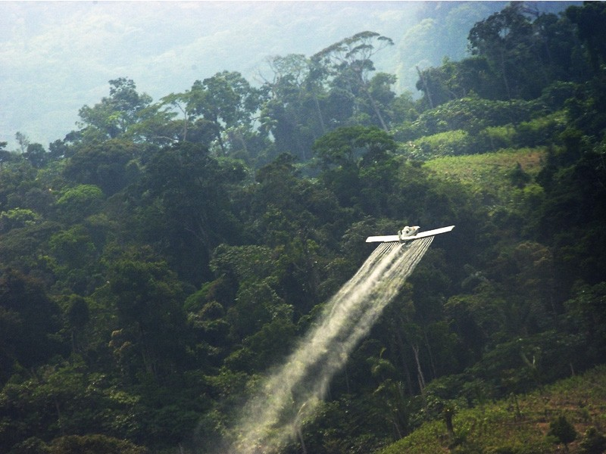
In 1962, President Kennedy hosted the first White House Conference on Narcotics and Drug Abuse, and in 1969, President Nixon launched Operation Intercept in an attempt to stem the flow of marijuana and other drugs from Mexico to the United States. The U.S. increased border patrols, added pursuit planes and motor torpedo boats, and demanded an inspection of every vehicle to cross the border. The Mexican-American border was essentially shut down from September 21st to October 10th, finally ending after pleas from then Mexican President Gustavo Diaz Ordaz to relax these regulations. Operation Intercept had mixed results, but it symbolized America’s new, stricter policy on drug trafficking and moved President Ordaz to take action against Mexico’s blooming smuggling industry. In 1971, US President Nixon formally announced a “war on drugs” and declared substance abuse to be “public enemy number one.” Two years later, he created the Drug Enforcement Administration (DEA) in order to “enforce the controlled substances laws and regulations of the United States and bring to the criminal and civil justice system... those organizations and principal members of organizations, involved in the growing, manufacture, or distribution of controlled substances appearing in or destined for illicit traffic in the United States.”. It was this organization that made it so difficult for Colombian cartels to smuggle narcotics through major ports like Miami, beginning in the 1970s.
Despite the formation of cartels and smuggling rings by 1985, Colombia only produced 10% of the world’s supply of coca leaf. Peru still produced 65% of the global supply, but as the “war on drugs” began to succeed, coca production shifted to Colombia during the 1990s. The US began cooperating with the Bolivian government to finance coca crop eradication programs in the Southern Andean region. These programs, which involved manual slash-and-burn of coca fields and aerial crop eradication via herbicides, continued for years under multiple Bolivian presidents.
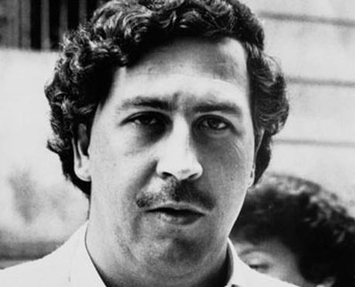
In the 1990s, attention shifted to Colombia, where two major cartels, the Medellin Cartel, led by the infamous Pablo Escobar, and their rival the Cali Cartel, had arisen and accrued massive profits from shipping cocaine to the United States. Colombia began a series of U.S. backed attacks against these cartels and, announcing an all-out war against the cartel, Colombian President César Gaviria and the DEA hunted down Escobar. With information from the Cali Cartel about Escobar’s whereabouts, he was eventually caught and killed by the Colombian military on December 2nd, 1993. The Medellin Cartel quickly crumbled, as did the Cali Cartel shortly afterwards. With both gone, the Colombian cartel system fragmented into many small smuggling groups, and remains fragmented to this day. Currently, there are over 300 small cartels trafficking drugs in Colombia, causing a rise in violence and instability because of turf wars and efforts to eradicate these small organizations, known as cartelitos. It is far more difficult to control and dismantle these cartelitos and stem their flow of drugs to the rest of the world, as they are less vulnerable to governmental and military pressure than large, infamous groups like the Medellin Cartel.
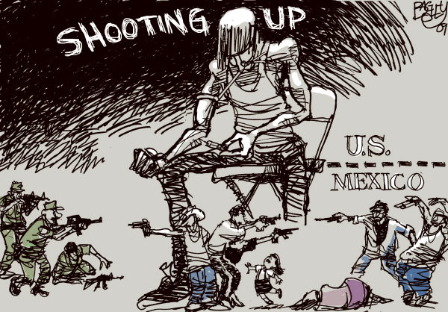
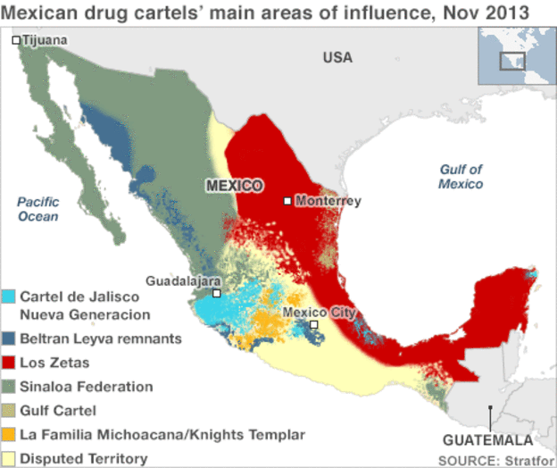
In 1982, the United States’ South Florida Task Force coordinated DEA and FBI constraints and patrolling of the traditional Caribbean routes used by the Medellin and Cali Cartels. These drug routes became far more dangerous to use, and were replaced over the mid-1980s and early 1990s with routes through Panama, Central America, the Gulf of Mexico, and the Pacific Corridor. This increased reliance on Mexico for actual narcotics transit, along with the timely demise of both major Colombian cartels allowed Mexican cartels to almost completely take over the smuggling trade. Mexico’s Guadalajara Cartel had been smuggling marijuana and heroin into the United States when they were hired in the 1980s to smuggle cocaine from Colombia. The cartel developed an extensive network throughout the United States and became very wealthy. When their leaders were captured in 1989, their trafficking routes were divided up amongst three new cartels, the Sinaloa, Juarez, and Tijuana. These cartels flourished under Mexico’s weak federal government and judicial sector, and violence abounded by the time President Felipe Calderon took office and began an intense military campaign against the cartels in 2006. He increased the role of the military in local security efforts in order to circumvent the largely corrupt police force. Through the Mérida Initiative, ”an unprecedented partnership between the United States and Mexico to fight organized crime and associated violence” begun in 2008, the Mexican military captured or killed 25 High Profile drug lords and have made drug-trafficking across the US-Mexican border far more dangerous and expensive. This campaign also served to splinter cartels into numerous smaller cartelitos, leading to more and more turf disputes and succession battles in the country.
The United States also backed Colombian President Andrés Pastrana in his fight against drug production and smuggling. This initiative became Plan Colombia, started in 2000 and designed to “increase Colombia's counter-narcotics capabilities, to expand and consolidate government presence, and to improve the livelihoods of the most vulnerable Colombians by providing sustainable social and economic opportunities, protecting human rights, strengthening rule of law, and making governance more transparent, participatory and accountable.” From 2000-2010, Colombia subdued The Revolutionary Armed Forces of Colombia (FARC), who had taken over coca cultivation and processing after the destruction of the Medellin and Cali Cartels, and reduce the country’s extraordinarily high levels of violence. Additionally, the United States supported Bolivia’s 1997 Plan Dignidad, designed to eradicate the production of coca leaf in the country by providing counter-narcotics capabilities and forgiving millions of dollars of Bolivia’s debt.

Current Situation
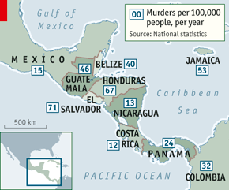
Now, the United States is the largest consumer of cocaine, Colombian and Mexican heroin, and Mexican marijuana. It has been estimated that $150 billion of illicit drugs are sold in the United States each year. Because of this massive demand in a country so close to Latin American narcotics producers, drug trafficking is still rampant in many countries. Additionally, drug-related violence has increased, as cartels take advantage of vulnerable countries.
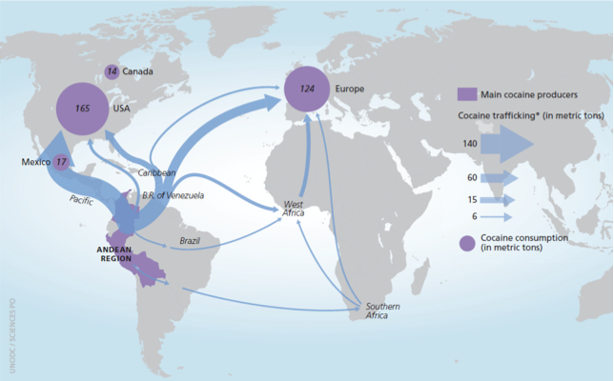
Overall, hubs of Latin American organized crime and, thus, violence, have shifted North in recent years, as recent operations to combat narco-trafficking in Colombia and Bolivia have been successful. Mexico’s cartels, which developed after Colombia’s, are gaining power. According to the United Nations Office on Drugs and Crime’s (UNODC) Global Study on Homicide 2013, Honduras, Venezuela, Belize, El Salvador, Guatemala, and Colombia have the highest homicide rates in the world, largely due to organized crime from drug trading. The map on the right shows homicide rates in Central American countries, which, as the bridge between Colombia, still the world’s largest cocaine producer, and Mexico, the primary drug exporter to the United States, has been attracting more and more attention from cartels. This may also be due to Mexico’s recent drug war, which has undoubtedly made it more difficult and expensive to smuggle drugs across the US-Mexican border. The weaker governmental and military forces in many Central American countries make them more ideal locations for drug trafficking, indicating just how easily trafficking hubs shift across the continent. Recently, Colombian traffickers have been using more Venezuelan and Ecuadorian territory as alternatives to Mexican routes. Venezuela, for example, is a convenient jump-off point for shipments destined for Europe via West Africa, or the United States via Honduras and Guatemala, where the drugs are transported in trucks across the Guatemala-Mexico border and, subsequently, the Mexico-US border. However, Mexico still traffics the vast majority of cocaine, methamphetamines, and marijuana to the United States. Production of all three has increased in Mexico over the past decade, as have levels of violence. Cocaine profits in Mexico have encouraged organized crime and violence over territory and major trafficking routes. Even as Mexico’s cartels begin to fragment, the drug war that began in 2006 continues. Although the Mexican government has captured and imprisoned multiple drug lords, like the infamous Joaquin "El Chapo" Guzman, leader of the Sinaloa Cartel, there are still concerns that they are able to run their cartels from prison and escape all too easily - as Guzman did on July 11th, 2015. According to reporter Theunis Bates of The Week, during Guzman’s first stint in prison in 1993, “with most of the prison officials on his payroll, he ordered meals from a menu, organized drug deals on cellphones, and had prostitutes, his wife, and several lovers brought in on prison trucks, as well as a supply of Viagra.” The corruption that still abounds amongst law enforcement and government agents has been a constant pitfall that prevents the efficacy of numerous drug control policies in the United States and Latin American countries.
Trends in drug consumption have also been shifting, as Europe’s cocaine consumption skyrockets while the United States’ falls. From 1998 to 2006, the number of cocaine-users in European Union and European Free Trade Area countries doubled, while American cocaine consumption dropped by 40% between 1998 and 2009. Drug use in Latin America is on the rise, with Latin Americans consuming 200 metric tons of cocaine in 2011. Colombia still dominates the cocaine trade, with Peru and Bolivia close behind. Together, the three trafficked cocaine to 174 different countries, primarily to the United States and European countries.

Action by the OAS
The OAS is extremely concerned about “The Drug Problem” in the Western Hemisphere, and recognizes it as a multi-faceted issue that affects governments, militaries, drug-dependents, and ordinary civilians across the world. The OAS “has many projects focused on supply and demand reduction and developing stronger anti-drug institutions within individual states.” However, the OAS also recognizes that “dependence on drugs is a chronic (or recurrent) illness that requires a public health response” and that “funding for drug control programs remains weak, especially with respect to prevention and treatment.”
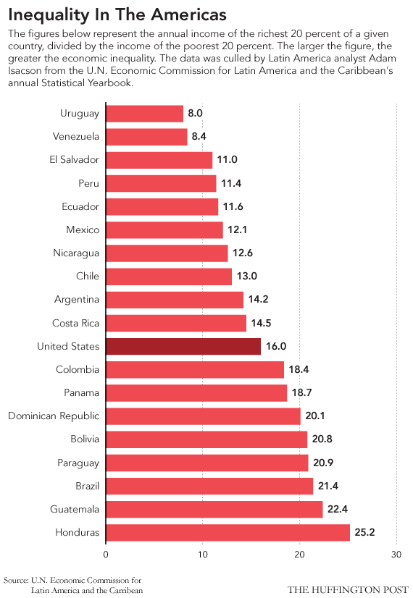
In 1986, the OAS created the Inter-American Drug Abuse Control Commission (CICAD) to tackle the “drug problem” and helps implement the demands of the 2010 Hemispheric Drug Strategy. CICAD’s action programs are designed to:
- Prevent and treat substance abuse;
- Reduce the supply and availability of illicit drugs;
- Strengthen national drug control institutions and machinery;
- Improve money laundering control laws and practice;
- Develop alternate sources of income for growers of coca, poppy, and marijuana;
- Assist member governments to improve their data gathering and analysis on all aspects of the drug issue, and
- Help member states and the hemisphere as a whole measure their progress over time in addressing the drug problem.
In order to reduce demand for illicit substances, CICAD’S Training and Certification Program (PROCCER) and Latin American Federation of Therapeutic Communities (FLACT) works to train counselors to provide addiction treatment and prevention services in OAS member states. On a governmental level, CICAD “[facilitates] the development of public policies in drug demand matters” in Latin American countries through a partnership with the European Union. Additionally, recognizing that drug dependency “must be dealt with as a core element of public health policy,” CICAD promotes the creation of drug treatment courts and alternatives to incarceration for drug-dependents. These courts may reduce the levels of violence and criminal behavior that punitive, intolerant punishments for drug use encourage.
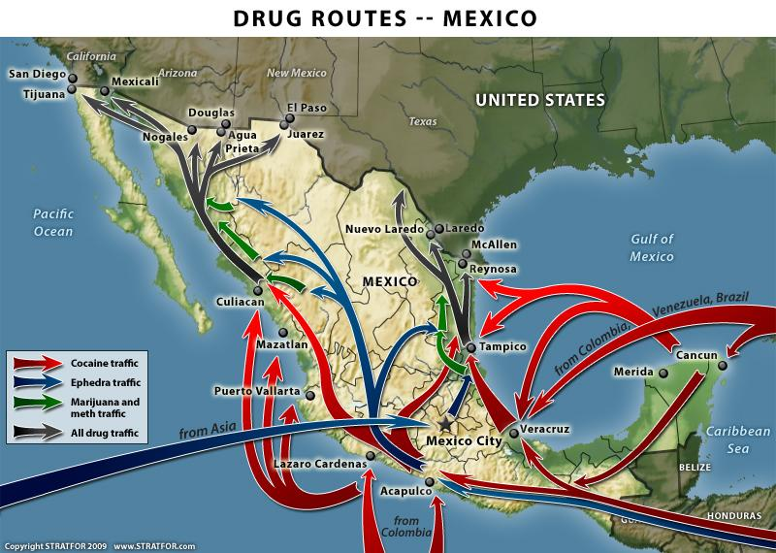
CICAD’s programs represent many of the goals the OAS has concerning the “drug problem,” as it tackles the issue from various angles, at the local and federal level, and with consideration to the economic and human cost of drug production, consumption, and trafficking. When addressing the veritable narcotic epidemic in the Americas, the OAS encourages member states to consider the violence associated with drug trafficking, the need for health care programs to treat drug dependencies, the potential for change in current drug policies, the human cost of drug trafficking, and the effects of military violence to counter illegal drug production and transfer. Since the extensive criminalization of narcotics in the Americas in the early 20th century, governments in the Americas have countered illicit drug trades with increasing levels of violence. According to the OAS’s recent report on Latin America’s Drug Problem, cartels and organized crime often arise from political instability and poverty and attract people who have lived in poverty and experienced unequal opportunities. In order to reduce drug trafficking and drug-related violence, member-state governments need to adopt a wider view of the problem. Without the mechanisms to drive away instability, poverty, and inequality - strong police, judicial, and corrections services, drug rehabilitation programs, universal education, high employment, a commitment to equal opportunities, and safe, clean urban living conditions to name a few - Latin American countries will not be able to drive out the drug trade that thrives in their absences. In 2010, in order to aid and organize member-states’ efforts to eliminate drug trafficking, the Hemispheric Anti-Drug Strategy was created by CICAD and adopted by the OAS. It outlines requirements and recommendations for Demand and Supply Reduction, Institutional Strengthening, Control Measures, and International Cooperation, and operates with the OAS’s main principles to respect international law, promote inclusion and equal opportunities for all member of society, commit to the concept of shared responsibility and work to strengthen hemispheric and regional cooperation, and encourage broad and open debate when forming policy.

Timeline of Events
late 1800s - A legal cocaine industry develops in Peru to service pharmaceutical and commercial concerns in Europe and the United States
1860 - Graduate student in German university gains cocaine alkaloid from coca leaves
1880 - Karl Koller proves cocaine to be effective anesthetic in eye surgeries, and a booming international market for cocaine is born
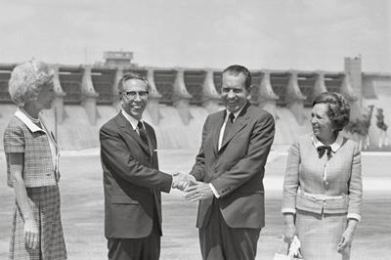
1910 - Mexican Revolution begins, and opium begins traveling up through Baja California, passing through border towns of Mexicali and Tijuana into opium dens in San Francisco and Los Angeles
1912 -The First International Opium Conference occurs. Delegates from China, France, Germany, Italy, Japan, the Netherlands, Persia (Iran), Portugal, Russia, Siam (Thailand), the UK and the British oversees territories attend. The conference identified opium, morphine, cocaine, and heroin as problematic drugs, places more stringent controls on Chinese opium production, and paves the way for national drug control legislation in the United States
1914 - Harrison Act in US regulates and taxes the production, importation, and distribution of opiates and coca products
1914 - The Harrison Narcotics Act in US is passed, which regulates and taxes the production, importation, and distribution of opiates and coca products
1914 - The Panama Canal opens, which makes it easy for opium to be transported from the Atlantic Ocean to the Pacific Ocean, where it transported to Nicaragua and enters Mexican ports. At the time, most opium was imported from Europe.
1920 - The Mexican government bans the importation of opium, so local poppy production flourishes.
1920 - Cocaine products are banned in the United States, and although the US petitions the League of Nations to internationally ban cocaine, coca-producing countries oppose it
1969 - President Nixon begins Operation Intercept, designed to cut off the flow of drugs from Mexico to the United States
1970 - President Nixon passes the Comprehensive Drug Abuse Prevention and Control Act of 1970. This act organized narcotics into 5 categories based on their respective risks of abuse and medical uses, and changed the penalties faced from the importation and exportation of narcotics.
1971 - American President Richard Nixon officially declares a “war on drugs” and names drug abuse “public enemy number one.”
1984 - The DEA and Colombian Police, in a series of raids on the Tranquilandia cocaine plant, seize $1.2 billion in assets and destroy the plant.
1993 - Pablo Escobar is killed, and Colombia’s Medellin Cartel is swiftly dismantled
1997 - Bolivian President Hugo Banzer develops "Plan Dignidad" to counter Bolivian drug trafficking. Plan Dignidad focuses on crop eradication, interdiction, efforts against money laundering, and social programs promoting prevention and treatment for drug dependents.
1996 - Colombian police and the DEA dismantle the Cali cartel.
2000 - Plan Colombia is instituted to counter Colombia’s drug trade
2006 - Mexican President Felipe Calderon sends 6,500 troops to Michoacán to stem cartel violence.
2007 - U.S. President George W. Bush pledges a $1.4 billion anti-drug package for Mexico and Central America, but violence escalates as the drug war continues.
2008 - Mexico captures hundreds of drug gang members. Trafficking routes are disrupted but violence does not cease. In Mexico, approximately 6,000 people die as a result of gang fighting and militant security forces.
2011 - The former presidents of Brazil, Colombia and Mexico speak out about the damage that punitive drug policies are inflicting on their countries (Global Commission on Drug Policy).
2012 - The President of Guatemala calls for a debate on alternatives to the war on drugs, an idea that quickly receives support from other leaders in Latin America, including the current presidents of Colombia and Costa Rica.

Sources

http://www.oas.org/dil/treaties_A-41_Charter_of_the_Organization_of_American_States.htm
http://origins.osu.edu/article/shifting-terrain-latin-american-drug-trafficking
http://www.borderlandbeat.com/2014/06/the-story-of-drug-trafficking-in-latin.html
http://www.cfr.org/mexico/mexicos-drug-war/p13689
http://theweek.com/articles/452325/mexican-drug-cartels-rise-dominance
http://www.oas.org/en/media_center/press_release.asp?sCodigo=E-194/13
http://www.cicad.oas.org/Main/Template.asp?File=/reduccion_demanda/default_eng.asp
http://www.cicad.oas.org/Main/Template.asp?File=/main/aboutcicad/basicdocuments/strategy_2010_eng.asp
http://www.unodc.org/gsh/
https://www.foreignaffairs.com/reviews/capsule-review/2005-05-01/drugs-and-democracy-latin-america-impact-us-policy-war-and-drugs
http://www.theguardian.com/global-development-professionals-network/2014/feb/03/us-war-on-drugs-impact-in-latin-american

Images

http://colombiareports.com/liberal-party-looks-legalize-medical-marijuana-colombia/
http://www.npr.org/2011/05/30/136690257/mexican-cartels-spread-violence-to-central-america
http://www.economist.com/news/americas/21602680-old-route-regains-popularity-drugs-gangs-full-circle
http://www.nytimes.com/2012/07/27/world/americas/venezuela-is-cocaine-hub-despite-its-claims.html?_r=0
http://www.cnn.com/2014/04/10/world/un-world-murder-rates/
http://www.bbc.com/news/world-latin-america-10681249
http://prescriptiondrugs.procon.org/view.resource.php?resourceID=005849
http://uscgaviationhistory.aoptero.org/history05.html
http://earthjustice.org/blog/2015-june/colombia-suspends-aerial-spraying-of-illegal-coca-crops
https://thevelvetrocket.files.wordpress.com/2010/05/drug_routes_2009_800.jpg
http://www.cagle.com/tag/dea/page/6/
http://billmoyers.com/2013/01/29/the-u-s-is-now-more-unequal-than-much-of-latin-america/
http://nsarchive.gwu.edu/NSAEBB/NSAEBB86/

Quotes

http://www.dea.gov/about/mission.shtml
http://www.state.gov/j/inl/merida/
http://www.oas.org/en/topics/drugs.asp
http://theweek.com/articles/452325/mexican-drug-cartels-rise-dominance

